Creating Custom Properties
1. Log into Administration.
2. Select the House Icon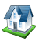. Open the Settings folder and select Custom Properties. (Image 2)
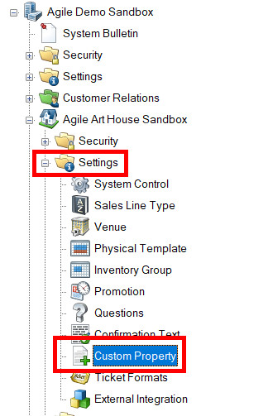
Image 2

3. In the Custom Properties window, right-click and select New then select Event. (Image 3)
Image 3
4. The Custom Property: Properties screen will appear. (Image 4)
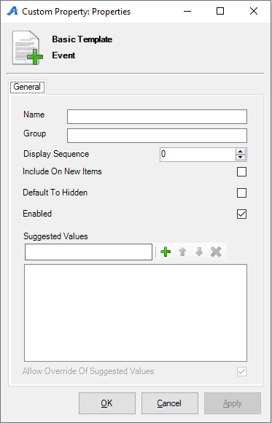
Image 4
5. Give the Property a Name and a Group name in the fields provided. (For this example, we have the title name as "Production Country" and the Group name is "Film Info") (Image 5)
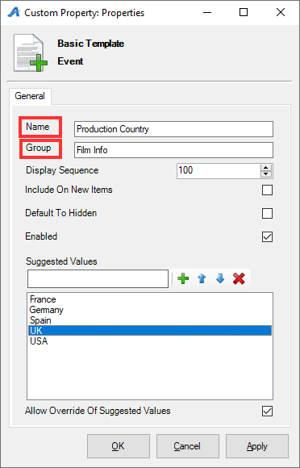
Image 5

6. The Display Sequence tells the system in what order you want the categories to appear online. (Image 6)
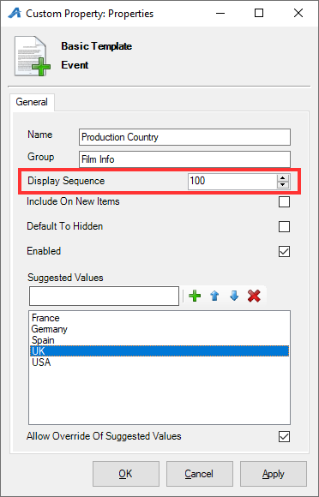
Image 6

7. Suggested Values allows you to create a list of often used properties that can be chosen from a drop down when adding to an individual show. (Image 7)
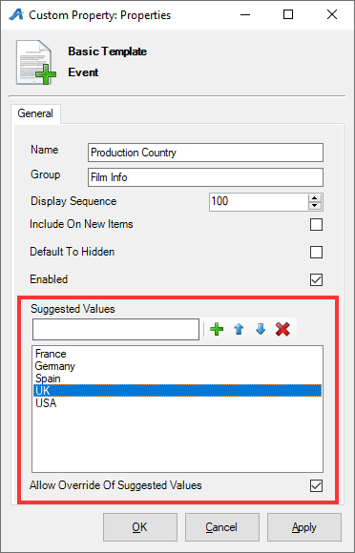
Image 7
8. Click Apply to save this custom property, and then click OK to close the screen. Your new custom property can now be seen in the Custom Property window. (Image 8)
Image 8
9. Repeat the steps to add additional custom properties that you need. Once completed, you will now have a list of different properties that you can associate specific information for a particular show or event. (Image 9)
