Setting Up a Gift Card Program
1. Log into Administration.
2. Click the House icon.
3. Open the folder that houses your Gift Card Program. If you do not have a folder with a Gift Card program, click here to learn how to Create a Blue Sales Organization Folder.
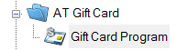
4. Click the Gift Card Program icon.
5. Right-click in the Gift Card Program area and select New.
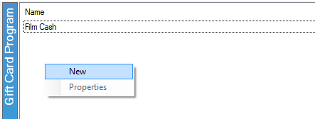
6. The Gift Card Program: New window should appear.
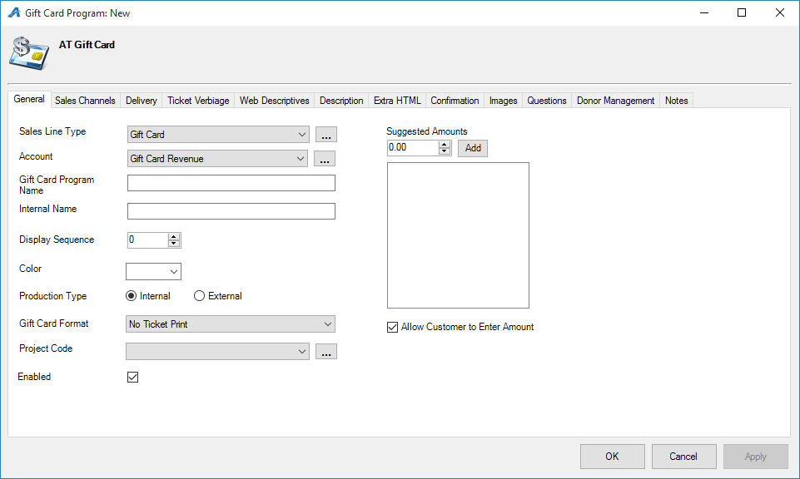
7. You will need to assign a sales line type and a revenue account. To enter a new sales line type or account, click the ellipsis button.
8. Enter a Name for the Gift Card Program.
9. Give the program an Internal name. Note: Internal names can only be seen by staff.
10. You will also need to choose a Production Type:
- Internal: With an internal gift card program, the Gift Certificate is produced by Agile (i.e. Print At Home Gift Certificate that has the Gift Card Number populated on the certificate).
- External: this is used when you have pre-printed cards and you are swiping the card to assign the number to the customer.
11. Next, if you have predetermined amounts for your gift cards, enter them into the space provided. If you want to give the customer the ability to enter an open amount, check the box next to Allow Customer to Enter Amount.

12. Click Apply to save this information.

13. Next you will need to open the Sales Channel tab.

14. Select your Sales Channels and the days that you want your gift cards to be on sale.

15. Next, go to the Delivery tab and select your delivery methods.

16. Click Apply.

17. Next, click the Web Descriptive tab. This is where you will enter a short description about your gift card program that will be displayed on the website.

18. Next, open the Images tab. This is where you will insert any image that you want to appear on your gift card program's web page.

19. The Questions tab is used when you would like the customer to answer specific questions regarding the gift card. Often we use this for setting up an alternate shipping name & address as well as a gift card message.

Note: you will need to generate the External Batches to send the print data to be printed onto the mag stripe cards. For this step, please call an Agile Support Representative.

