Assigning a Terminal Key
In Agile, the Terminal Key assigns a unique ID to a terminal (i.e. computer or POS station). In order to sell or print tickets in Agile Sales and POS, a Terminal Key must be used to assign a terminal to the machine they are using to process sales functions. Within the properties of a terminal, you may also associate any necessary ticket printers, cash drawers, or other devices with your Box Office setup.
NOTE: Most users do not have the permissions to assign (i.e. create) a completely new terminal and terminal key. If you need a new terminal key, please contact our support team at support@agiletix.com or 615.360.6700.

Creating the Terminal and its Terminal Key
1. In Administration, click the Settings folder at the regional level to see your administrative folders. Then, select the Location icon.
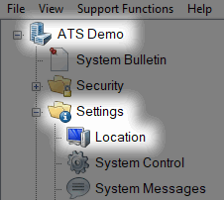
2. In the Location field, select the Group where the new terminal and its key should be created.
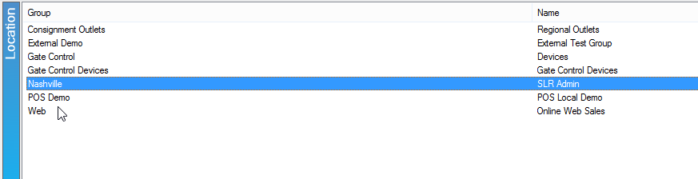

3. In the Terminal field, right-click and select New.
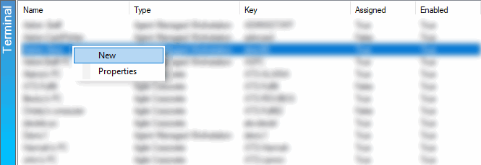
4. The Terminal: New window will appear. In the General tab, enter the Terminal Name, Key, and address information. Then, click Apply to save your changes.
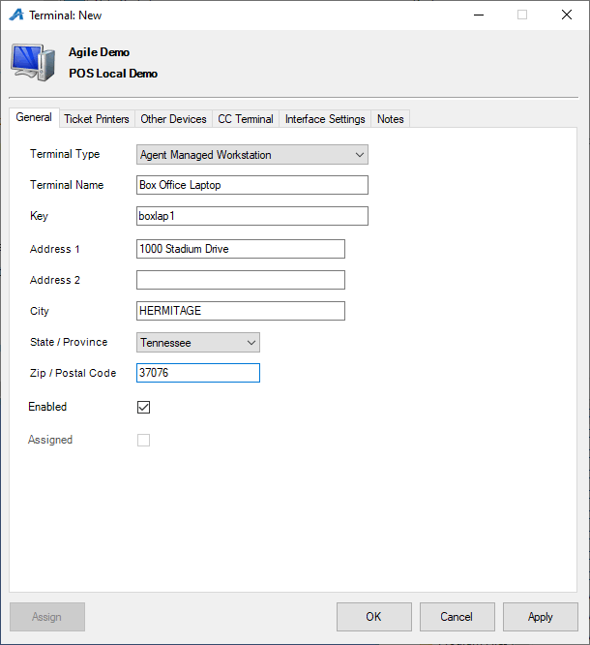

Setting up Ticket Printers
5. If you have any ticket, card, or receipt printers that need to be associated with this terminal, click the Ticket Printers tab.
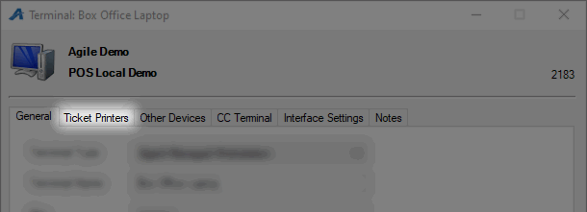
A. In the Printer field, right-click and select New.
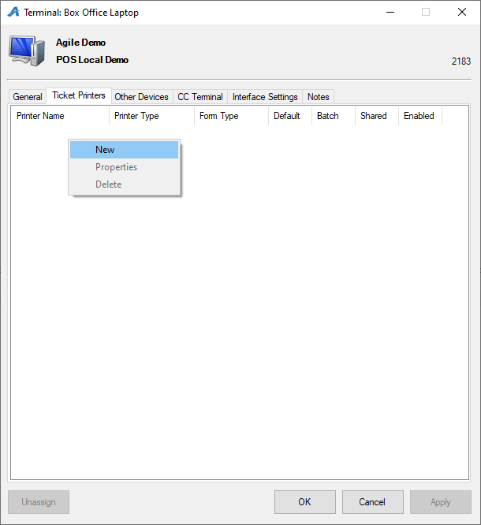
B. The Terminal Printer: New Window will appear.
- Choose the corresponding Printer Type from the drop down.
- Choose the Form Type from the drop-down.
- If your printer has a cutter, choose the Cut Type.
- Enter the Printer Name description.
- Choose the Browse button to select the installed printer driver from the Browse Local Printers drop-down list.
- If this is the main ticket printer, check the box next to Default.
- If this printer will be used to print bulk fulfillment tickets, check the box next to Batch Printing.
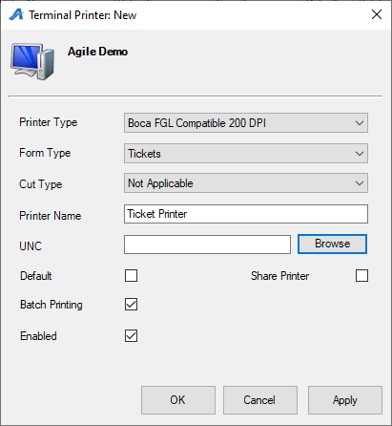
C. Click Apply and OK to complete this setup.

Setting Up Other Devices
Certain computers and POS stations will need to have a Cash Drawer and Guest Display assigned to the terminal.
6. Click the Other Devices tab.
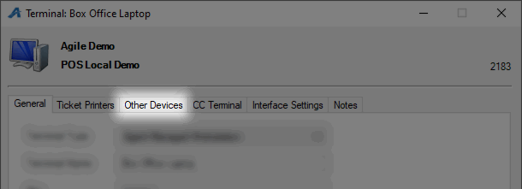
A. Cash Drawer - Check the box next to Cash Drawer and then select the COM Port which the Cash Drawer is plugged into. NOTE: Most POS stations are set up for COM 1 by default, but you should test-ping the drawer to ensure that it is pointing to the correct COM port.
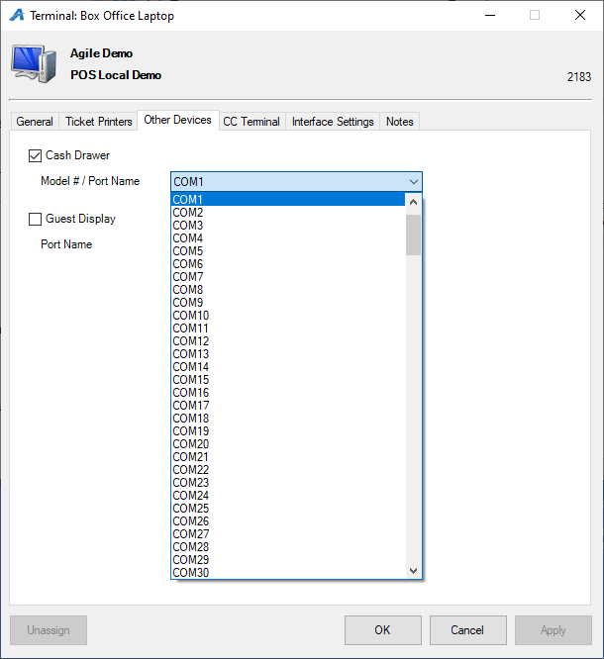
B. Guest Display - Check the box next to Guest Display and then select the COM Port that the display unit is plugged into.
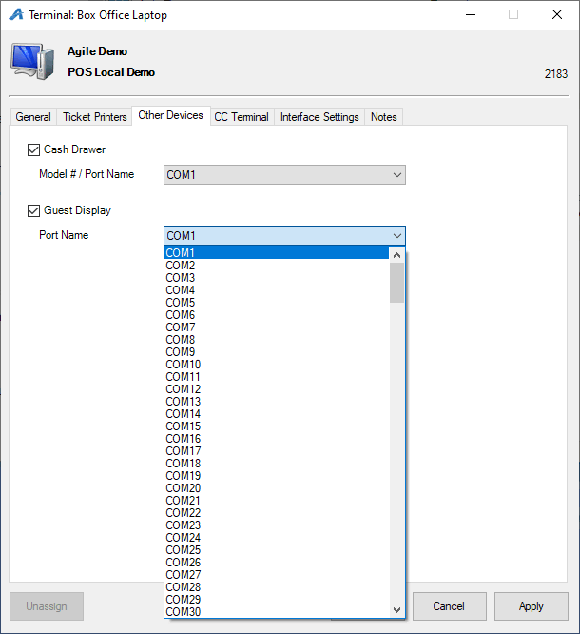
7. Click Apply and OK to complete this setup.
Assigning a Terminal
Now that the Terminal Key and has been created and associated with all necessary devices, you may use its terminal to sell and print tickets. There are two ways to assign the terminal.
8. When in Sales, click Action at the top of the screen. Then, select Assign Terminal.
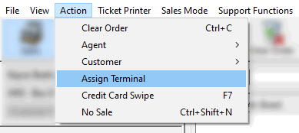
9. The Assign Terminal Key window will appear
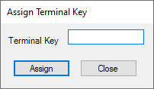
11. Enter the correct Terminal Key for this terminal and click Assign.
