How to Purchase Tickets Online
1. First, go to the ticket purchasing page on the organization's web page.
2. Click the View More button under the event for which you wish to purchase tickets.
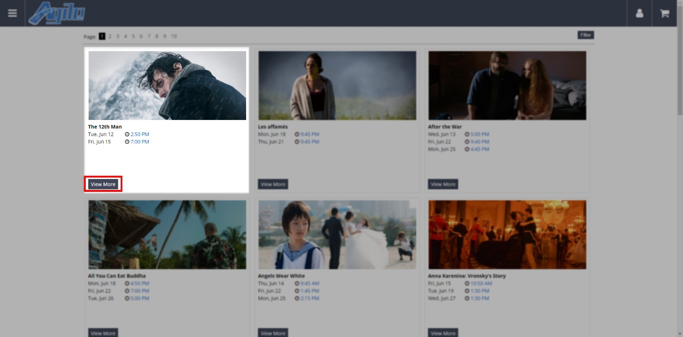

3. You should now see different details about the event, such as a description, pictures, trailers, and more. To purchase tickets, click the Buy Tickets button next to the time you wish to attend.

4. A window will appear. Select the number of tickets you will be purchasing from the drop-down menu and click Add.
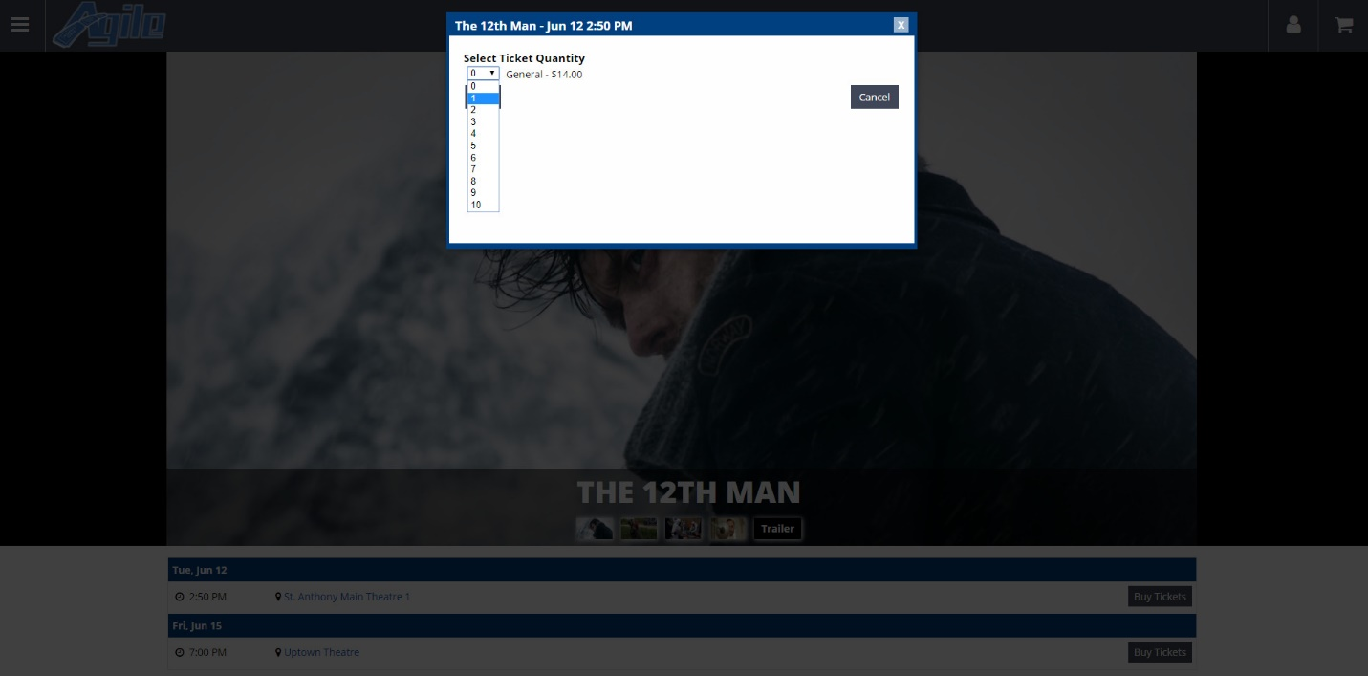

5. If you wish to purchase more tickets, click the Return to List button and repeat the previous steps. If you are done shopping, click the Proceed to Checkout button.
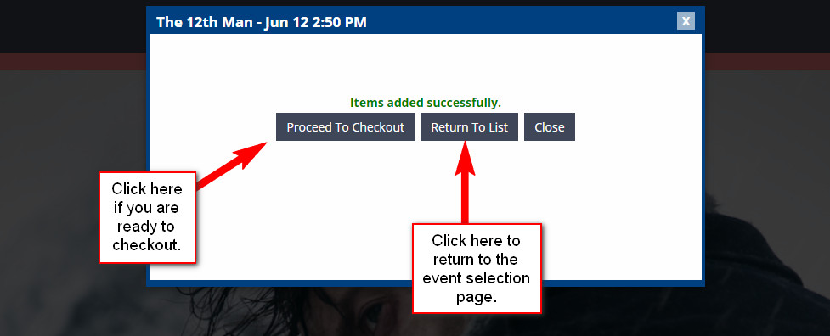

6. Once you have all the tickets you wish to purchase in your cart, click the Cart icon at the top of the page to proceed to the checkout page.
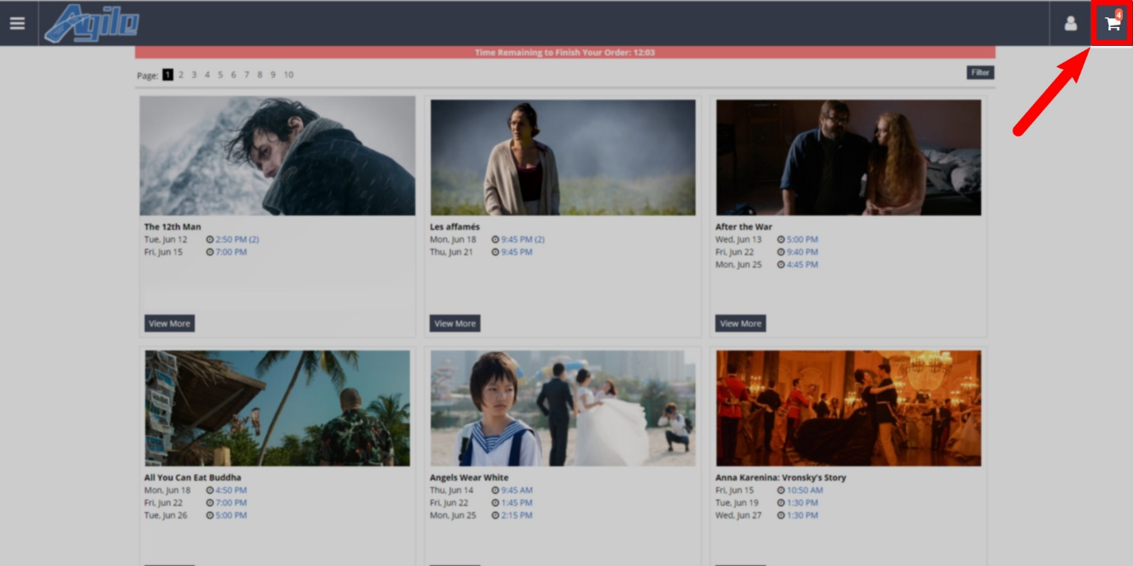

7. Next, you will need to select your Delivery Method. This is the method in which you will receive your tickets such as Will Call, Print at Home, E-Ticket Delivery, and more.
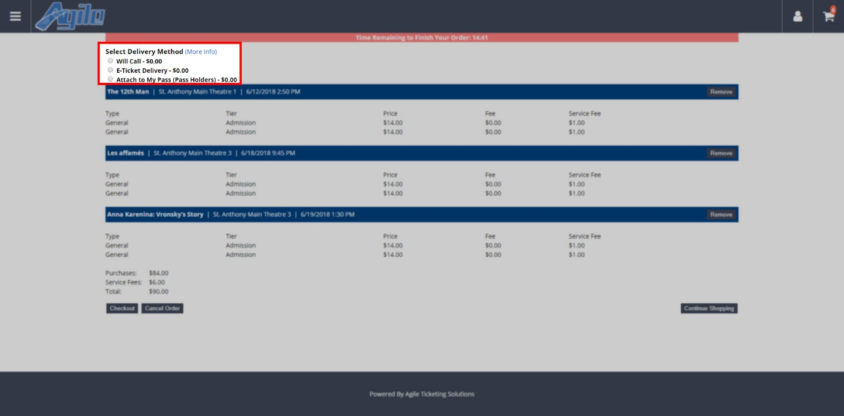

8. Review your order. If everything looks correct, click the Checkout button.
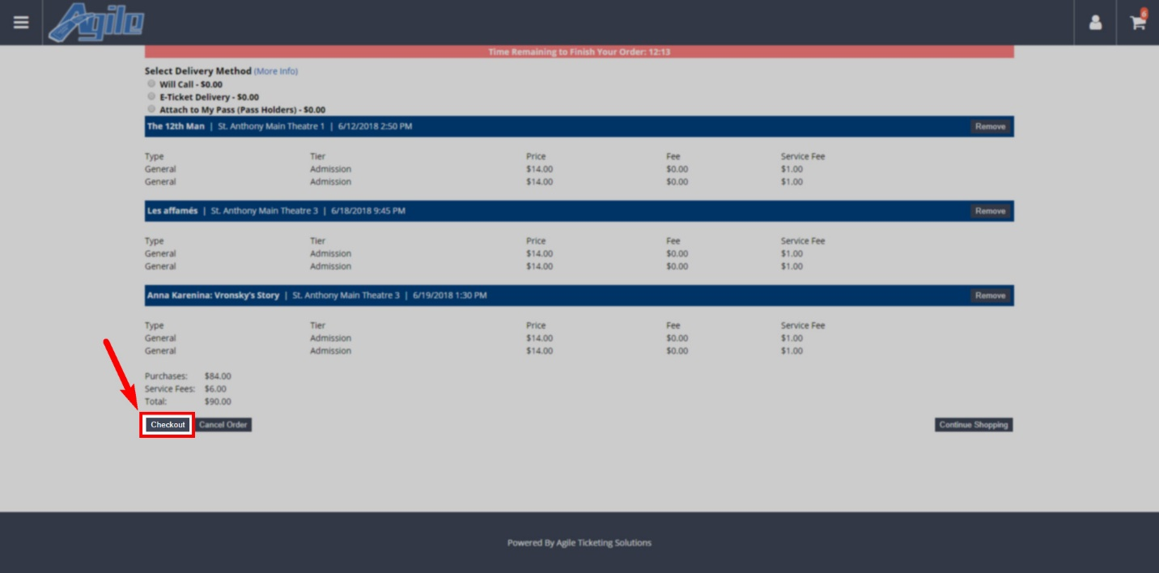
(NOTE: If you are purchasing a Ticket Pack, you will be required to sign in to your customer account or create a new customer account before proceeding to checkout)

9. You will now need either to sign in to your account, create a new account, or (if the organization has enabled it) create a guest account. To create a new account, click either the Sign-Up button on the right side of the screen or the Don't have an account yet? Click here to sign-up. button below the Sign In box.
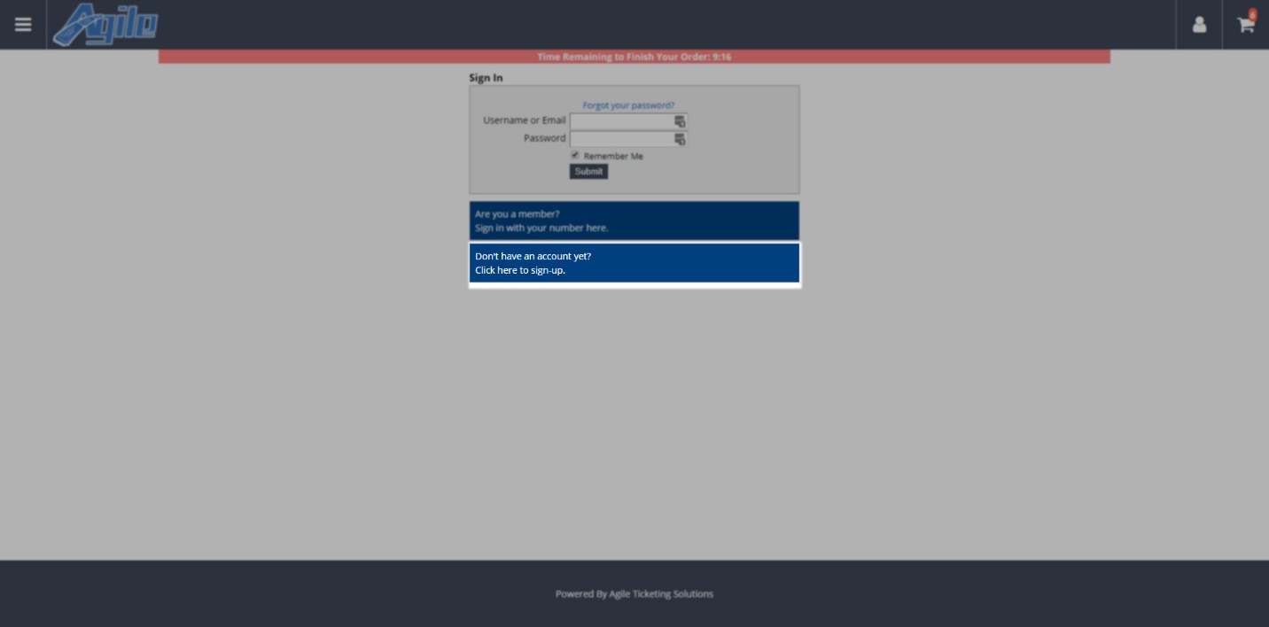

10. Enter your account information and your billing address. Then, click Submit.
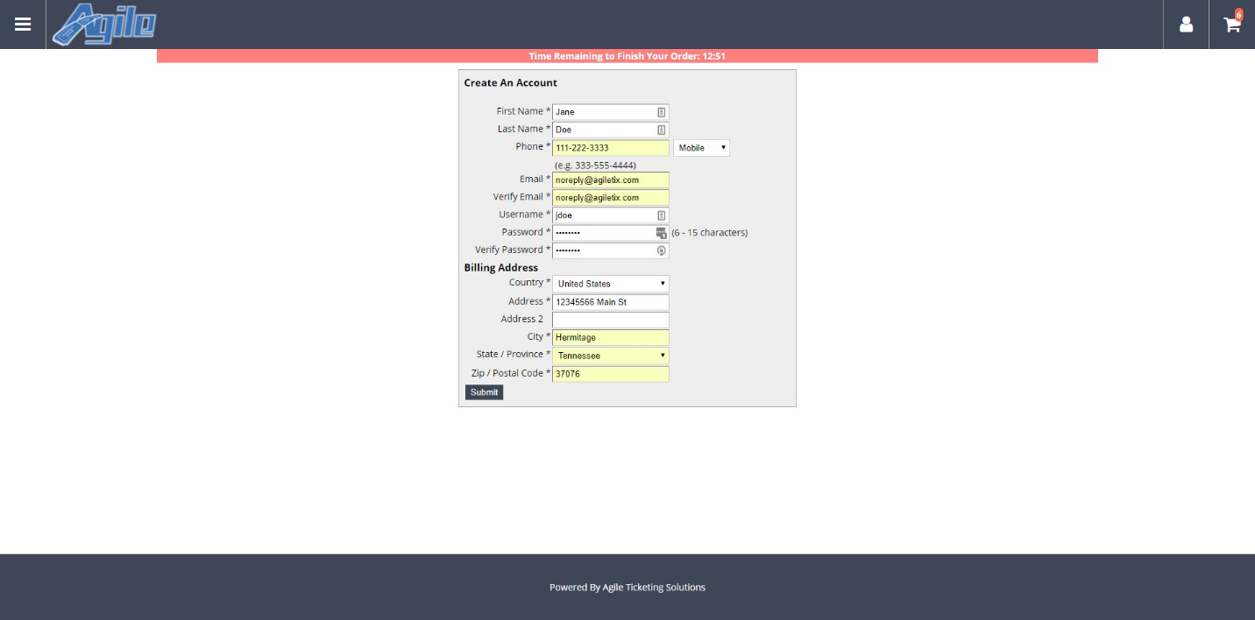

11. Enter your credit card information. (Please note that your credit card information can NOT be seen by anyone once you have entered it)
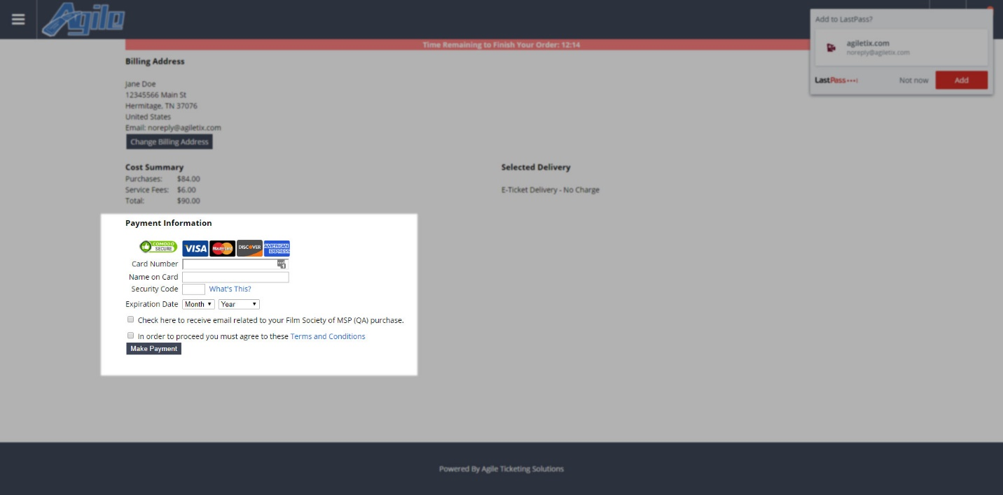

12. Check the box next to Terms and Conditions and click Make Payment.
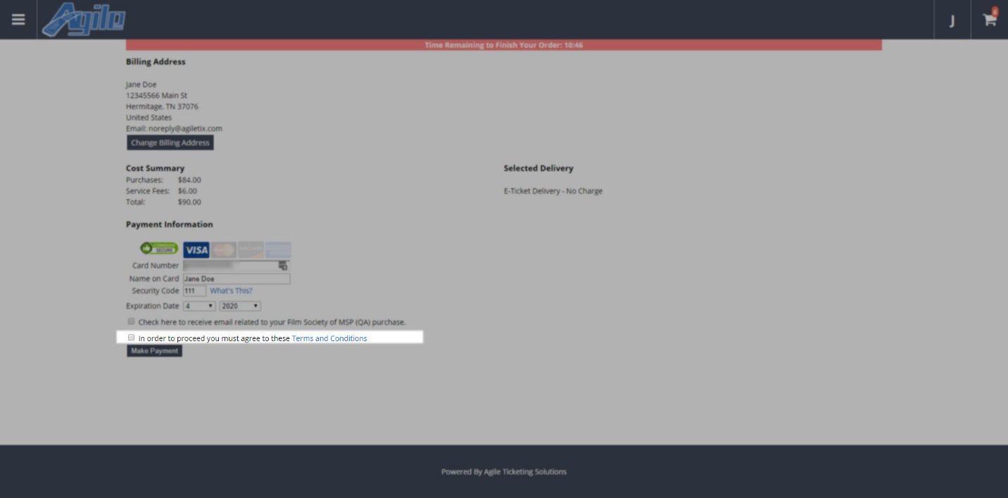

13. This will take you to your purchase confirmation page. From here, you can review your purchase and print your tickets at home.
