Searching for an Existing Customer
There are multiple ways to search for an existing customer.
AMS Sales
1) Login to the Sales side of Agile.
2) Click the Customer icon. 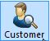
3) Type a Keyword to search for the customer (last name, phone number, email, customer #, etc.) and click the Search button.
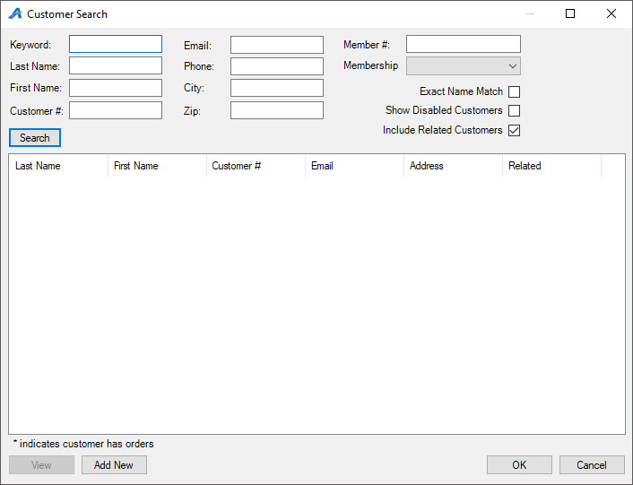

POS
1) Login to the Sales side of Agile.
2) Click the POS icon.
3) Click the Search icon.
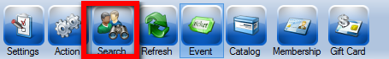
4) Enter the customer's information and click Search.
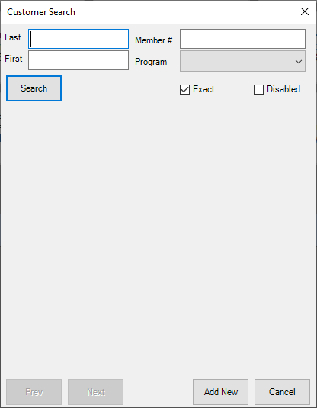

Administration
1) Login to the Administration side of Agile.
2) Expand the Customer Relations folder and click the Customers icon.
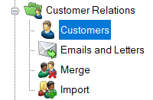
3) Enter the customer's information and click Search.
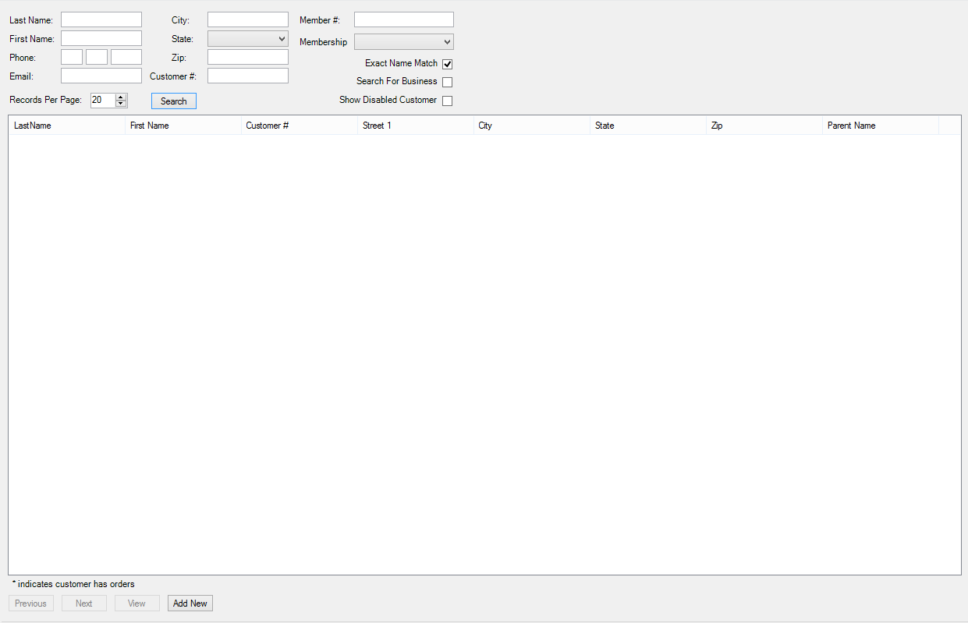

NOTE: If the customer is not coming up, try searching for a limited amount of information (ex. last name only). To broaden the search range, do not check the Exact Name Match or Search For Business boxes.

