Customer Image in Fulfillment
Customer Images is a feature that allows clients to add a picture of a customer to their membership cards or festival passes. Some of your patrons may have purchased a membership or pass but have not uploaded their images. This tutorial will show you how to filter the orders in fulfillment that have images versus those that do not have images. This will allow you to contact those customers about getting an image before printing their passes or membership cards.
1. In the Sales application, click Support Functions and then Fulfillment.
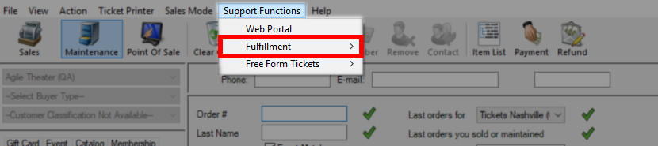
2. Open the Membership Fulfillment page.
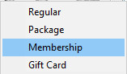
3. Click the Pass or Membership program to see all Orders To Fulfill. Under the Member Name column, you will see orders that do not have an image associated with the order designated with [no profile image].
4. In the bottom-left corner of the window, check the Hide Orders Needing Profile Images box. This will allow you to filter and print only the orders that have images associated with the pass or membership.
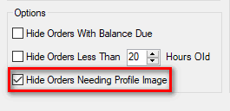
5. To add an image to an existing membership/pass order, check the box next to the order.
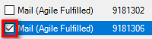
6. At the bottom of the window, click the Add to Scratch Pad button.
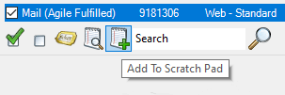
Select Go To Scratch Pad.
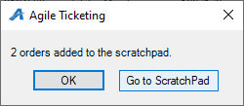
7. Click the Order Number on the Scratch Pad. From here, you will be able to go in and edit the Customer Record to add the image. To learn how to Edit a Customer Record, click here.

