Adding and Managing Account Benefits in Web Portal
1. Go to portal.agiletix.com
2. Log in using your Username, Password, and Domain.
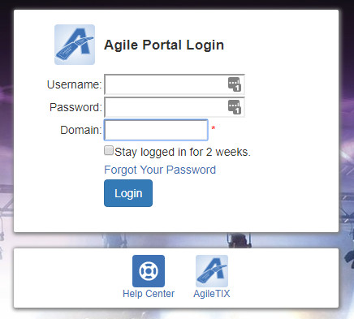
3. Click the Customer Icon on the left side of the screen.
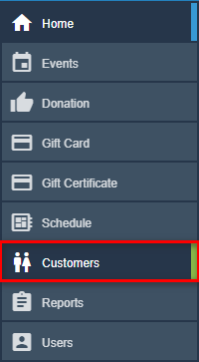
4. In the Keyword box, enter the name, phone number, address, or email address of the customer.
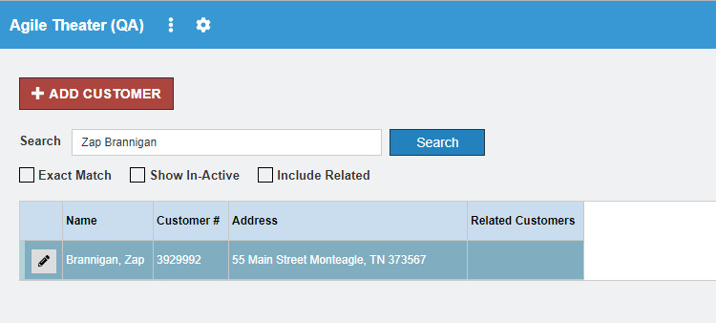
5. Click the Edit icon next to the customer's name.
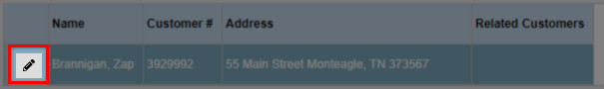
6. Scroll down to the Account Benefits tab.
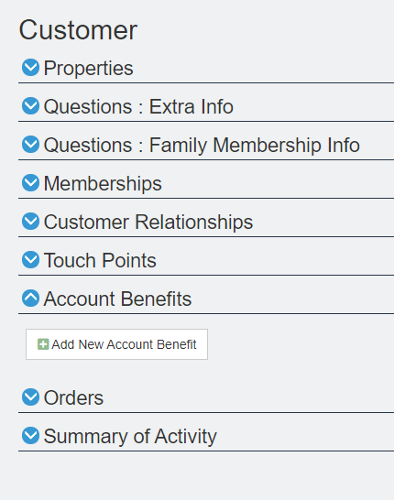
7. To add a Benefit for this customer, click the Add New Account Benefit button.
8. Select the type of benefit you are adding.
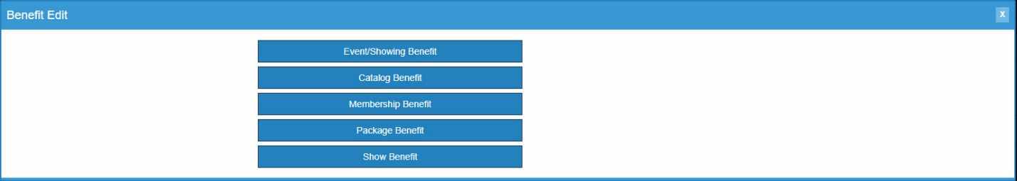
- Event/Showing Benefit: Allows you to chose a specific event(s) or showing(s) that the member can use to get tickets based on their benefit level.
- Catalog Benefit: Allows the customer to have a benefit for specific items (i.e. T-shirts, Drink Discount, etc.).
- Membership Benefit: Used to access discounted memberships or pass types.
- Package Benefit: Allows users to access specific packages (e.g. Season Subscription package).
- Show Benefit: Allows the organization to restrict the benefit to the entire run of a single Show or Event (e.g. Greatest Movie is showing 10 times in the week, but the member can only select a single date for the entire run. Once they have selected an event in that run, they will not be able to choose another event).
For this example, we will be creating an Event/Showing Benefit.
9. On the Benefit Page, name your Benefit.
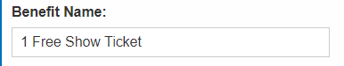
10. Then, select your organization from the drop-down menu.
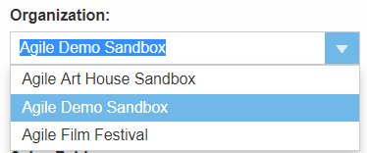
11. Select the correct Sales Line Type. NOTE: You MUST make sure that this matches the Sales Line Type of your Events. If you have multiple Events with different Sales Line Types, you will need to create a Benefit for each Sales Line Type.
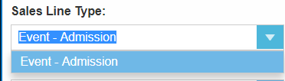
12. Next, you will need to select the Sales Folder where the events for this benefit are located.
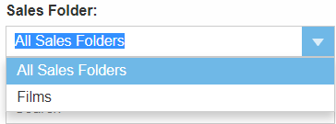
13. If this benefit is for a Specific Event/Showing, type the event/show name and select the specific Event from the drop-down menu. If all Events/Showings are available for this benefit, leave the default as Nothing Selected.
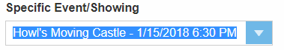
14. Specify the tier from the drop-down menu.
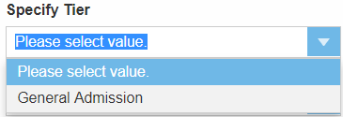

15.From the drop-down menu, Specify Ticket Type.
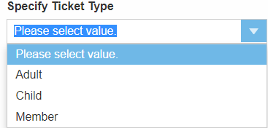
NOTE: If you do not select the correct ticket type for this benefit, the benefit will be open-ended and allow anyone to access the benefit.
16. Next, set your restrictions:
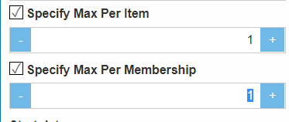
- If you want to restrict how many redemption tickets per item/event that a customer can receive, check mark Specify Max Per Item and enter how many tickets per item/event a customer will be able to redeem.
- Make sure to enter the max number of tickets that are available for each pack by entering the amount in Specify Max Per Membership area (e.g. If you have a 6-pack, then you will want to limit the number of tickets per member to 6).
17. Finally, select your Start Date and End Date. The start date is the date when this benefit will be available to the customer. The end date is the day when the benefit will no longer be available.
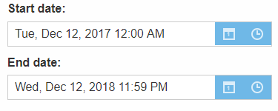
18. Once you have filled out all information, click the Save button at the bottom of the screen.
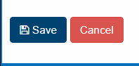
19. If you ever need to edit the benefit(s), click the Edit icon next to the benefit name in the customer record.
