Building a Show in Web Portal
The Show function is primarily used for recurring events such as movies. The Show level contains all static data such as duration, descriptions, and images.
1. Log into the Web Portal at portal.agiletix.com.
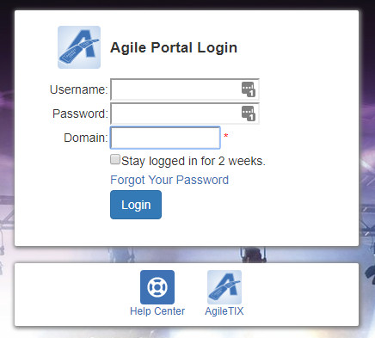
2. Click Events in the menu on the left side of the screen.
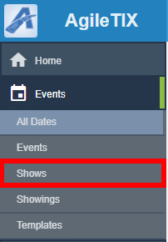
3. Click the + Add Show button at the top of the screen.
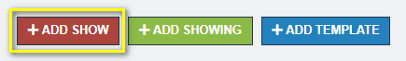
4. Select the Folder in which you wish to build the New Show and click Continue.
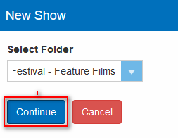
5. In the Properties tab, enter the Name of the show. This is the name that will appear to the public.
Note: Name has a 250-character limit and will be seen online by customers. Sort Name (found in the Additional Information tab) has a 50-character limit and will only be seen by your staff in Sales.
7. Enter the Duration (In Minutes) of the show.
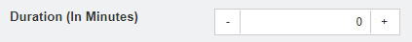
8. Type a short summary for the show in the Brief Description. Customers will see the Brief Description alongside the show as they browse a web page with a Display Type of Detailed, Highlight List, List, Simple, or Tiles. The Brief Description has a 1000-character limit.
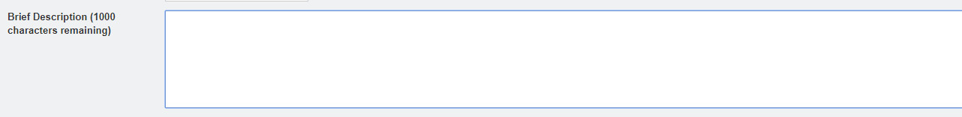
9. Close the Properties area and open the Media section.
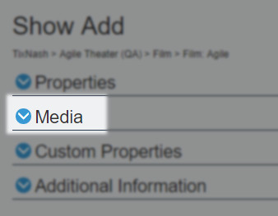
10. The Media section allows you to upload images and trailers. The ideal image size is 560 pixels wide by 315 pixels high. To upload your media content:
A. Click the Add Media button.
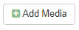
B. Select the Type of Media you will be uploading.
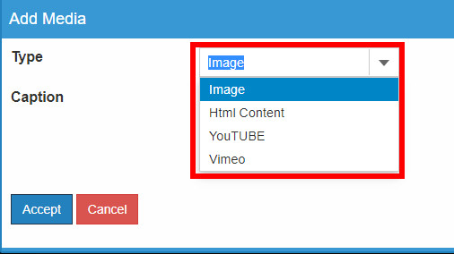
C. Add a Caption that will appear on the Image. (This is not required.)
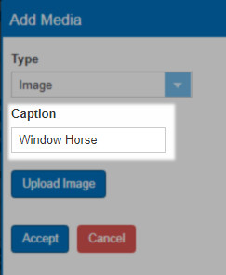
D. For images, click the Upload Image button and select the image file from your computer.
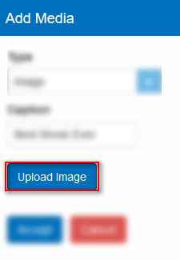
E. Once you have uploaded your image, click the Accept button.
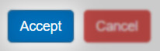
F. When uploading a Video or Trailer, select the Media Type from the drop-down menu. Videos must be in either YouTube or Vimeo format.
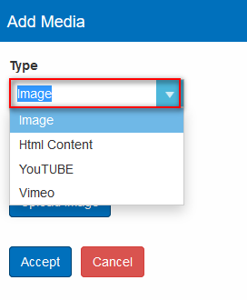
G. Add a Caption that will appear on the trailer.
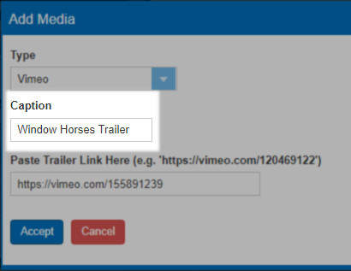

H. Copy the link and add it to the Paste Trailer Link Here field.
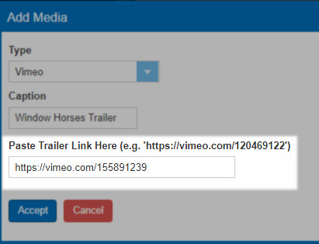
I. Once you have uploaded your videos/trailers, click the Accept button.
J. Repeat the process to add additional images or videos.

K. You can reorder your images and trailers by clicking the Move Up or Move Down buttons.
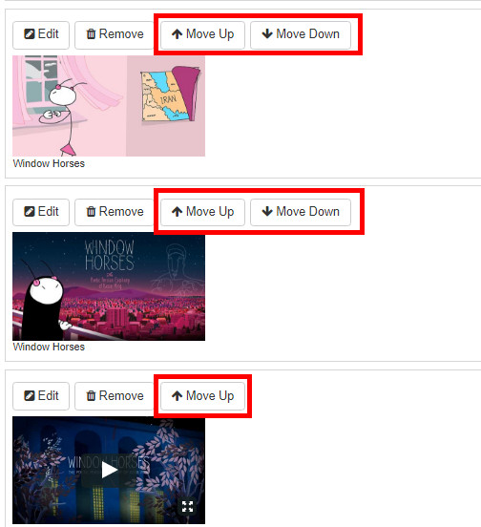
L. Close the Media area once you have completed adding your Media content.
11. Click the Custom Properties tab to begin adding any additional content for your show (Rating, Release Year, Cast & Crew, etc.).
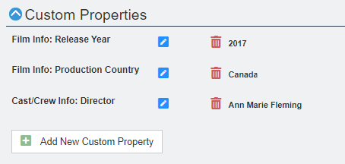
NOTE: If you do not have information for specific Custom Property fields, leave the category blank.
12. Click Included Shorts if you have short films that need to be added to your show. Select each short from the drop-down menu. (Click here to learn how to build a short.)
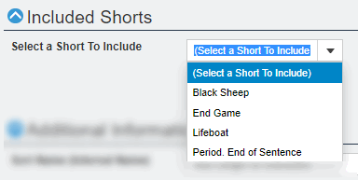
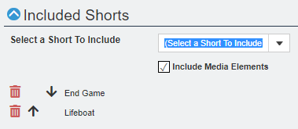
13. Once you have added your Shorts, close the Included Shorts tab and open the Additional Information tab.
14. Enter the Sort Name (Internal Name). This name will only be seen in the Agile Software. We recommend using a name that will make it easier for staff to find shows in the system, such as "Great Gatsby, The" instead of "The Great Gatsby."
NOTE: The Sort Name is what your staff will see in Sales and has a 50-character limit. Name (in the Properties Tab) is the true title of the Show/Event and will appear online with a 250-character limit.

15. Next, select the Type of show you are building.
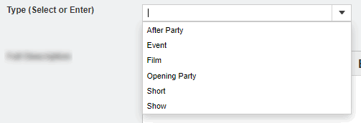
16. Make sure that the Enabled box is checked.
17. Enter all detailed information about your show in the Full Description. This will appear on the ticket page for the show.
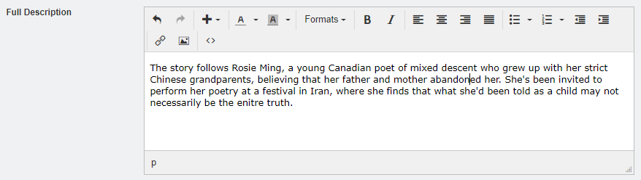
18. Once you have entered all the above information, click the Save Changes button.
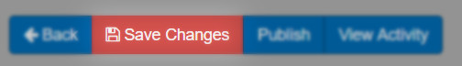

You are now ready to build your showing dates and times for this show. Click Here to learn how to create showings.

