Sending an Email to Customers for a Specific Event
Clients of Agile may need to make adjustments and changes to a specific event that is already on-sale. When that happens, you may need to contact the customers that have purchased tickets to notify them of these changes. Follow these steps to learn how to email these specific customers.
1. In Administration, click the House icon to open the organization tree.
2. Click the green Customer Relations folder.
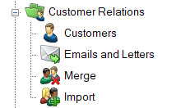
3. Click Emails and Letters.
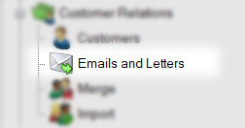
4. In the Emails and Letters field, right-click and select New.
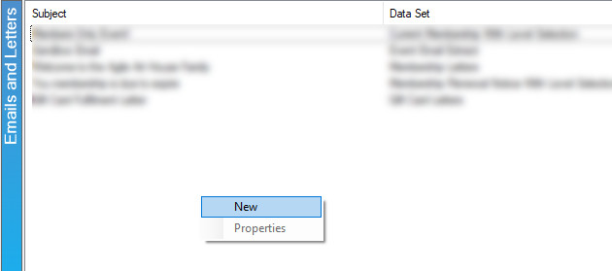
5. In the Query Data Set drop-down menu, choose Event Email Extract.
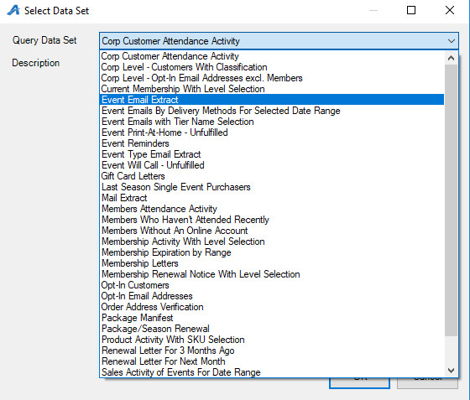
6. Click OK to save the Query Data Set you have chosen.
7. Click the Set Parameters button.

8. Click the Plus sign next to your organization's name.
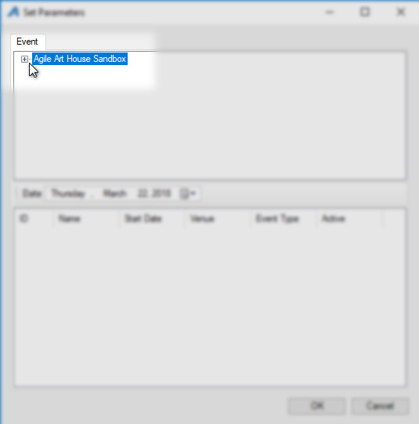
9. Choose the name of the folder where the event is built.
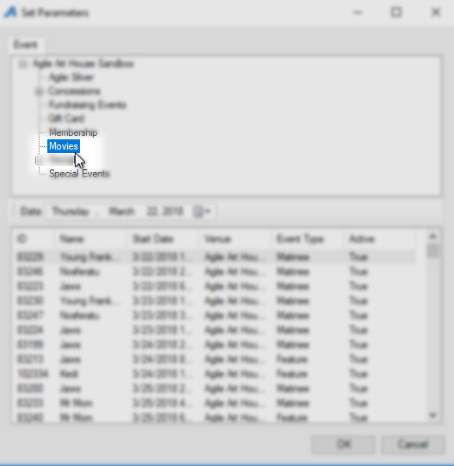
10. Choose the Event for which you will be sending the email and click OK.
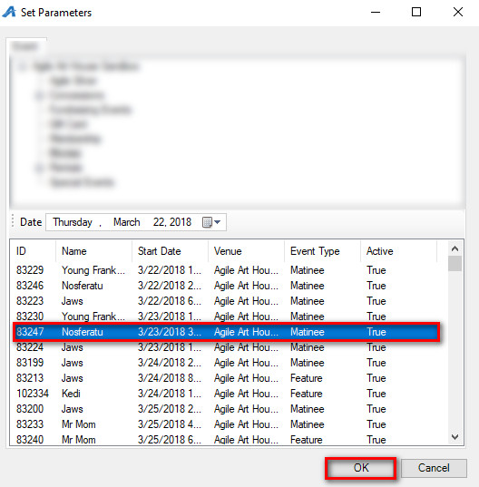
11. You will see the list of all people who purchased tickets for that event.
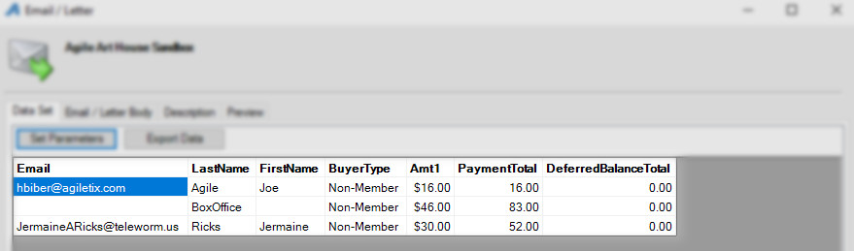

12. Click the Email/Letter Body tab.
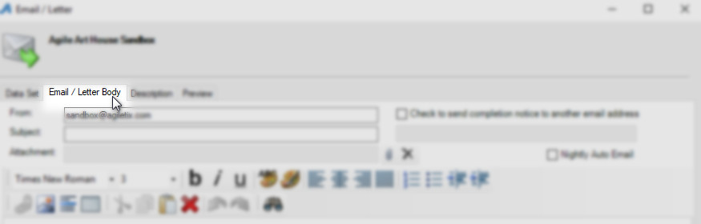
13. Enter the From email address.
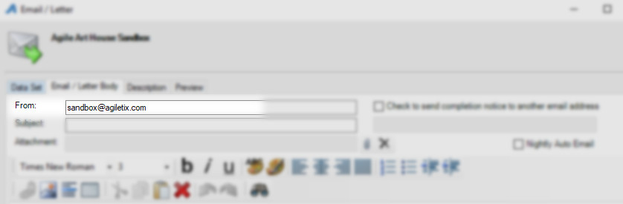
14. Enter the Subject Line.
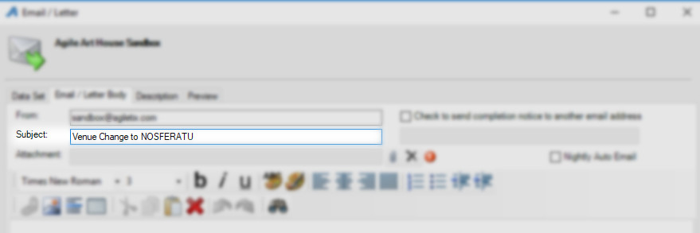

15. Write the body of the email. NOTE: You can insert an image at the top of the email. You can also right-click and insert any of the query data such as first name, last name, etc. into the email.
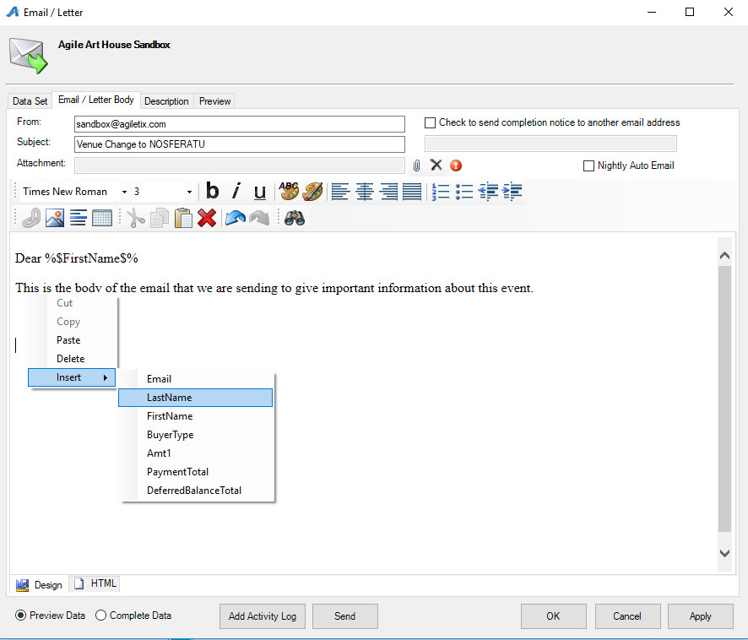
16. Once you have drafted the email, click the Preview tab.
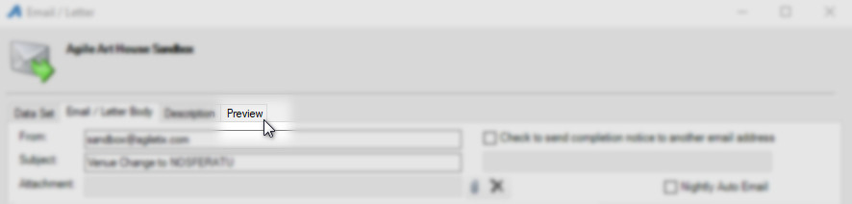

17. Click the Send Test button in the bottom-right corner to send yourself a sample of the email to proof.
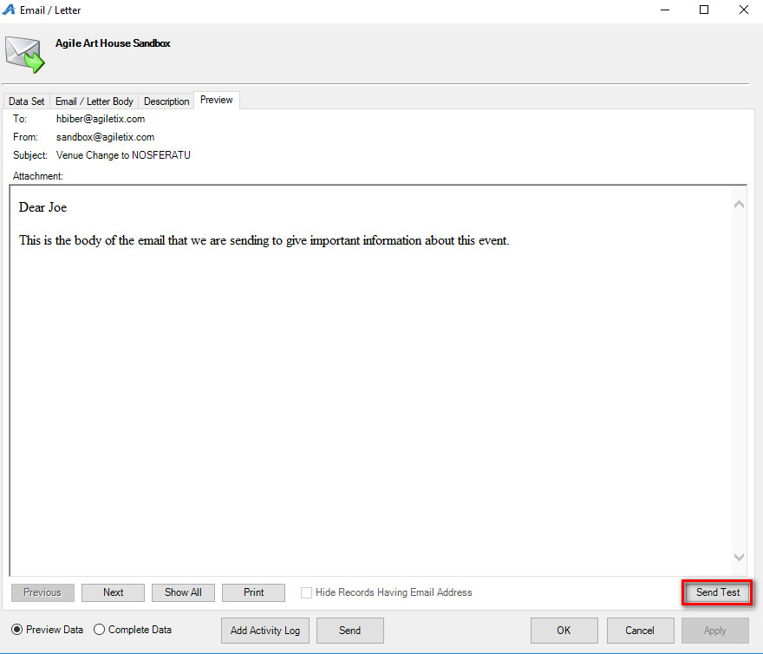

18. If everything is correct, click the Send button to send the email. NOTE: Only press the send button once. If you continue to click Send, it will send the same email multiple times to those customers.
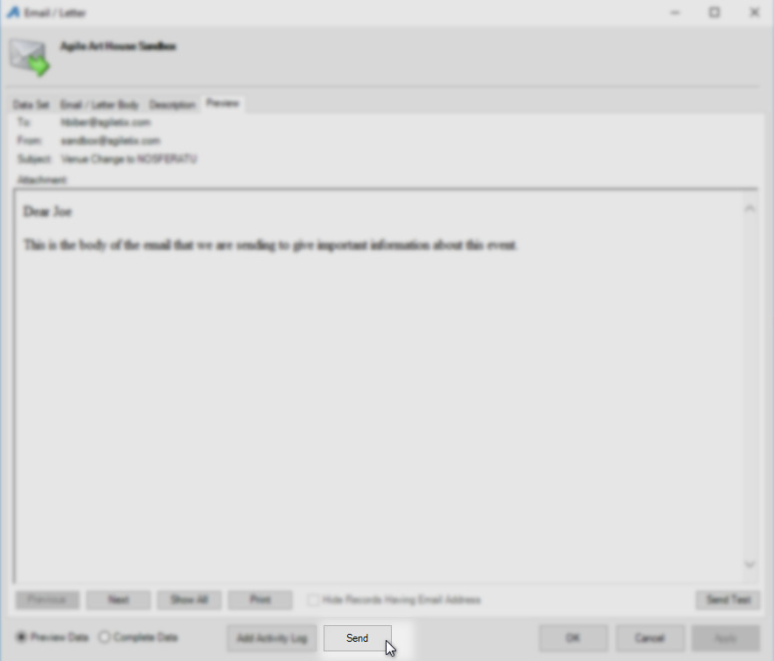

19. Click OK to close the window.
