Order Maintenance: Viewing Specific Orders or Last Orders Sold or Maintained

If you are needing to view and make changes to an existing order, click **Maintenance** at the top of the screen.  
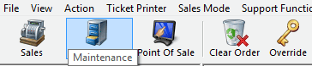

In Maintenance, there are several ways to look up an order. The following is a highlight of the most relevant search methods:

* **Order Number**: Brings up a specific order.
* **Last Name**: Brings up the orders for every person with that last name in the system.
* **Customer Number**: Brings up all the orders that a customer has purchased. If you do not know a customer number, click the magnifying glass to bring up the Customer Search window and type the customer's information. Once you click the customer and select **OK**, all the orders under that customer number will appear.
* **Document Number**: If you have the credit card number or gift card number with which an order was placed, type it here. Be sure to check the box next to the payment method to which the number refers.
* **Last orders you sold or maintained**: If you want to adjust an order that you recently sold or maintained, click the **green check mark***.*
* **Member Number**: Brings up all the orders tied to this member's number.

[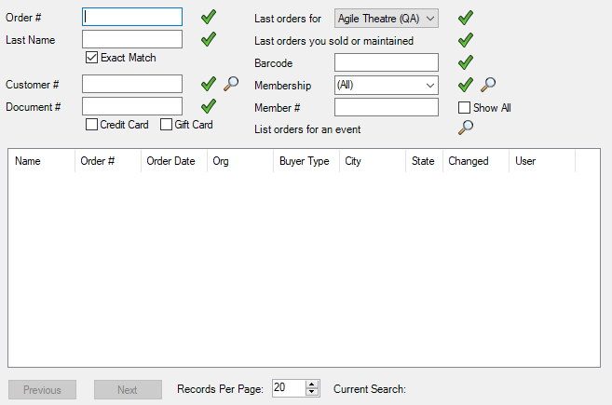](https://support.agiletix.com/hc/article_attachments/360051738971/OMVSOLOSMsearch.png)

* If you want to bring up a list of orders for a specific event, click the magnifying glass next to "List orders for an event." The **Event Search** window will appear. Select a date range that includes when the event happened. If you know what the event was called or a word from its title, you may enter that into the "Keyword" box to narrow the search.

[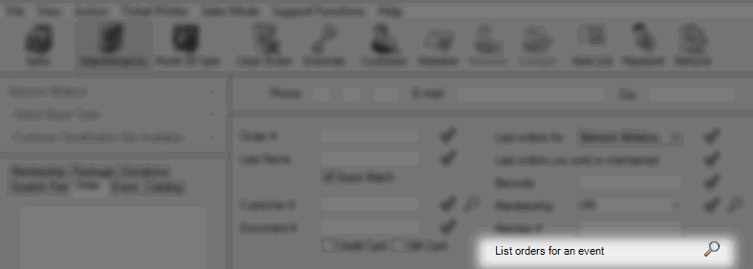](https://support.agiletix.com/hc/en-us/article_attachments/202462860/List_orders_for_an_event.png)

[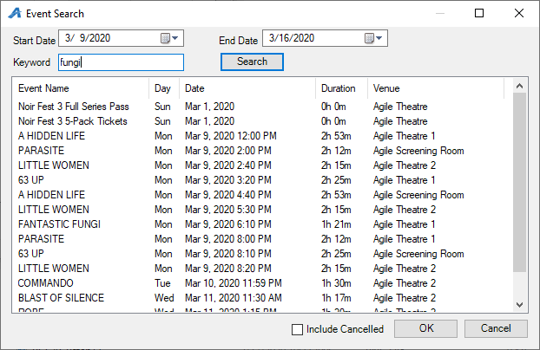](https://support.agiletix.com/hc/article_attachments/360051612012/OMVSOLOSMeventsearch.png)

Depending on how you looked up an order, you may need to find the specific order you are wanting to maintain. The search results in Order Maintenance can be sorted several different ways. Two of the most helpful sorting methods are by **Name** and **Order Date**.

[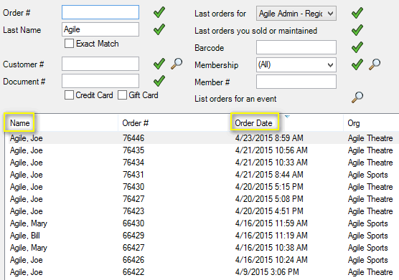](https://support.agiletix.com/hc/en-us/article_attachments/202448830/Sort_By.png)

Once you have identified the order you wish to edit, double-click the order and make the desired changes.