Will Call Fulfillment for an Individual Show

Will Call tickets can be printed in advance of a show so that customers can quickly pick them up at the box office.

1. First, log in to Agile Sales and **Cash In** for the day. (Please see "[How to Cash In and Create a Daily User Batch in AMS](https://support.agiletix.com/hc/en-us/articles/204319670-How-to-Cash-In-and-create-a-Daily-User-Batch-in-AMS)" if you are unsure how to do this.)
2. Select the Buyer Type (AMS – Box Office) and click the **Event** tab (See Image 1).

[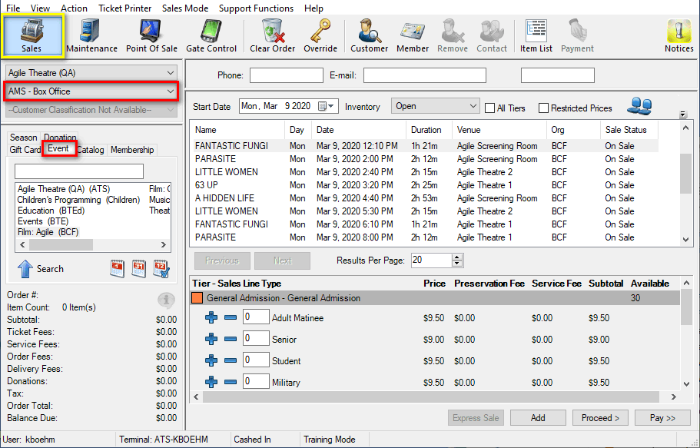](https://support.agiletix.com/hc/article_attachments/360051599172/WCFISstep2.png) Image 1

1. Under the **Event** tab, select the Sales Organization that houses the event for which you are trying to print tickets. Then, select the individual showing of the event that needs Will Call tickets printed (See Image 2.1).

[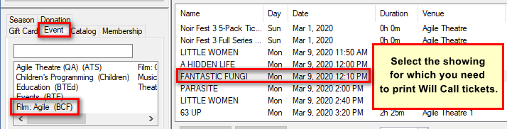](https://support.agiletix.com/hc/article_attachments/360051729551/WCFISstep3acc.png)Image 2.1

If necessary, use the Keyword Search textbox to find the event (See Image 2.2).

[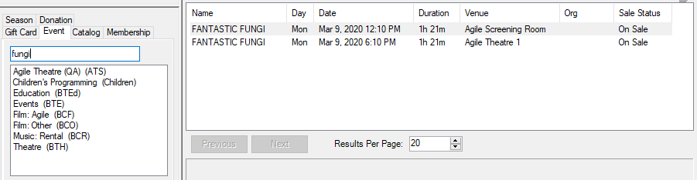](https://support.agiletix.com/hc/article_attachments/360051730791/WCFISstep3.2.png) Image 2.2

1. Once you see the event that you wish to print, right-click the event and select **Fulfill Tickets** (See Image 3).

[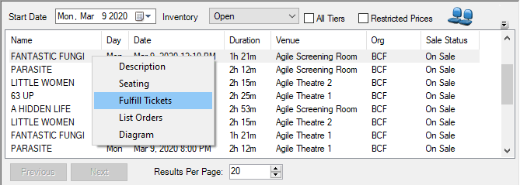](https://support.agiletix.com/hc/article_attachments/360051599332/WCFISstep4.png)Image 3

1. The Fulfillment window will appear (See Image 4).

[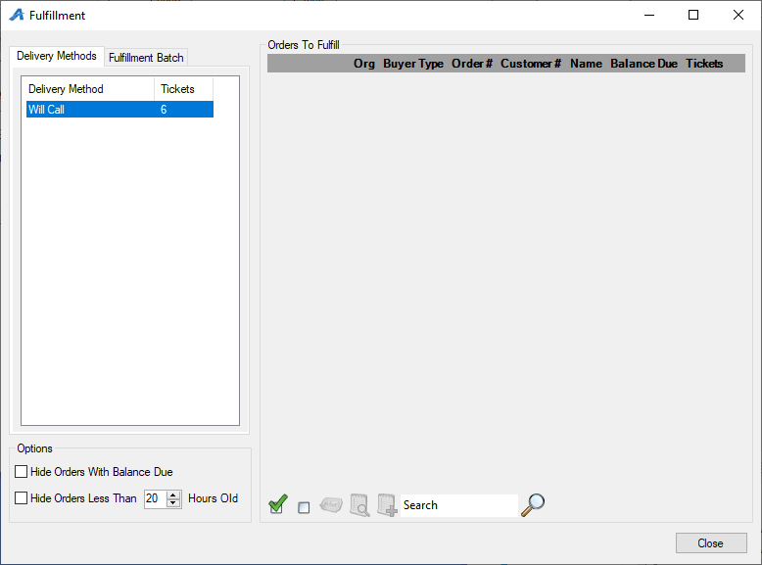](https://support.agiletix.com/hc/article_attachments/360051599412/WCFISstep5.png)

Image 4

1. The left side of the screen will display the number of Will Call tickets that may be printed. Select **Will Call** so that the list of Will Call orders will populate on the right side of the screen (See Image 5).

[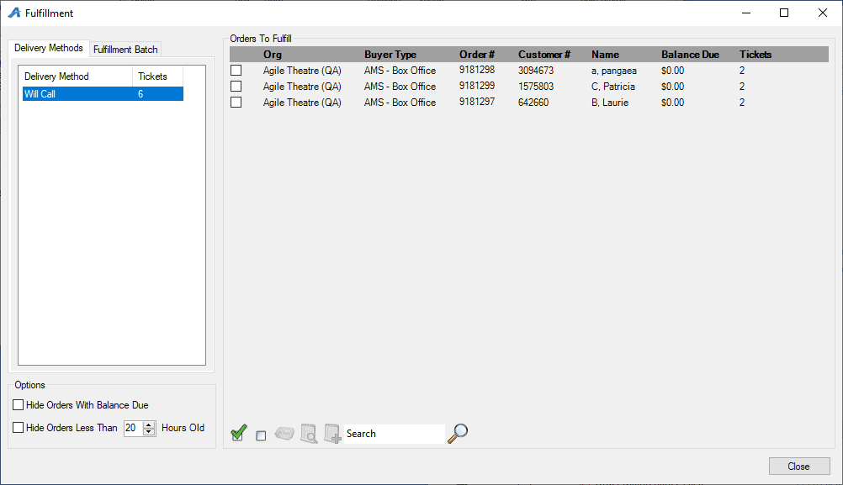](https://support.agiletix.com/hc/article_attachments/360051599432/WCFISstep6.png)

Image 5

1. Click the **green check mark** at the bottom of the screen to select every order (See Image 6).

[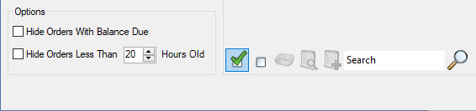](https://support.agiletix.com/hc/article_attachments/360051726111/WCFISstep7.png)Image 6

1. Once all the orders are selected, click the **Ticket Icon** at the bottom of the screen (See Image 7).

[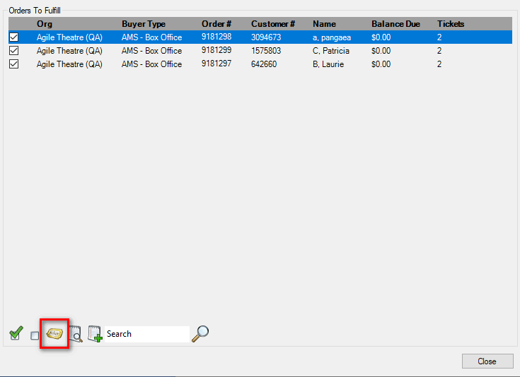](https://support.agiletix.com/hc/article_attachments/360051599472/WCFISstep8.png)Image 7

1. **The Fulfillment Options** screen will appear (See Image 8). Select a **Header Format** and un-check **Print Payment Receipts**. Set **Sort Orders By** to **Last Name** so that tickets will print in alphabetical order by last name. If necessary, type any notes about this fulfillment in the **Batch Description** box. From the **Available Printer** list, double-click your fulfillment printer to move it to the **Selected Printers** column.  Make sure everything is correct and select **OK**.  
   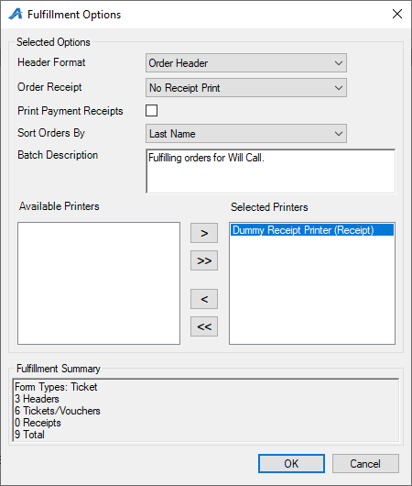  
   Image 8
2. A progress screen will appear. Once the progress bar is complete, click **OK**and wait for your tickets to finish printing (See Image 9).  
   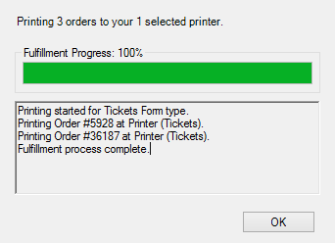  
   Image 9  
     
   Your Will Call tickets are now ready for customer pickup.