Placing a Show On Sale
Once you have built your Shows and added your showing dates, you are ready to place them on-sale.
1. Right-click the Showing date and select Properties. (Image 1)
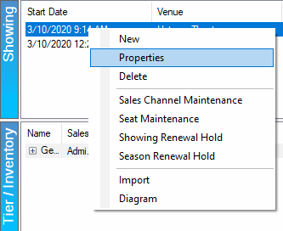
Image 1
2. Click the Sales Channels tab. (Image 2)
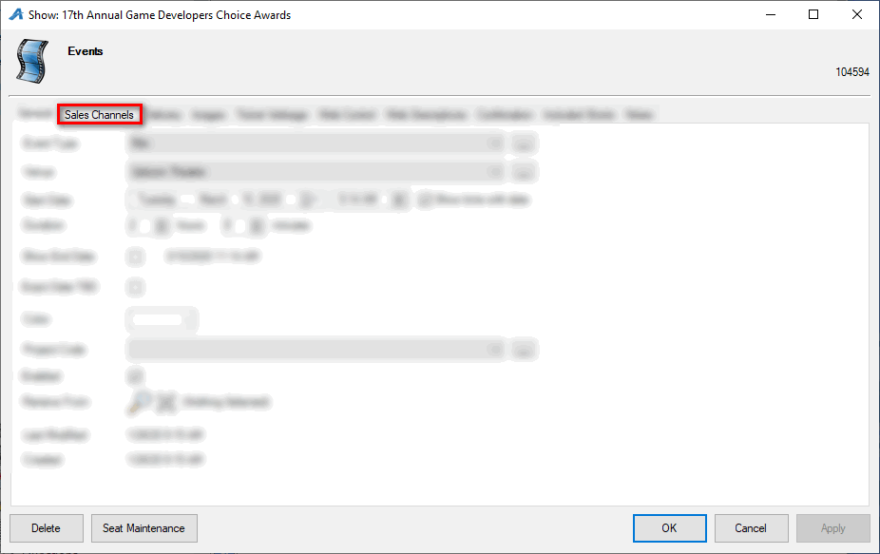
Image 2
3. Check the boxes next to the Sales Channels that need to be available for purchase. (Image 3)
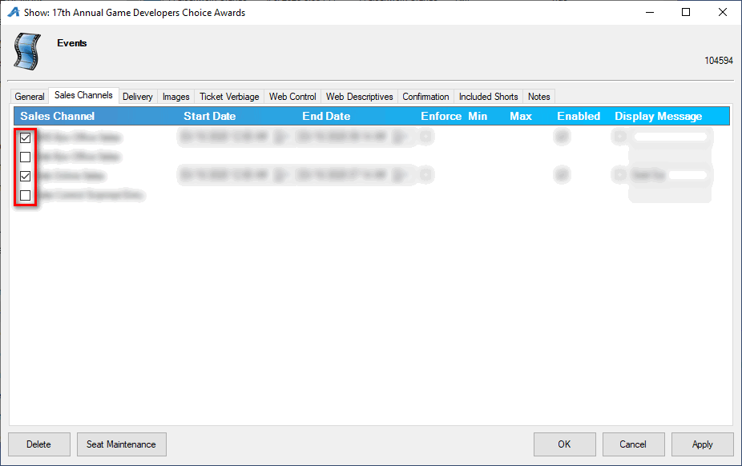
Image 3
4. Adjust the Start Date next to the date on which you want these tickets to be available for purchase. (Image 4)
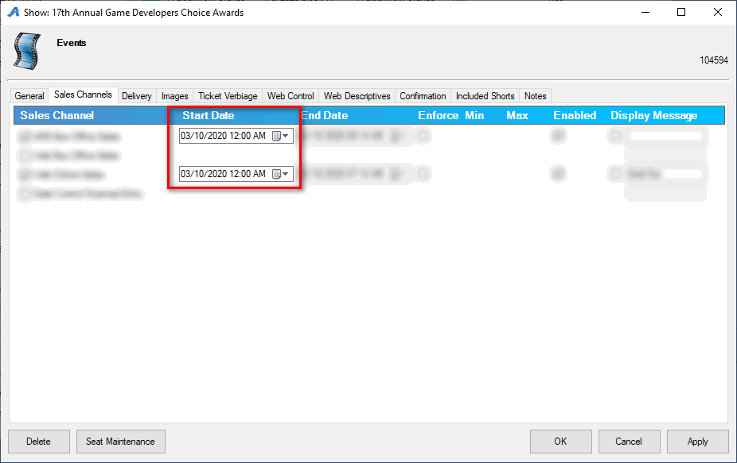
Image 4
5. Adjust the End Date to the date and time you want sales to end. NOTE: Some organizations have preset Event Defaults that will automatically calculate how many hours before or after an event for a specific sales channel to end sales (i.e. Web Sales end 2 hours prior to the start of the concert, Box Office Sales end 4 hours after the concert). (Image 5)
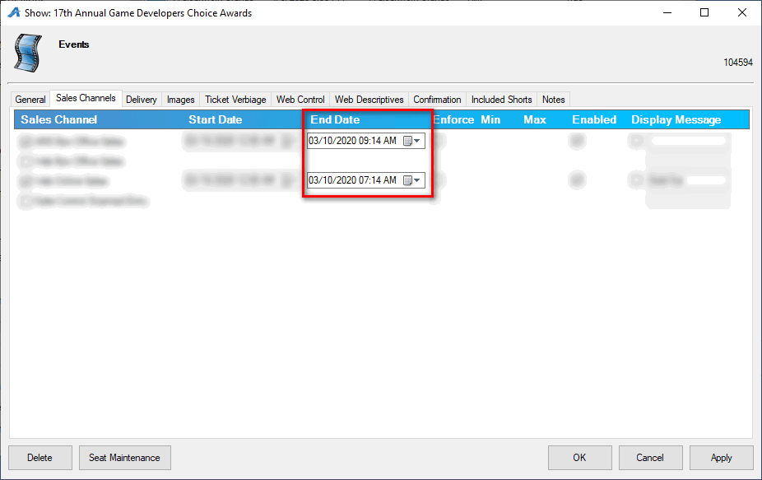
Image 5
6. Enforce Min Max allows you to create a Minimum number of tickets and a Maximum number of tickets that the customer is allowed to purchase. (Image 6)
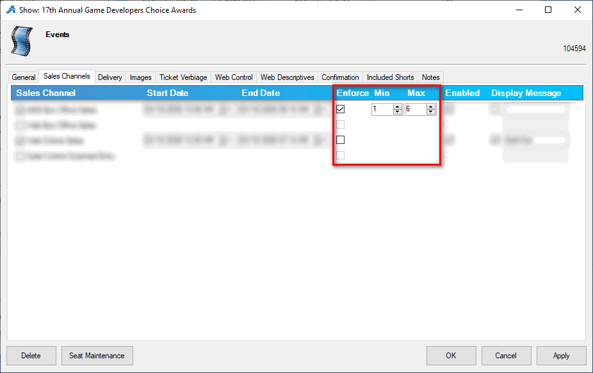
Image 6
7. Display Message allows you to add a specific message that will appear online if the event has no more inventory left to sell or if you do not want tickets to be available (e.g. Rush Line Only, Sold Out, etc.) (Image 7)
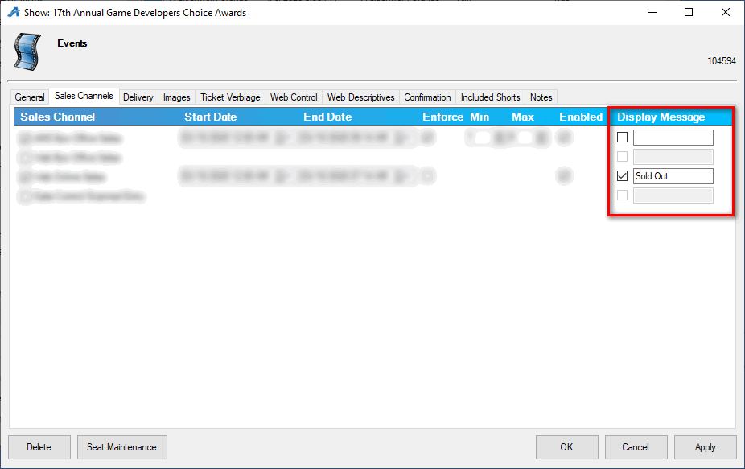
Image 7
8. Once you have enabled the Sales Channels and set your on-sale dates and times, click OK to save the information.

