Changing a Billing Address on an Existing Order
1. Log in to Sales.
2. Select Maintenance. (Image 1)
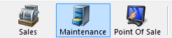
Image 1
3. Search for the customer by entering the Order # or the customer’s Last Name. Then, click the appropriate green check mark. (Image 2)
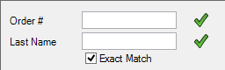
Image 2
4. Double-click the correct order to bring up order contents on the Item Summary page. (Image 3)
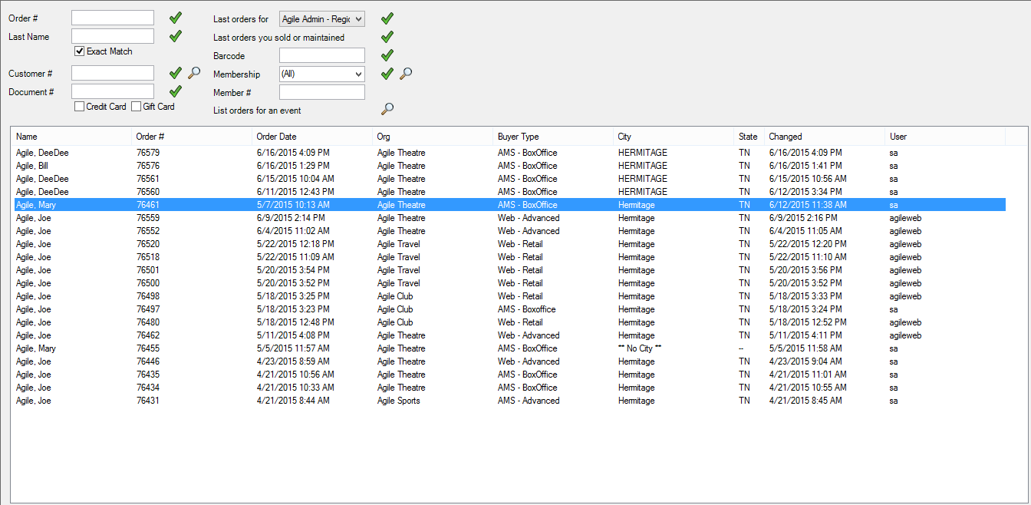
Image 3

5. Once in the Item Summary, click the Billing Address at the top of the page. (Image 4)
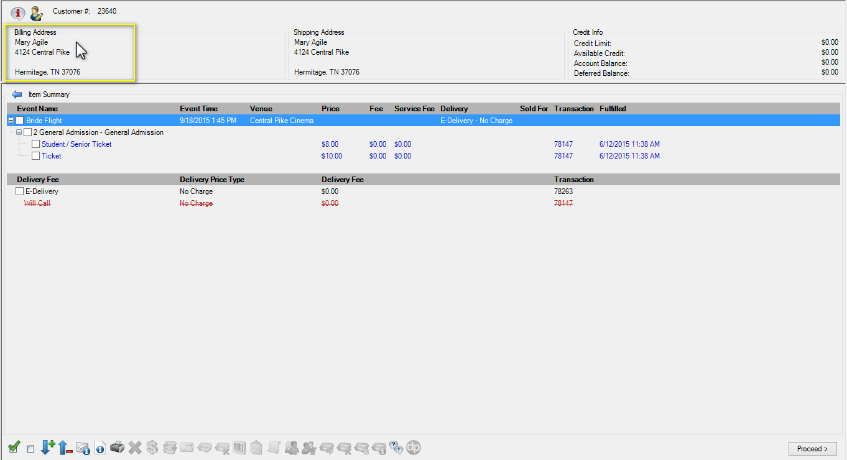
Image 4
6. The Address window will appear. (Image 5)
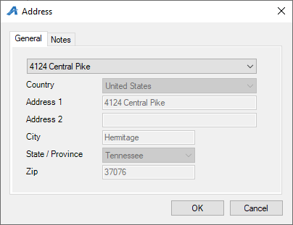
Image 5

7. From the drop-down menu, select either an address already in the system or Add a New Address to input a new billing address. Once the billing address has been changed, click OK. (Image 6)
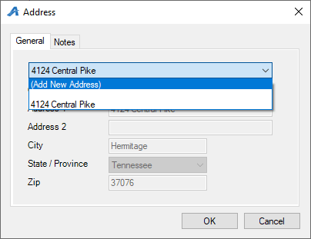
Image 6
8. You will be taken back to the Item Summary page. Click Proceed. (Image 7)
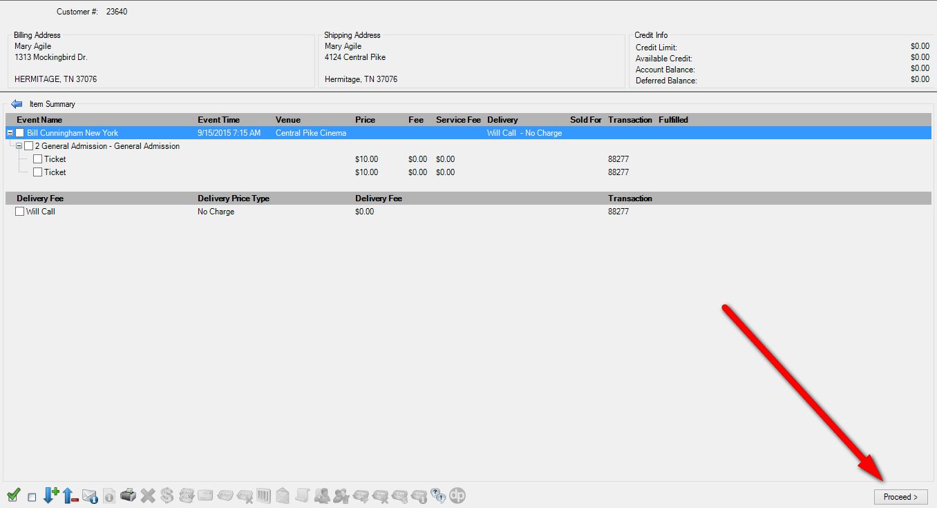
Image 7
8. You will be taken to the Payment screen. Click Finalize to save the changes to the Billing Address. (Image 8)
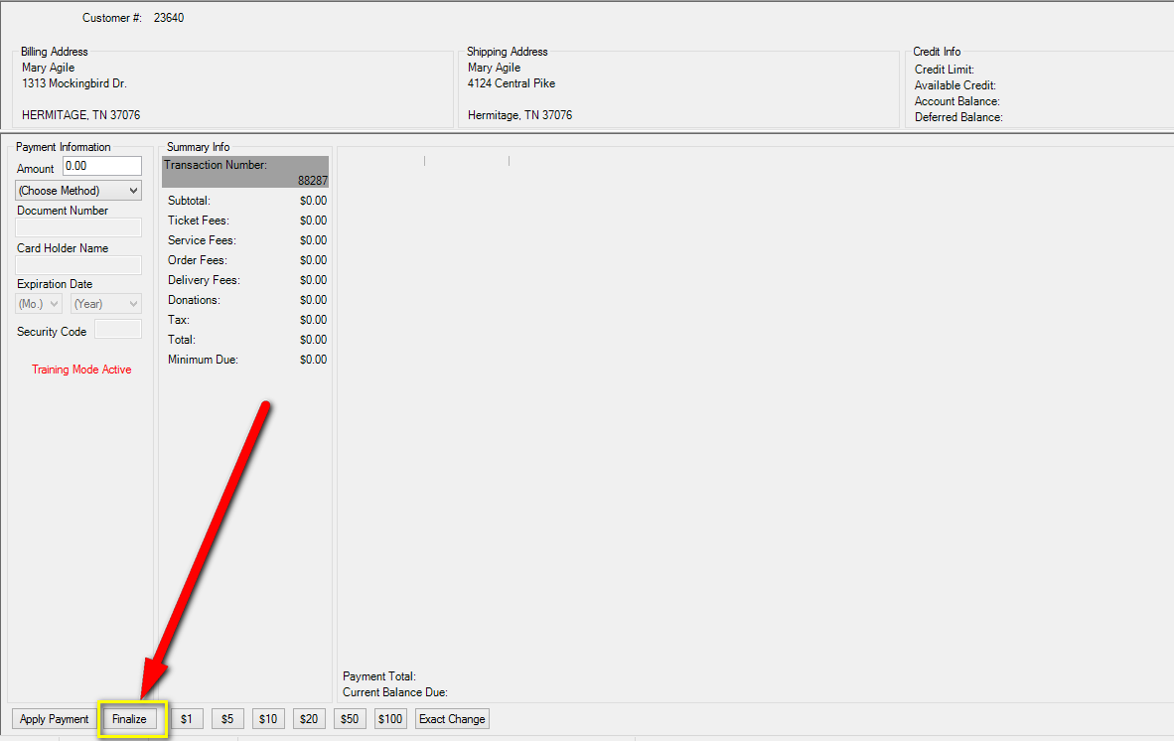
Image 8

