Merging Multiple Customer Accounts
- Log in to the Administration side of Agile.
- Double-click the Customer Relations folder.
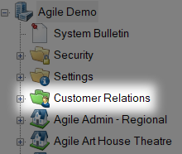
- Double-click Merge.
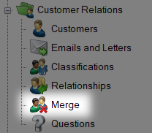
- On the Merge screen, type the last name, first name, or email of the customer with multiple accounts.
NOTE: You may put in a combination of the three to see if there are multiple people with the same email or the same person with multiple emails. This can often be the case if someone makes a new account using a different email or if family members utilize the same email address. In these instances, you will want to confirm with the customer before you merge the accounts.
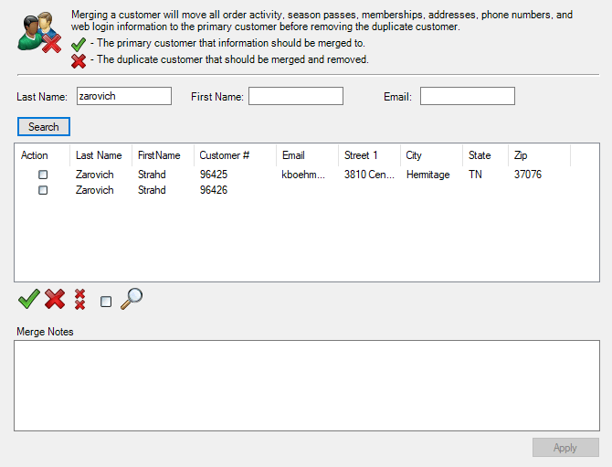
- At the top of the screen, you will see a green check mark and a red X. This part of the screen explains how the customers will be merged.
- In the boxes below Action, the first box you click will become a green check mark. This will designate the account into which all information will be merged.
- Any additional boxes you click will be marked with a red X. These accounts will be removed after their information is merged into the check-marked account.
NOTE: If the customer has different contact information listed for each account, confirm with them which information is correct and up-to-date. However, if the customer does not recognize the information in an account, that account may belong to a different customer with the same name. Only proceed to Step 8 if you have confirmed that you are not merging the accounts of two different customers.

- Once you are sure that the correct accounts are being merged, click Apply at the bottom of the screen.
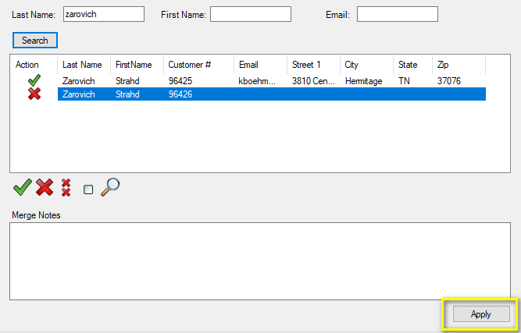
- A window will appear asking whether you are sure that you want to merge the selected customers. Select Yes.
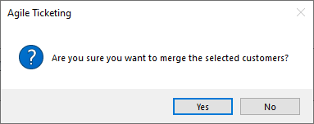
- You should now see only one account in the window with a green check mark next to it.
