Building an Individual Event
1. Log into Administration.
2. Click the House icon.
3. Open the blue Sales Organization Folder that houses your events.
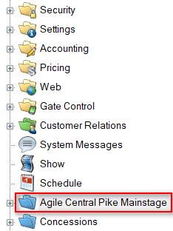
4. Click the Event icon.
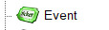
5. In the Event field, right-click and select New.
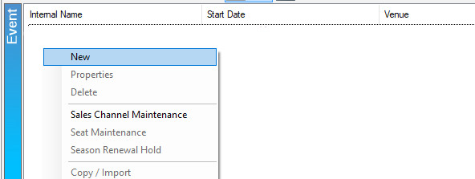
6. In the General tab, you will:
- Select the Event Type.
- Enter the name of the Event into the External Name and Internal Name fields. The External Name will appear on your website and should be the true title of your event. The Internal Name will only appear in Agile Admin and Sales to you and box office staff.
- Enter the Start Date and Time and the End Date and Time.
- Add the Duration of the Event.
- If applicable, add or select your Distributor.
- If you are an organization that sends gross revenue for a film to Rentrak, check the box next to Rentrak.
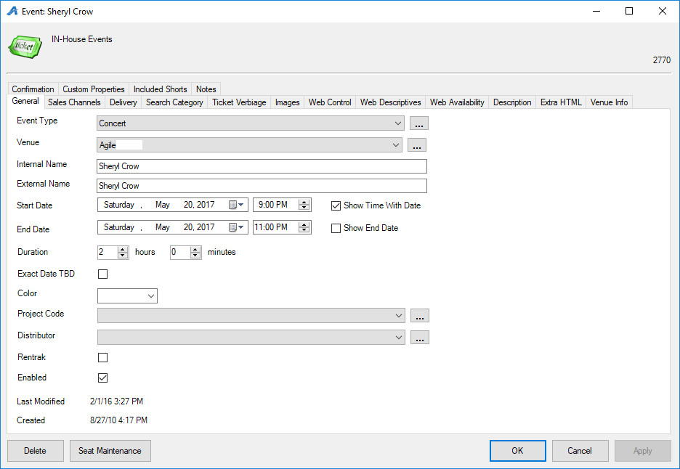
Note: If you need to add a new Event Type or Venue, select the Ellipsis Button to the right of the drop-down field. Enter the new Venue or Event type and select Add New.
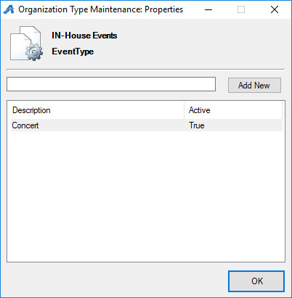
7. In the Sales Channel tab, check the box next to each Sales Channel from which you wish to sell. Enter the Start Date when the event should go on sale and then enter the End Date for when sales should end to end for each Sales Channel. (For example, an organization may continue selling tickets at the Box Office half an hour into an event but stop online sales two hours before the event starts.) Make sure the Enabled box is checked for each Sales Channel you plan to use. The Display Message allows you to enter a short message that will appear when there is no more open inventory for sale ("Sold Out," "Rush Line Only," etc.).
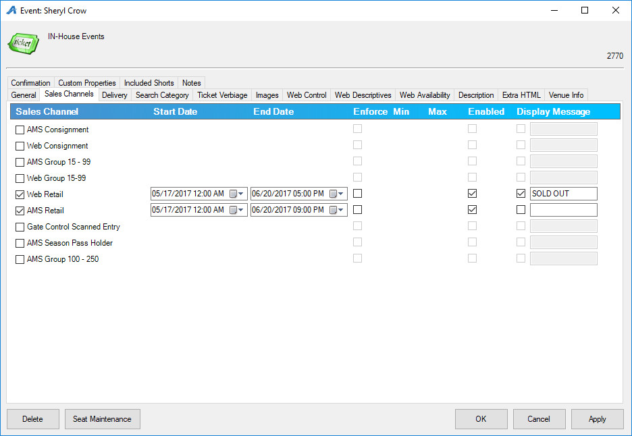
8. Delivery Methods allow your customers to choose how they will receive their tickets. Check the boxes next to your organization's preferred delivery methods. Start Days allow you to dictate to the system how many days before the event you would like this delivery method available to the customers. Cutoff Days tell the system when to turn this delivery method off prior to the event.
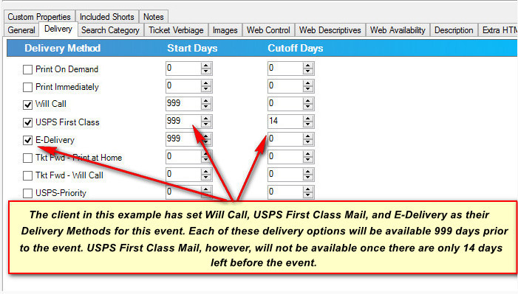
9. Ticket Verbiage – This is where you can add specific information that needs to appear on the ticket. (Most ticket formats pull the elements directly from the database, but these fields can be added to the ticket formats if you need special information to appear on the ticket.)
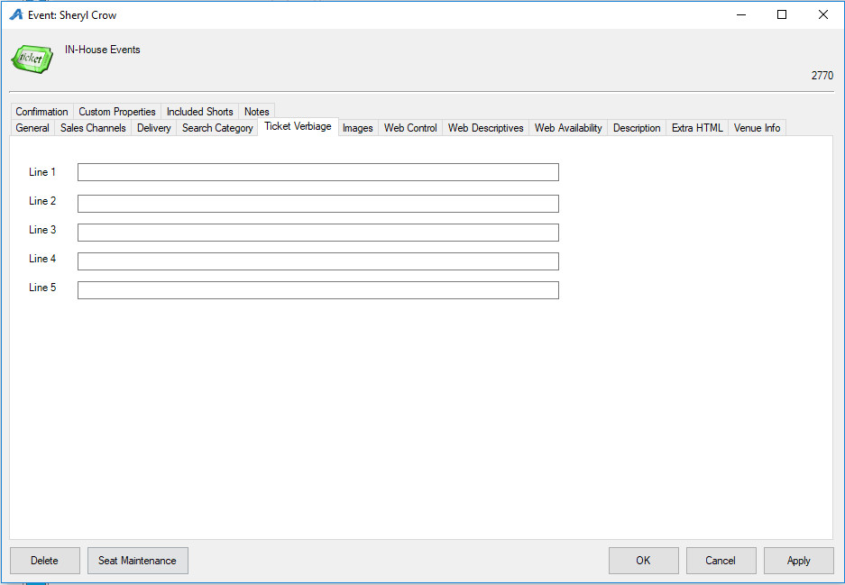
10. The Images tab is where you will upload still images and video/trailers that will appear on the event page online. To upload an image, click the Upload arrow and select the image that will become the Main Image and Thumbnail Image. To add additional images, click Add Image. To add a trailer, click Add Trailer and place the YouTube or Vimeo embed link. Click Preview to finalize the trailer.
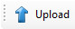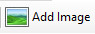
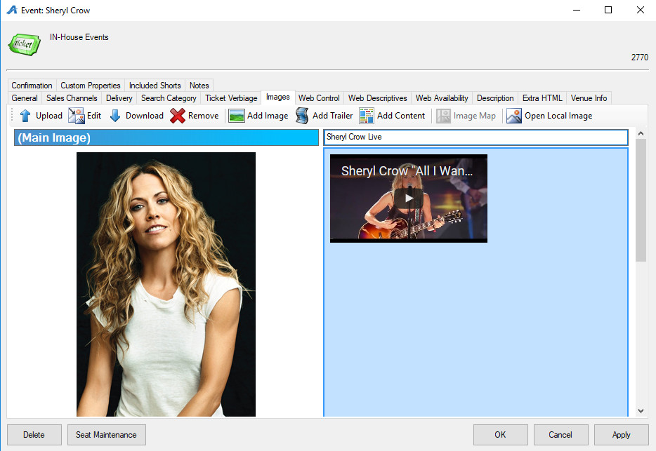
11. In the Web Control tab:
- Check the box next to Show Event Price Info On Web Sales to show specific pricing information.
- Check the box next to Show Tier Color On Web Sales if you have a reserved seating chart with different price levels. If you are building a General Admission Template, do not check this box.
- Allow Seat Selection On Web Sales should be checked if you have a reserved seating chart and you allow your customers to select their own seats.
- Checking Show Customer Service Contact Link will allow you to publish a customer service link with Box Office contact information.
- You can enter an External Event ID that is up to 50 characters long.
- Select the Ticket Search Type from the drop-down menu. The Ticket Search Type allows you to choose how the customer sees ticket information online.
- If the Display Message at Available Qty is checked, a display message will appear when this quantity of tickets has been reached. This is used to share a specific message once a show is sold out.
- Check Override Display Date if you want the date that appears online to be different from the actual date of the event. This option is typically used to adjust the display dates of midnight events/screenings. An event on the evening of Friday at midnight technically takes place on Saturday at 12:00 AM. Override Display Date may be used to change the display date so as not to confuse customers.
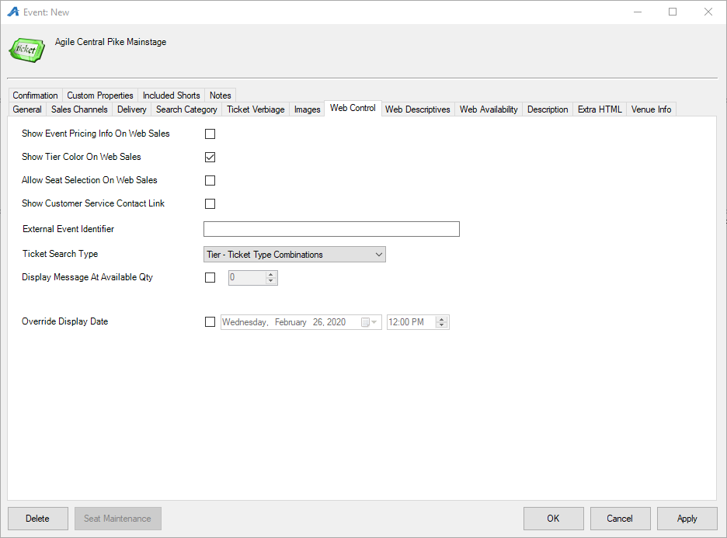
12. The Web Descriptives tab is where you can add a short description of the event that will appear in a thumbnail tile view.
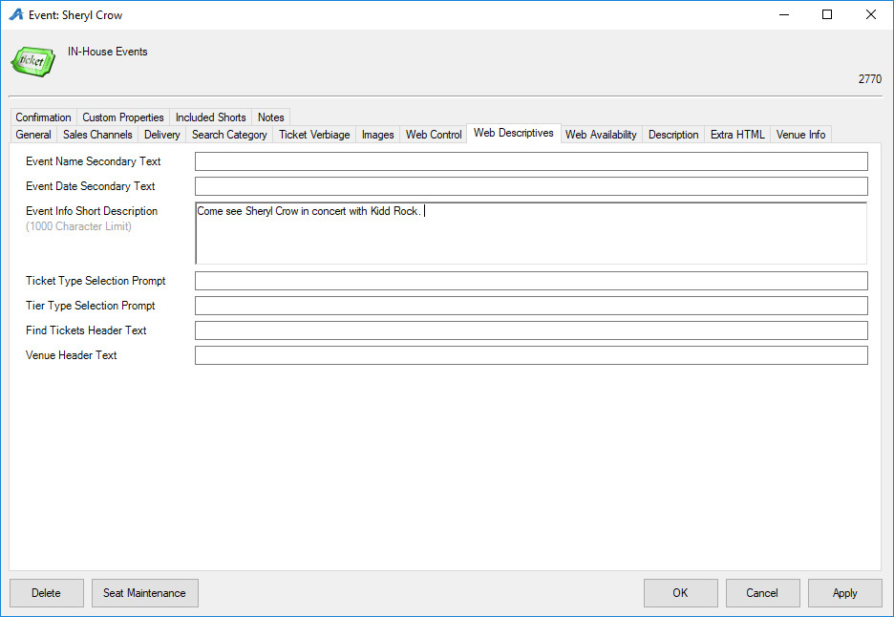
13. Web Availability is an area where you can put additional information about a sold-out performance.(Some Venues use this to give specific instructions on how to get tickets via Rush or Standby Line).
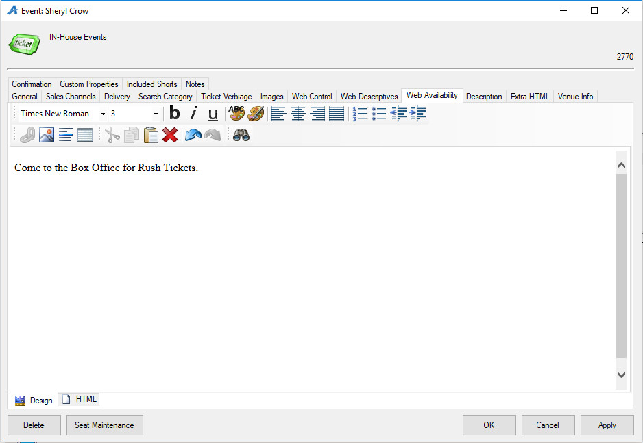
14. The Descriptions tab is where you can add a full description of the show/event.
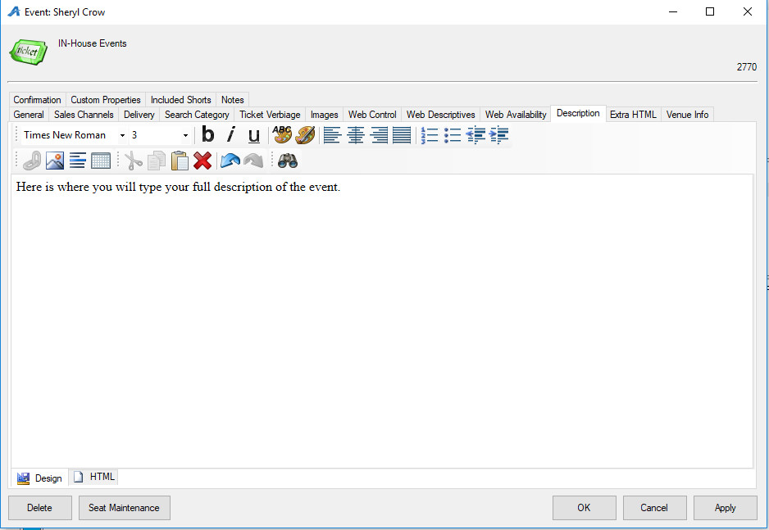
15. The Confirmation tab allows you to add confirmation text about this specific event that the customers will receive via email confirmation once they complete an online purchase.
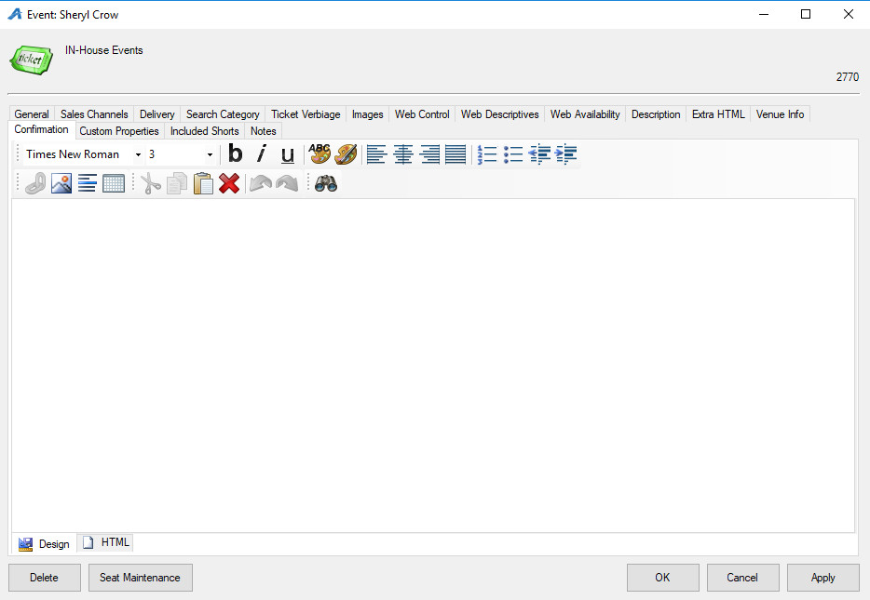
16. Custom Properties are specified by the organization but are generally used to provide information about a specific event (e.g. Run Time, Country of Origin, Cast and Crew, etc.).
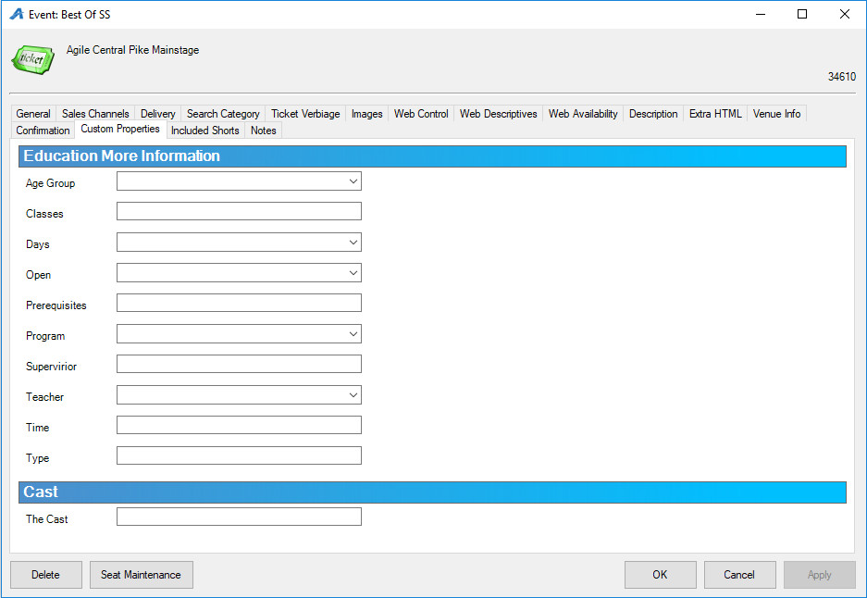
17. Included Shorts is generally used by Art Houses and Film Festivals that show short films prior to a feature length film or have a shorts program with all of the shorts bundled into a feature-length show.
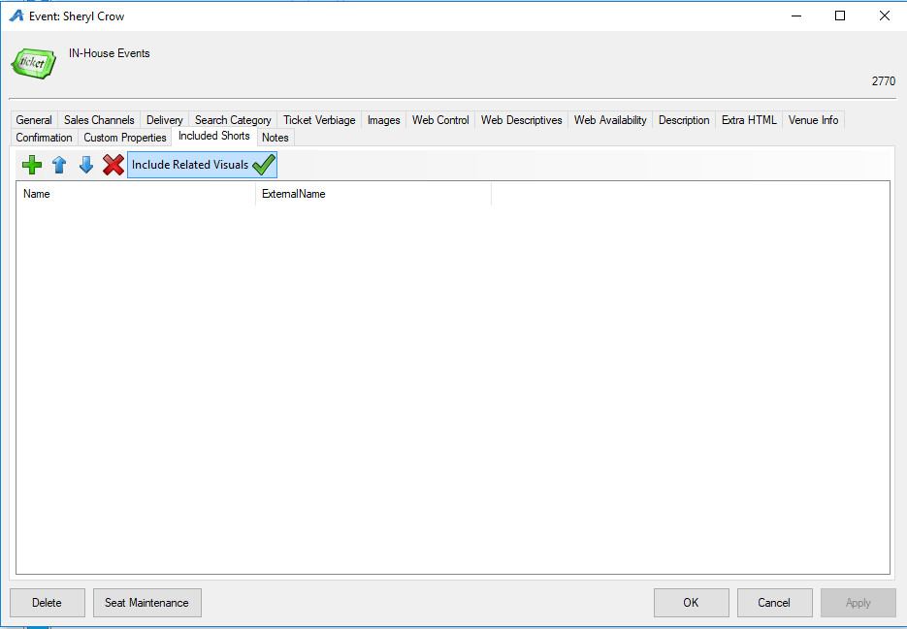
18. Once you have filled out this information, click Apply to save your changes and OK to exit the window.

19. Right-click in the Tier/Inventory area and select New Tier.
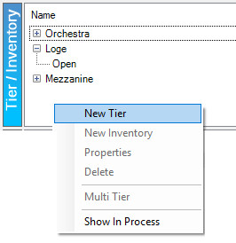
20. In the General tab:
- Select the Sales Line Type and Tier Name.
- If desired, enter a Zero Available Qty Message that will appear when the open inventory in this tier reaches zero.
- If you want customers to see how many tickets are still available online, check the box next to Show Available Qty on Web.
- Set a Tier Priority for the tier. This option is similar to Display Sequence and will determine the order of the tiers online.
- In the Color box, choose a color for the tier. This is usually used on reserved tiers.
- To associate a certain timer with the tier, check the box next to Time Based Tier.
- If you are ready for the tier to be put on sale, check the Enabled box.
- If you are building a General Admission tier, check the General Admission box.
- In the Initial Default Inventory box, enter the total number of seats here, if known.
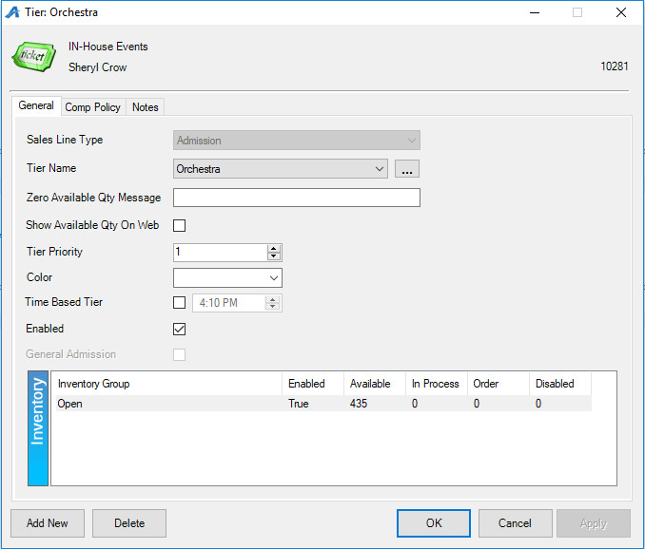
21. Click Apply to save.
22. An Open Inventory Group will appear in the Inventory area of the window. If this is the only inventory group needed, click OK and build the pricing. If you need to add more Inventory Groups, proceed with these additional steps:
A. Right-click in the Inventory box and select New.
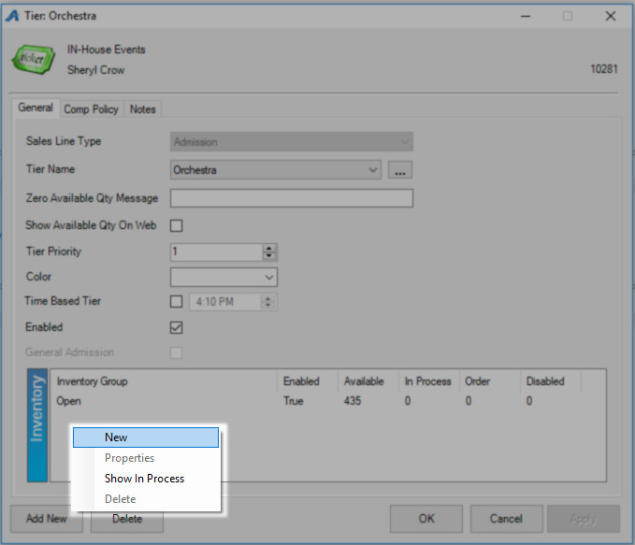
B. From the Inventory: New window, you can rename your inventory group. You can also adjust the Quantity available for sale.
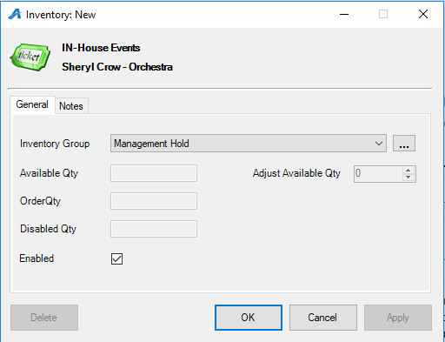
23. Once you have added all necessary inventory groups, click Apply to save and OK to exit the window.

24. Next, you will need to add prices. On the Event page, highlight the event and then highlight the Tier/Inventory. In the Event Price section, right-click and select New.
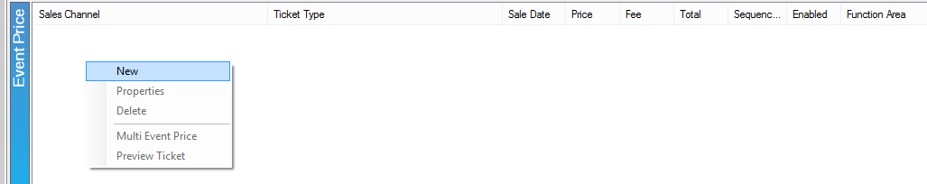
25. In the Event Price: New: window, right-click in the Price box and select New Price.
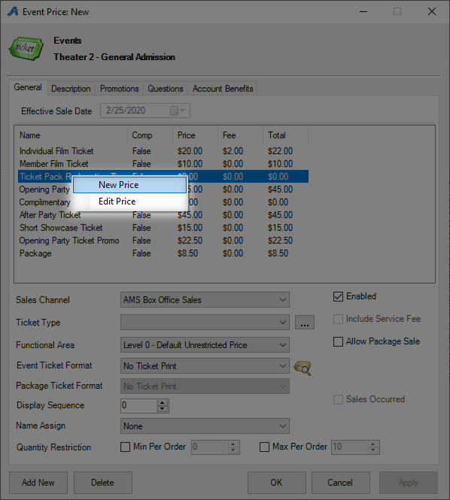
26. The Price: New window will appear.
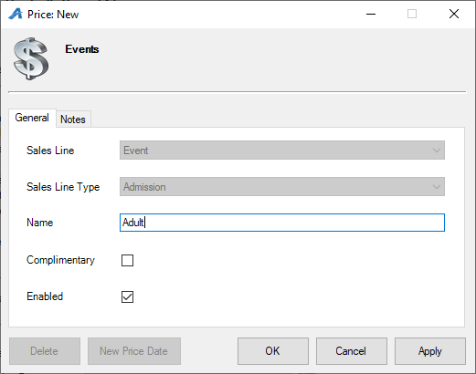
A. Choose the applicable Sales Line and Sales Line Type.
B. Enter the Name of the price. This will not be seen by the customer, but it should be easily identifiable for accounting purposes. We recommend being very detailed in the price name (ABC Venue Adult, Subscription Adult, Gold Member Price, etc.).
C. If it is a complimentary price, check the box next to Complimentary.
D. The Notes tab is for internal use only and will not be seen by the customer.
27. Click Apply to save your changes and OK to close the window.
28. In the Price Distribution: New window, right-click and select New.
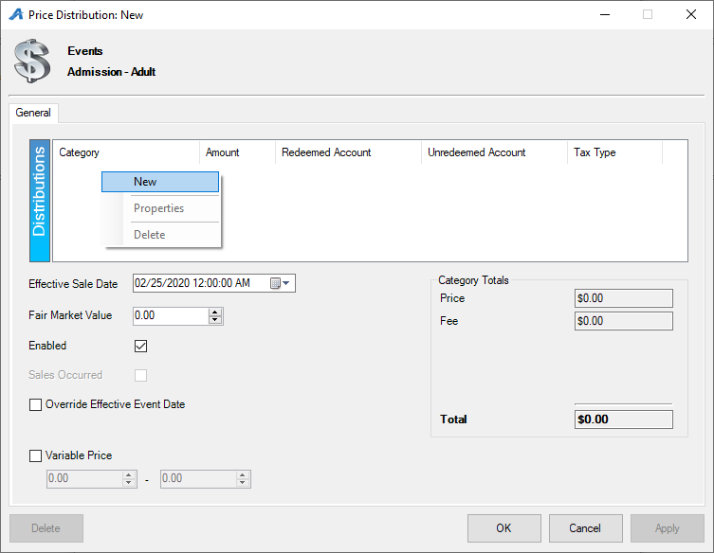
- Price Category: Choose Price.
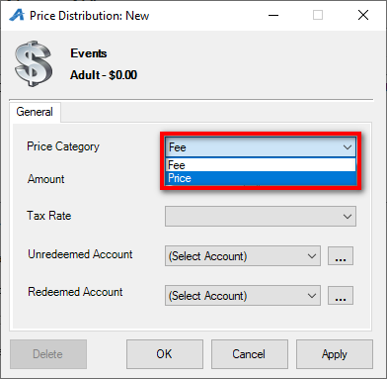
- Amount: Enter the dollar amount of the price.
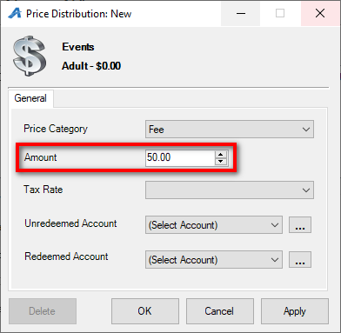
- Unredeemed/Redeemed Account: choose the appropriate revenue accounts from the drop-down list. Or, create them using the ellipsis button to the right of the drop-down.
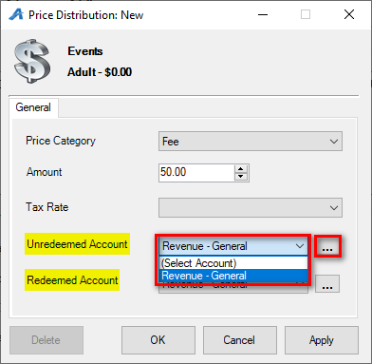
- Select Apply and OK.
Note: If the price also includes a fee, repeat the above steps but choose Fee in the Price Category.
In the Price Distribution: New Window:
- Effective Sale Date: Choose the date when this price should be effective. Agile will automatically deactivate the price at the set time. If the price should always be effective, set the Effective Sale Date to a time far off in the future.
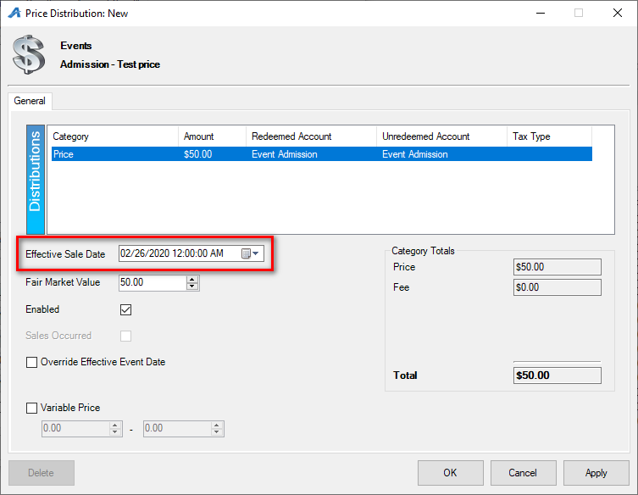
- Fair Market Value: Enter the value of the item being sold. Fair Market Value shows up on certain Gross Revenue Reports.
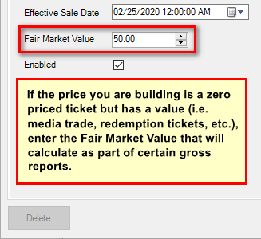
29. Click Apply and OK once all the pricing information has been created.
30. In the Event Price: New window, select the price that you just created from the list of prices and fill out the following information:
- Sales Channel: The Channel through which you sell the ticket (Web Sales, Box Office Sales, etc.).
- Ticket Type: The name of the ticket that will appear to the customers both online and on their tickets.
- Functional Area: Determines who has the ability to buy these tickets (e.g. Level 0 -Default Unrestricted Prices are available for everyone to purchase, but Level 1- Restricted Price(s) are generally hidden from view unless a permission or benefit is set for purchase).
- Event Ticket Format: Preset formats that pull select information to print onto tickets.
- Package Ticket Format: If this price is bundled in a Package, you can choose a specific ticket format to print.
- Display Sequence: Allows you to determine in what order the list of prices appears online and on the Box Office screen.
- Name-Assign: Allows you to capture names for each ticket (This is not required).
- Quantity Restriction: Allows the restriction of the number of tickets that can be sold at this price per order (e.g. a Minimum of 2 and a Maximum of 8 tickets per order).
- Enabled: Checking this box activates the price.
- Include Service Fee: Allows you to include any service fee that you have set up. See Creating a Service Fee for more information.
- Allow Package Sale: Must be checked if you are bundling events together for a package.
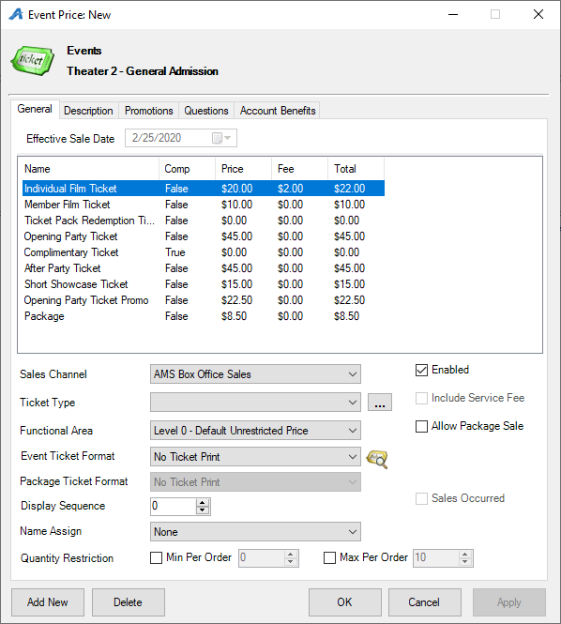

Please note: if you wish to delete an event, simply right-click the event and select Delete. This will delete the event and all its Inventory and Pricing.

