Redeeming a Ticket Pack Using Account Benefits
Ticket Packs are a way for our clients to sell non-dated tickets that a customer can use at any time for certain events. These packs are set up in Agile as a Catalog item that attaches Account Benefits to a customer's account. The customer can then redeem their benefits at the box office or log in online with their username, email address, and password to use their benefits.
1. Log in to Sales.
2. Click the Customer Icon 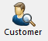 in the top toolbar.
3. Search for the Customer by filling in the fields. Click the customer's information to start the ticket process. NOTE: If a customer has more than one customer account, you should merge them into one record. If you do not know how to merge a customer, see Merging Multiple Customer Accounts. (Image 1)
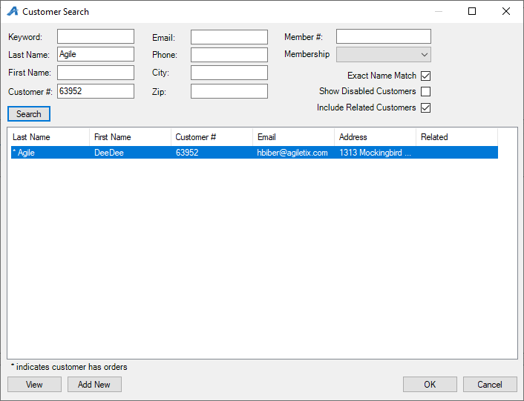
Image 1
4. Select the first film that the customer wishes to redeem. Pay attention to the Customer Benefit Summary. If a customer has partially redeemed their ticket pack, this number will reflect that as well. If a customer has redeemed all their tickets, the message will indicate there are 0 tickets remaining. (Image 2)
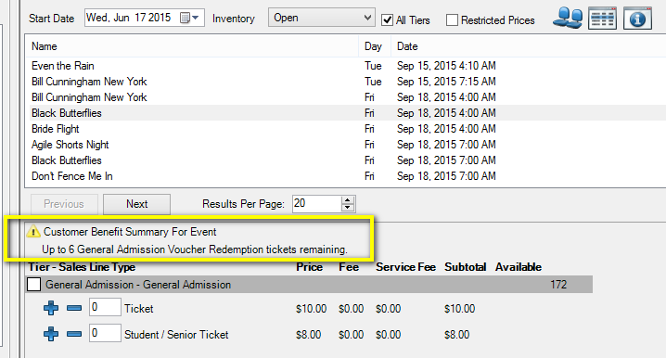
Image 2
**Note: Make sure to choose the correct ticket type as well. Some tickets require the ticket type to be Ticket Pack Redemption. If another ticket type is added to the cart instead, the account benefits will not be redeemed properly.
**Note: If the Restricted Prices box is checked, the system will always show and allow sales of the Ticket Pack Redemption ticket, regardless of whether or not a customer has purchased a ticket pack. This is why it is extremely important that the first step is always pulling up the customer record.

5. When adding tickets to the order, watch for the message below indicating that you have redeemed more tickets than the customer has available in their account. If “Yes” is clicked, then the system will override the account benefits and allow you to redeem these extra tickets. If “No” is clicked, the system will not add the inventory to the cart. You may then select a different number of tickets to match the customer's remaining account benefits. (Image 3)
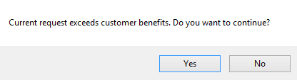
Image 3
**Note: Once the customer has redeemed the ticket pack, they can also purchase additional tickets in the same order.
6. Once all the tickets the customer wants are in the Item Summary, click Proceed. (Image 4)
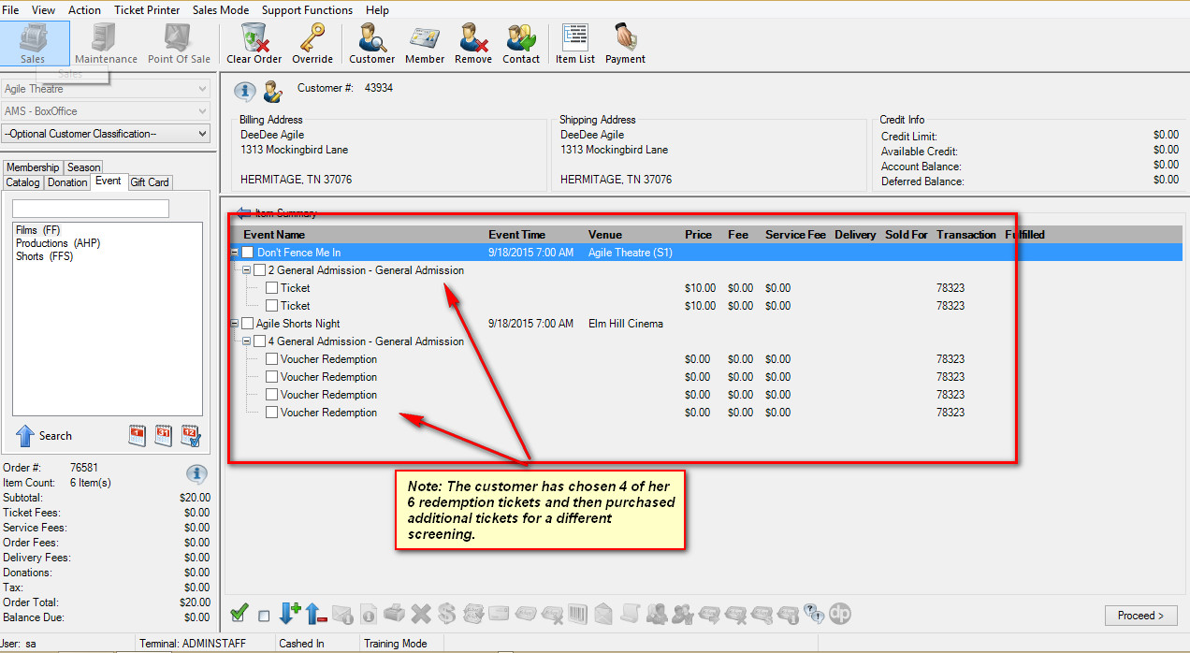
Image 4

7. Collect payment if necessary and click Finalize. (Image 5)
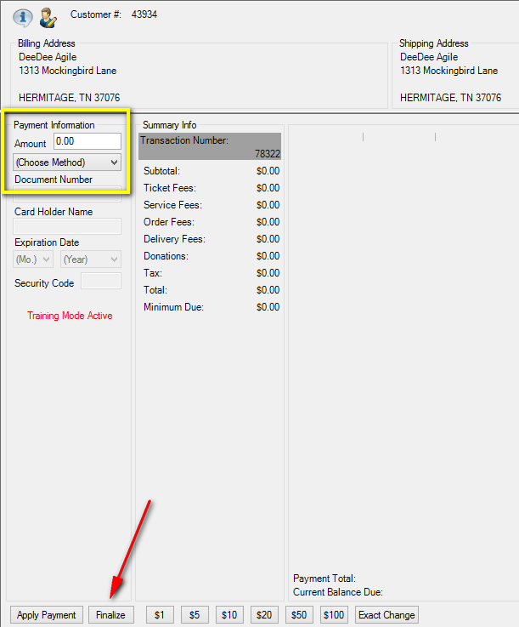
Image 5

