Creating Member Benefit Groups and Adding Member Benefits

Member Benefit Groups
In Agile, a membership program allows organizations to create specific permissions and benefit groups that are associated with a specific membership level. NOTE: Benefit groups need to be created prior to building the Membership pricing levels, as they will need to be associated with the price type and level.
1. Login to Administration.
2. Select the House icon for your organization.
3. Open the Blue Sales folder that houses your Membership program.
4. Click the Benefit Group icon.
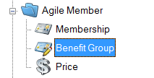
5. Right-click in the Benefit Group area and select New.
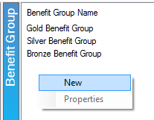

6. The Benefit Group: New window will open. In this window, you will need to name your Benefit Group. The benefit group should be named to match the Membership Price Level (i.e. VIP, Silver Level, Gold Level, etc.).
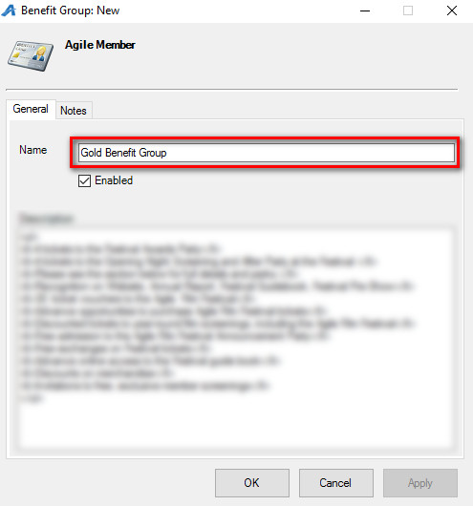
7. In the Description field, please enter the list of benefits that this Membership Level will receive. Information in this area will be merged onto the Welcome Letters that are sent with membership cards.
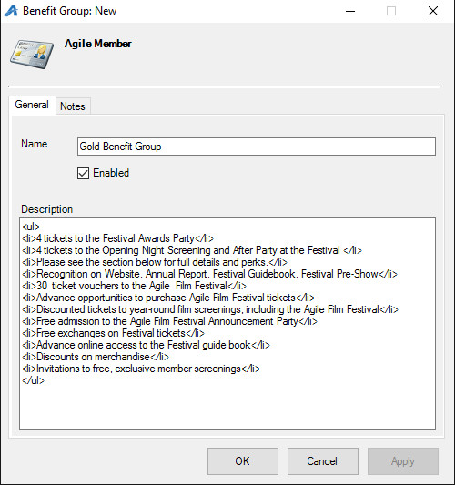
8. Click Apply and OK to save this information.
9. When all Benefit Groups have been created, you will need to associate the Benefit Group Type with a corresponding Membership Price Level. Click Membership in the Sales Organization Folder for your membership program.
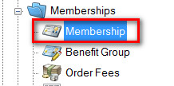
10. Highlight the Membership program.
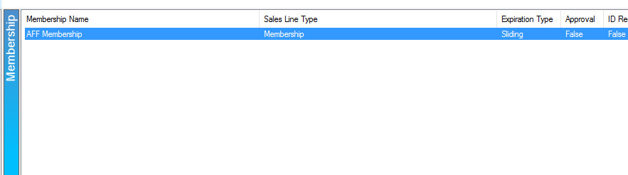
11. Right-click the Membership Price field. Select New if you are creating a new Membership Price or right-click and select Properties on an existing Membership Price to edit its Benefit Group. For more information on creating a new membership price, see Adding a Membership Price.

Member Benefits
Member Benefits allow an organization to set up specific permissions for a customer based on their specific membership level. These benefits can be based on Events, Shows, Catalogs, Memberships, or Packages.
1. Select the Benefit Group where you will be adding a benefit.
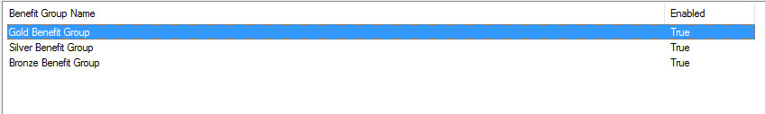

2. In the Benefit area, right-click and select New. Choose the type of benefit you are creating.
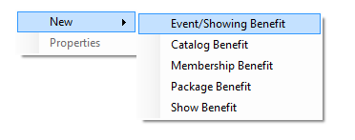
3. The following Benefit types can be selected:
- Event/Showing Benefit: Allows you to choose a specific event(s) or showing(s) that the member can access with their membership level.
- Catalog Benefit: Allows the customer to have a specific benefit for specific items (i.e. Member T-shirts, Member Drink Discount, etc.).
- Membership Benefit: Generally used to access discounted memberships or passes.
- Package Benefit: Allows members to access specific packages, such as a Member Season Subscription package.
- Show Benefit: Allows the organization to restrict the member benefits to the entire run of a Show or Event (e.g. Greatest Movie is showing 10 times in the week, but the member can only select a single date for the entire run. Once they have selected an event in that run, they will not be able to choose another event).
For this example, we will be building an Event/Showing Benefit.
4. The Benefit Window will appear. In the General Tab, add a Benefit Name (i.e. Member Comp Benefit, Member Discount, etc.).

5. Next, select the Organization.

6. Select the Sales Line Type. NOTE: If you have different Sales Line Types, it is very important to select the correct Sales Line Type in order for the benefit to work correctly.
7. Next, you will need to select the Sales Folder where events for this benefit are located. NOTE: If your member benefits are the same for all events, then leave the default selected as All Sales Folders.
8. If this benefit is for a Specific Event/Showing, click the Magnifying Glass icon and select the specific Event for this benefit. If all Events/Showings are available for this benefit, leave the Nothing Selected default.
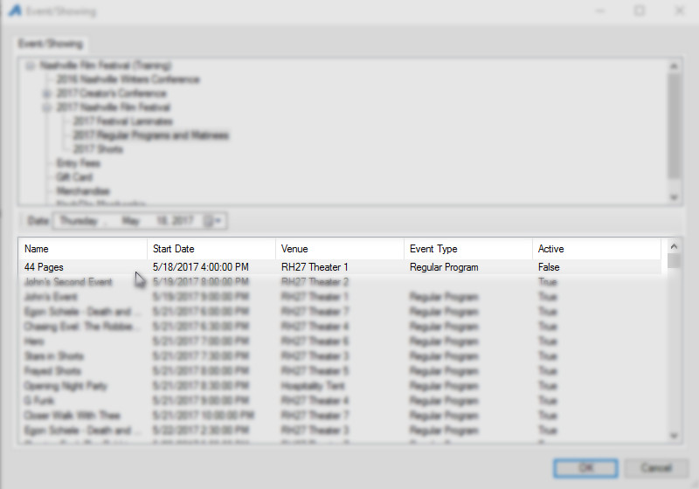
NOTE: You can remove the specific event by clicking the Red X icon.

9. Specify Tier from the drop-down menu.

10. From the drop-down, Specify Ticket Type.
NOTE: If you do not select the correct ticket type for this benefit, then the benefit will be open-ended and allow anyone to access this benefit.
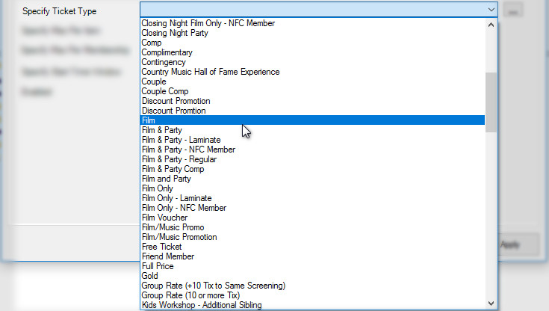
11. Next, you will set up your restrictions.
- Specify Max Per Item - This allows you to restrict the number of tickets the member can get per Event.
- Specify Max Per Membership - This allows you to restrict the total number of tickets a member can get in a calendar year.
- Specify Start Time Window - This restricts the member from using this benefit for multiple events that begin within the same 30-minute window. (e.g. If a customer uses this benefit to buy a ticket to The Good Movie at 11:30 AM, they will not be able to use the benefit on The Best Movie at 11:45 AM on the same day.)
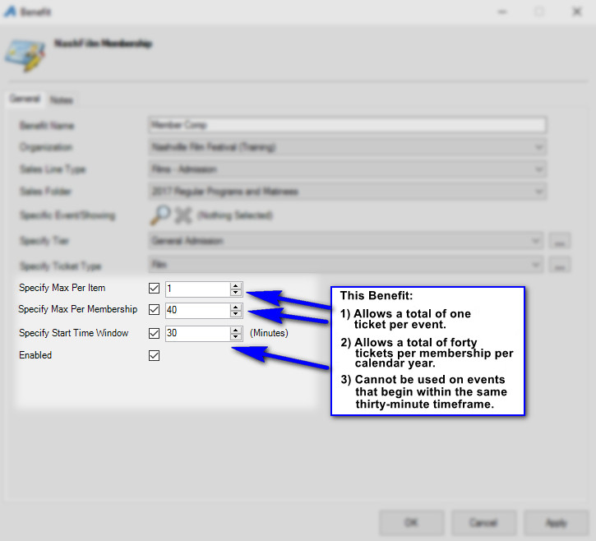

12. In the Brief Description, you can describe the benefit the customer has and enable them to see how many benefits they have left in their membership. This description will appear on the customer's My Benefits page in their online account.
Please note that in order for this field to work properly, you must enable and specify the Max Per Item, Max Per Membership, or Start Time Window.
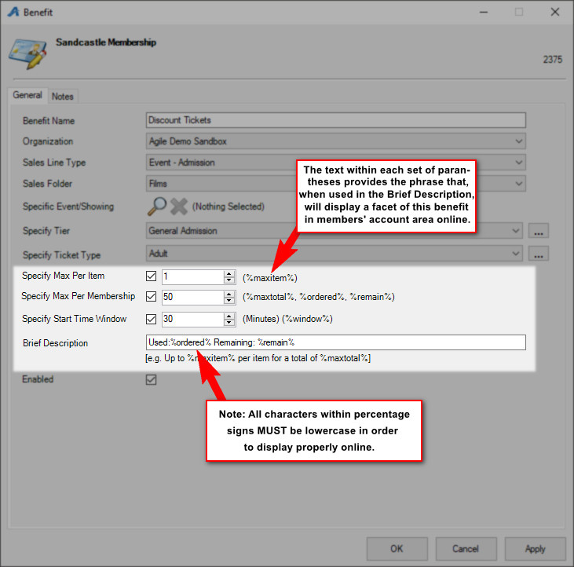

13. Once completed, click Apply to save the benefit and OK to close the window.
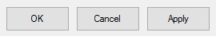
We recommend that once you have set up the benefit(s), you go online or in AMS to test that the benefits are working properly.

