Adding a General Admission Tour
1) Login to Administration.
2) After creating the template (see Building a Venue Template for more information), right-click in the Tier/Inventory section and click New Tier.
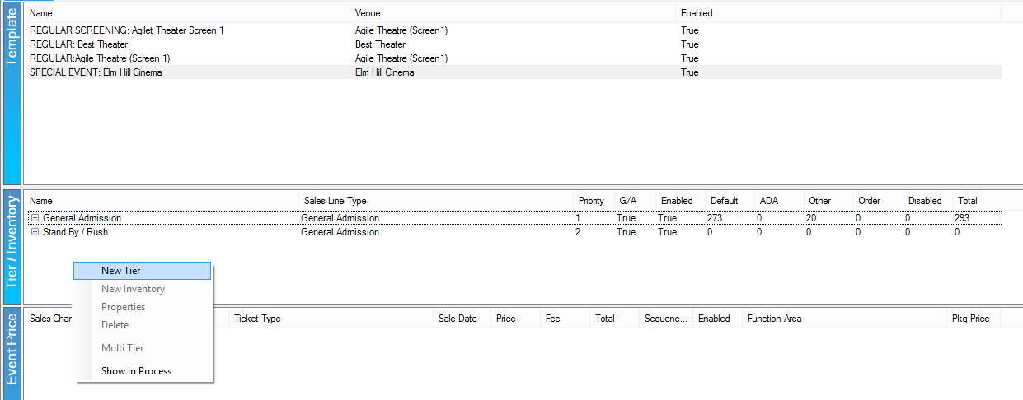
3) The Tier: New window will appear. In the General Tab, address the following:
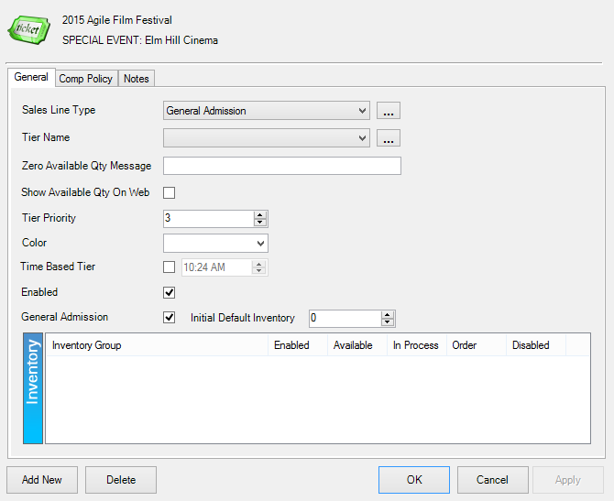
- Sales Line Type: Select the correct option from the drop-down tier, usually General Admission or Admission.
- Tier Name: Select the correct option from the drop-down tier, usually General Admission.
- Zero Available Qty Message: Type a message here that will appear when the event is sold out. If left blank, Not Available will automatically populate.
- Show Available Qty On Web: Check this box if the quantity should be seen online.
- Tier Priority: Similar to display sequence, this orders the tiers online.
- Color: Choose a color for the tier. This option is usually used on reserved tiers.
- Time Based Tier: This allows you to associate a certain timer with that tier.
- Enabled: Check this box to activate the tier.
- General Admission: This box must be checked to indicate that this is a General Admission tier.
- Initial Default Inventory: Enter the number of seats here, if known.
4) Click Apply.
5) An Open Inventory Group appears. If this is the only inventory group needed, then click OK and build the pricing.
6) If more Inventory Groups are needed, right-click in the Inventory box and select New.
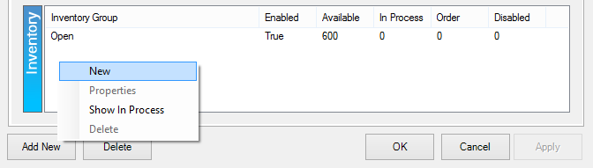
7) This will open the Inventory: New window. In the General tab, address the following:
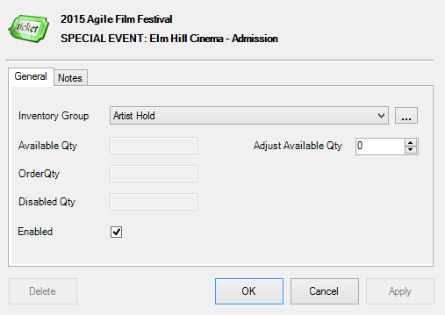
- Inventory Group: Select the name of the inventory group.
- Adjust Available Qty: Enter the number of seats that should be in this tier.

