Editing Customer Information in AMS
There are several ways to edit a customer's contact information.
If the customer has already been selected on the AMS screen:
At the top of the AMS screen, there are two icons beside the Customer #: The Customer Notes icon and the Edit Customer icon. Selecting the Customer Notes icon will open the Customer Details window on the Notes tab, where you can then make any internal notes about the customer which the customer will not see. Selecting the Edit Customer icon will open the Customer Details window on the General tab.
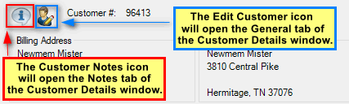
After clicking either icon, you may make edits as described by Steps 4 through 11 of the following section.

If the customer record has not already been selected on the AMS screen:
1. Click the Customer icon at the top of the screen to search for the customer's account.
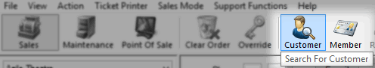

2. A Customer Search window will appear. Type a Keyword to search for the customer (e.g. last name, phone number, email, customer #, etc.) and click the Search button.
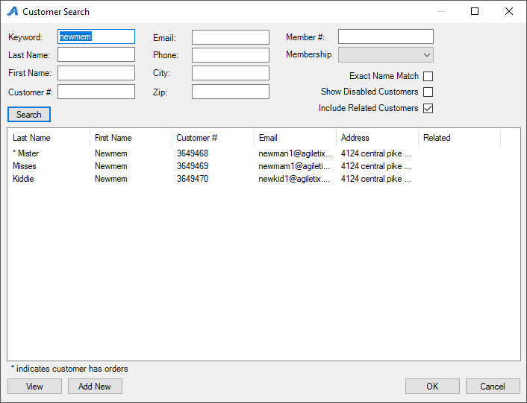
3. A list of customer records will appear in the search window. Click View at the bottom of the window to open the customer record.
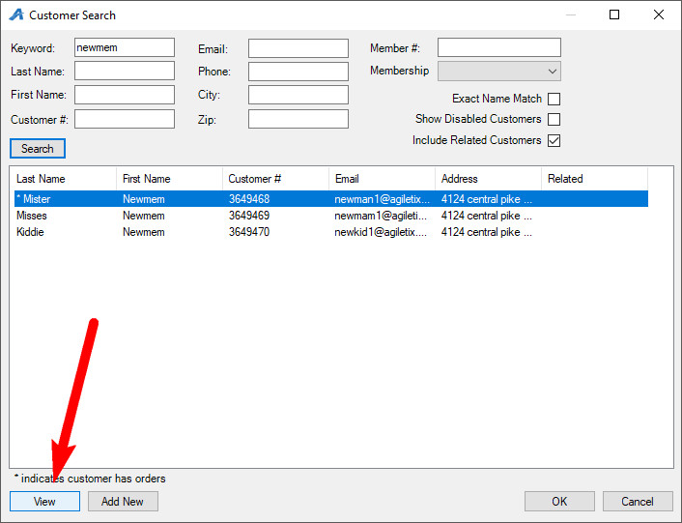
4. In the General tab, you can make changes to the customer's contact information and any answers to the customer question prompt. You are also able to add and edit customer images. To learn more about customer images, see Adding an Image to a Customer Record.
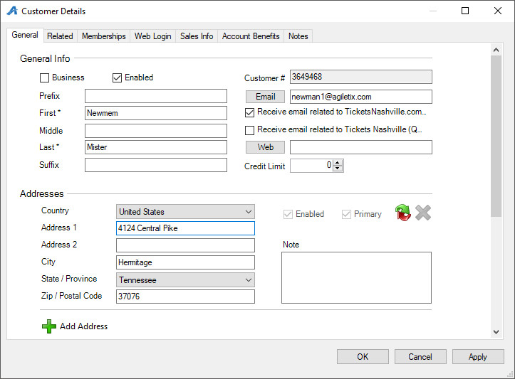
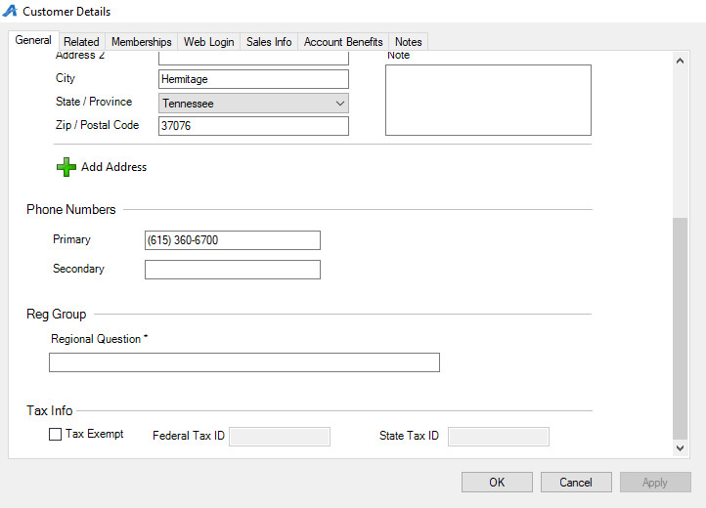
5. The Related tab allows you to add customers that need to be associated with this customer record to complete a household (i.e. Mrs. Newmem can be added as Mr. Newmem's wife).
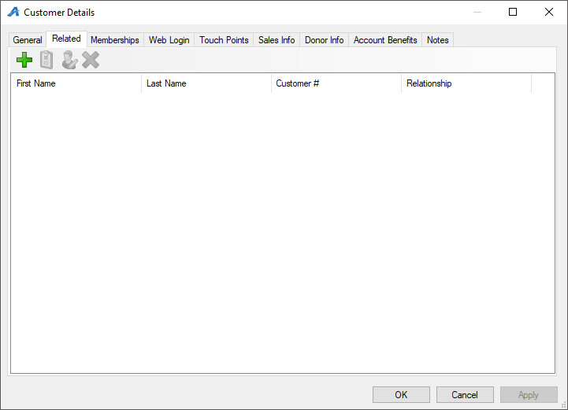
- To add a relationship to a customer record, click the green plus sign.
- Click the drop-down and select the type of relationship the customer has with the other customer (business, contact, sold for).
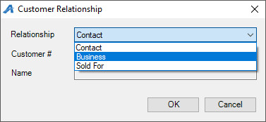
- Type in the related Customers' Number, or search for the related customer by clicking the Magnifying Glass.
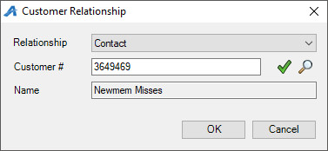
- Once you see the related customer's name in the Name field, click OK.
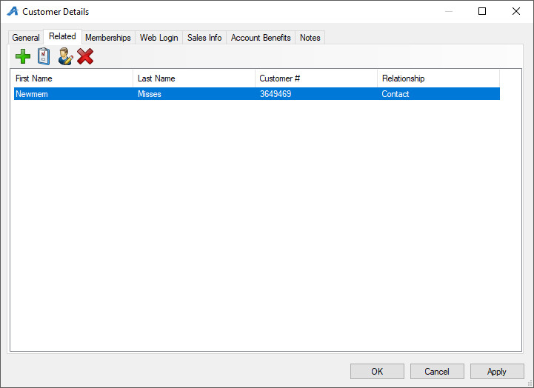
6. The Membership tab allows you to manage a customer's membership. You are able to manually edit a member's expiration date as well as additional member benefits. Click to learn how to Manually Add Membership Benefits to an Existing Member.
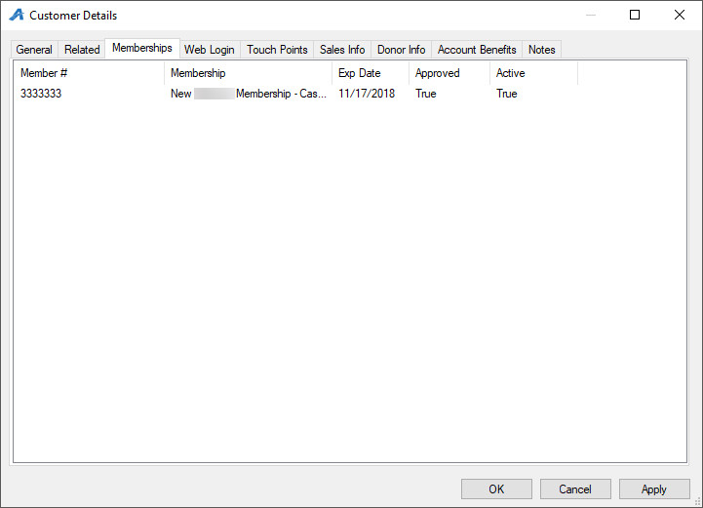
7. The Web Login tab is where you create and manage that customer's login information.
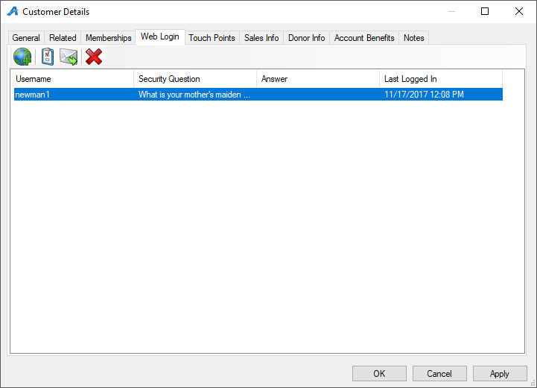
- To create a new username and password for the customer, click the Globe icon.Enter the username, and generate a random password.
- If a customer has forgotten their password, click the Random Password button to generate a new temporary password for them.
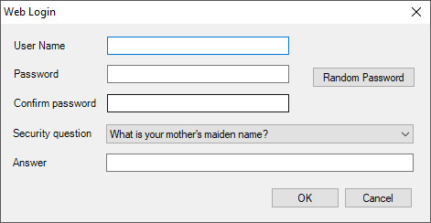
- Clicking the Envelope icon will send a reset password email that allows the customer to change their own password.
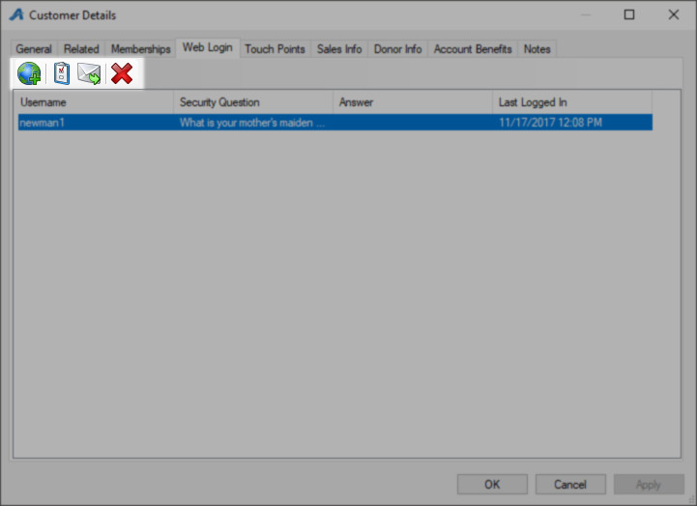
8. In the Touchpoints tab, you can add and manage touchpoint tasks for this customer. (Click here to learn more about touch points.)
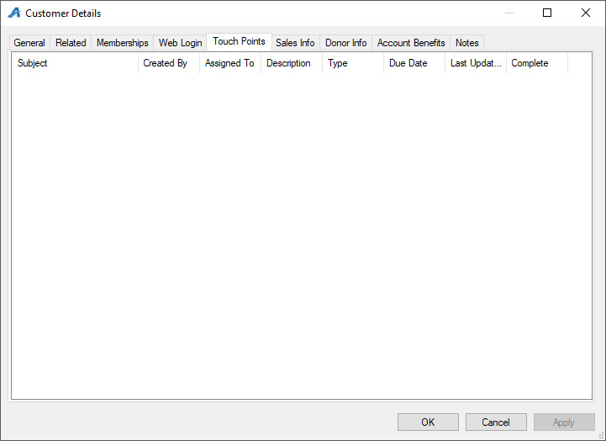
9. The Account Benefits tab is where you will be able to manage any benefits associated with this customer's account. To add a new benefit, right-click and hover over new. Then, select the type of benefit that you are adding. To edit an existing benefit, right-click the benefit and select Properties.
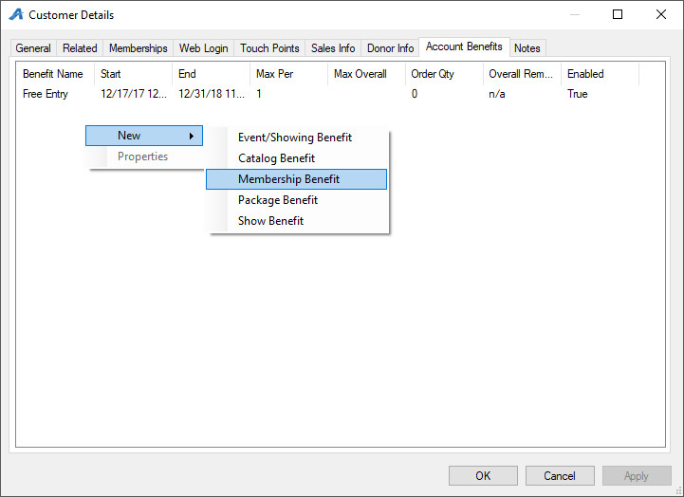
10. The Notes tab is where you can keep internal notes about this customer. The Operator Notice checkbox tells the system that when this customer record is pulled, the note will appear to your staff (i.e This is a Board Member. Please pay special attention to him).
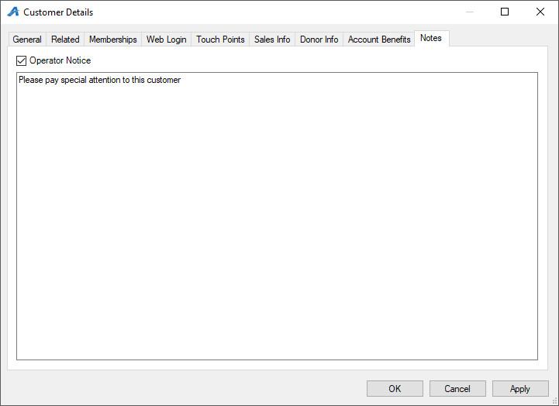
11. Click Apply to save your changes and OK to close the window.

