Creating Customer Questions
Customer Questions are used to classify customers or get more information about customers (such as birthday information, eating preferences, job title, etc.). This is especially useful when your organization wants to collect information for marketing purposes. These questions are asked only once, when a customer first creates their account, but customers may edit their answers later online.
Customer Questions should be customer-specific rather than order-specific. To make order-specific questions, see Creating Order Questions.
1. Log in to Administration.
2. Select the Corporate Organization icon.
3. Depending on your needs, create the Customer Questions in either of the following locations:
- The blue Sales Folder most relevant to the questions being created (Membership, Events, etc.)
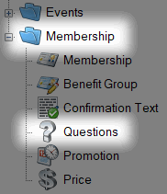
- The Settings folder for the Corporate Organization.
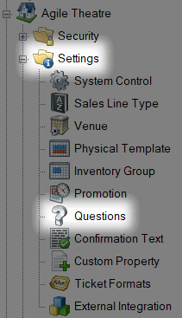
In either location, select the Questions icon.
4. Right-click and select New Customer Question.
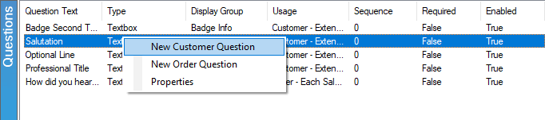
5. Under the General tab, enter the following:
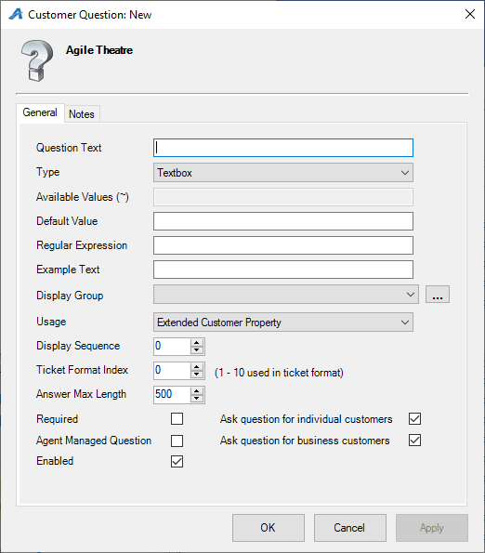

A) Question Text: This is the Question that will appear online.
B) Type: These are the options for how the customer will answer the question.
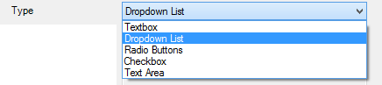
C) Available Values (~): Enter the possible answers to the question. Separate each answer with a "~". Note: This option will not be available for the Textbox, Checkbox, or Text Area types.
D) Default Value: This answer will be automatically selected. If left blank, no answer will be automatically selected.
E) Regular Expression: This defines how the data should be entered and defined.
F) Example Text: If the answer requires a Regular Expression Format, give an example here (e.g. "Enter birthday as MM/DD/YYYY").
G) Display Group: Select the appropriate item from the drop-down list or add a new display group by clicking the ellipsis button.
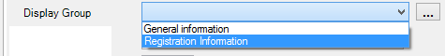
H) Usage: "Statistics" should be selected if the data from this question will be pulled in a report and used for statistical analysis. Otherwise, select "Extended Customer Property."
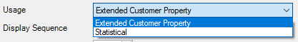
I) Display Sequence: Use this to dictate in what order the question should appear online and in AMS.
J) Ticket Format Index: This allows you to assign the answer to the question as text on the ticket format (This option is generally used for passes and memberships, but it can be used on any ticket format).
K) Answer Max Length: This allows you to dictate how many characters are allowed for the answer to the question.
L) Required: Check this box if the question must be answered by the customer before finalizing the order.
M) Agent Managed Question: Check this box if the question should only be asked by ticket agents. The question will not be available online and can only be used in AMS.
N) Enabled: Check this box if this question should be enabled.
O) Ask question for individual customers: Check this box if individual customer accounts should be asked this question.
P) Ask question for business customers: Check this box if business accounts should be asked this question.
6. Notes: Use this space to record any internal notes about this question. These will not be seen by the customer.
