Turning on Guest Checkout
- Login to Agile Administration.
- Select the Corporate Organization (the house icon) and expand it to show your organization's administration options. 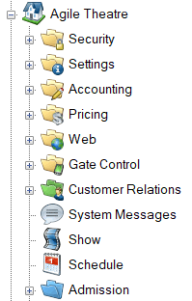
- Expand the Web folder and click the Entry Points icon. 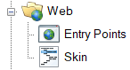
- Double-click the Entry Point Group where you want to enable Guest Checkout.
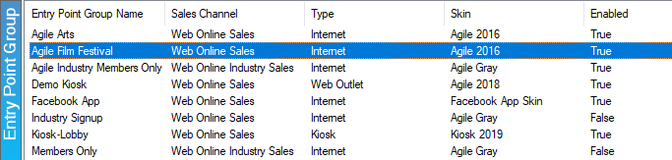

- The Entry Point Group window will appear. Check the box labeled Guest Checkout.
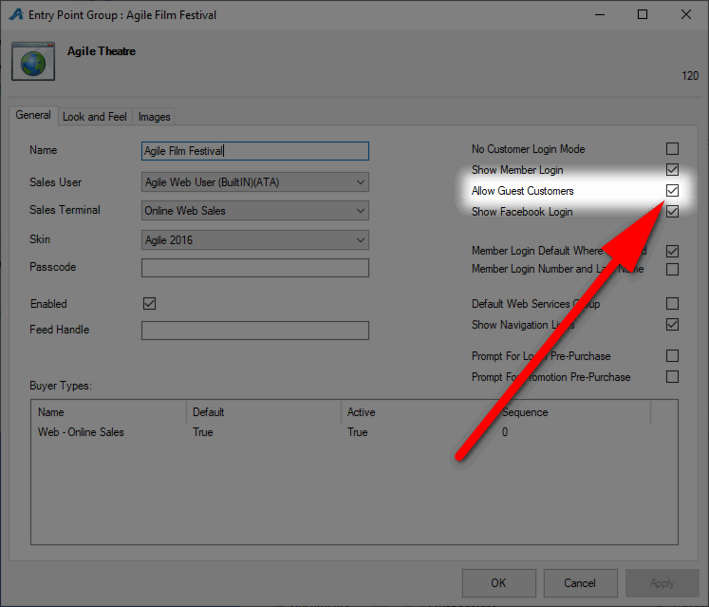
- Click Apply to save your changes and OK to close the window.

