Changing a Shipping Address on an Order
1. Log in to Sales.
2. Select Maintenance.
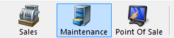

3. Search for the customer by entering the Order # or the customer’s Last Name. Then, click the appropriate green check mark.
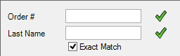

4. Double-click the correct order to bring up order contents on the Item Summary page.
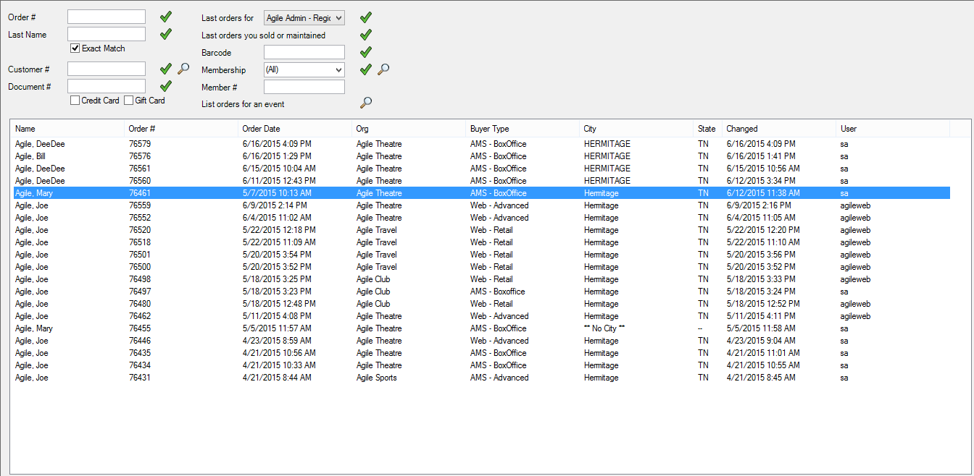

5. Once in the Item Summary page, click the Shipping Address at the top of the page.
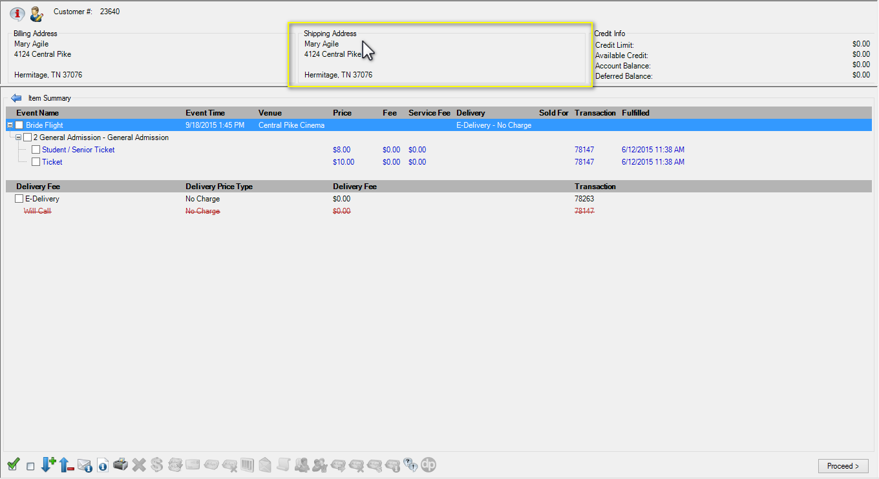

6. The Customer Address page will pop up.
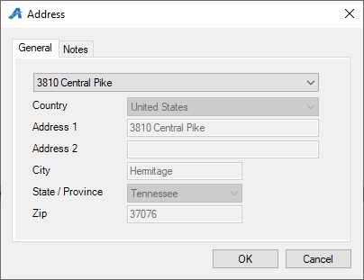

7. From the drop-down, select either an address already in the system or (Add a New Address) to create a new shipping address. Once the address has been changed, click OK.
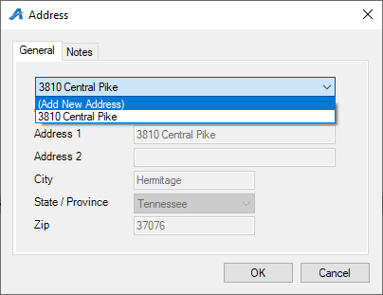

8. Back on the Item Summary page, click Proceed to save your changes.
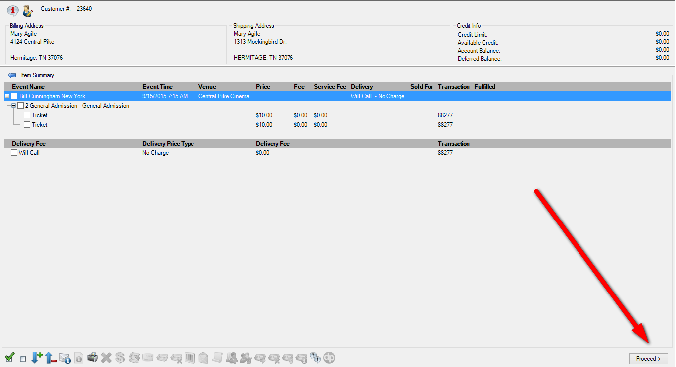

9. This will take you to the Payment screen. You will then click the Finalize button to save the changes.
