Manage/Adjust/Transfer Inventories
1) Log in to the Administration side of Agile.
2) Find the event/show/template you wish to adjust.
3) In the Tier/Inventory tier, expand the tier.
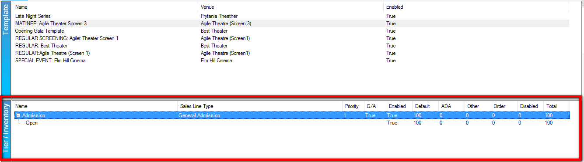
4) Right-click the Inventory.

Transferring Inventory from One Tier to Another
5a) Right-click the tier from which you wish to remove inventory and select Transfer Inventory.
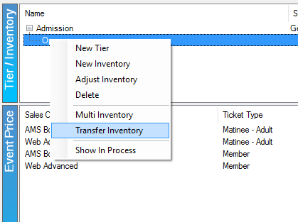

5b) Change the Transfer To drop-down list to the correct inventory.
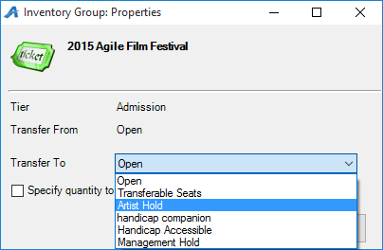
5c) Enter the specific quantity to transfer and click Apply and OK. The inventory's quantity should now reflect this change.
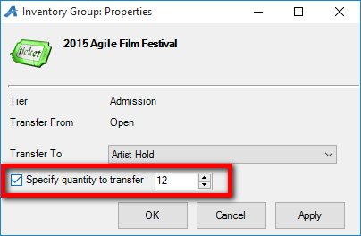

Adjusting Inventory Within a Single Inventory Tier
6a) Right-click the tier you wish to adjust and select Adjust Inventory.
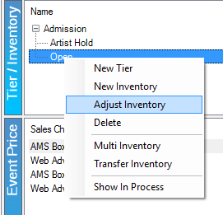
6b) Enter the amount you wish to adjust in the Adjust Available Qty box. To remove inventory, enter a negative number (e.g. -47). To add inventory, enter a positive number (e.g. 28).
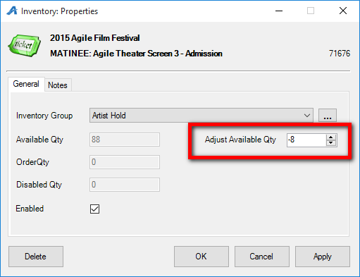
6c) Click Apply and OK. The inventory quantity should now reflect this change.
Transferring Inventory for Multiple Events
7a) Right-click the tier you wish to adjust and select Multi Inventory.
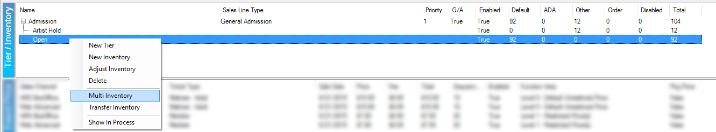

7b) Select the correct inventory from the Transfer To drop-down list.
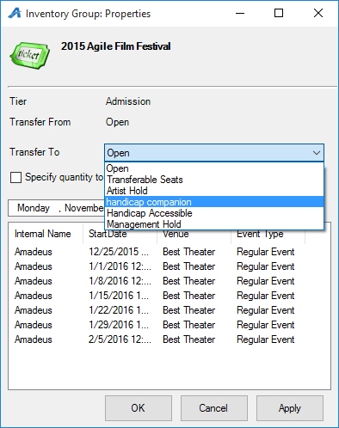

7c) Enter the specific quantity to transfer.
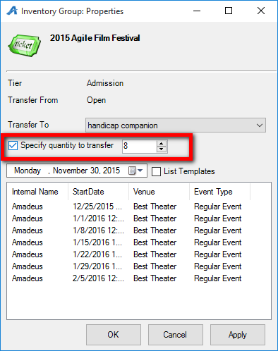
7d) Set the date back to include all events that should be affected and click the white box to update. Click the check mark next to List Templates if you are adjusting templates.
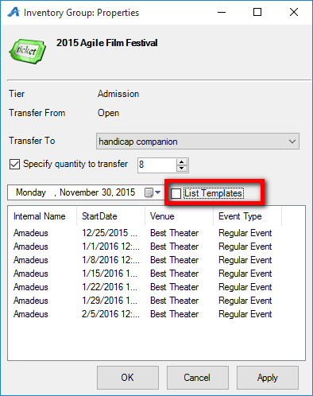
7e) Select the correct events to adjust. Each column (Internal Name, Start Date, etc.) can be sorted for an easier selection process. Click Apply and OK. The inventory quantities should now reflect this change.
