Placing Multiple Shows/Events
Multiple shows or events can be placed on sale at the same time by following with the following steps:
1. Select all the Shows or Showings that you wish to put on sale. Click the first with your mouse. While pressing the Shift key, select the last you wish to put on sale.
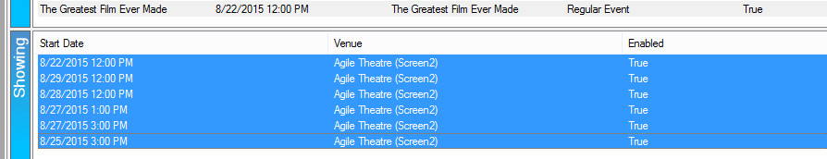
2. Right-click and choose Sales Channel Maintenance.
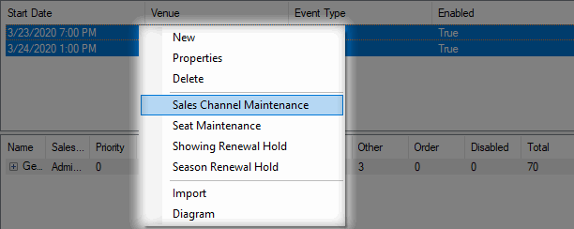

3. Click the Sales Channel drop-down list and select a Buyer Type.
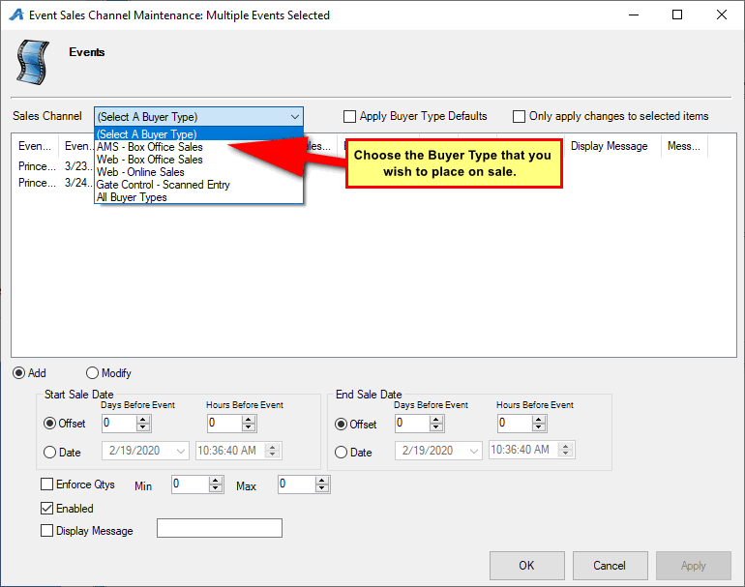
4. At the bottom of the screen, the Start Sale Date should be adjusted to the date and time you want these events to go on sale for this Sales Channel. Select either Offset to start sales a certain number of days or hours before the event or Date to start sales on an exact date and time.
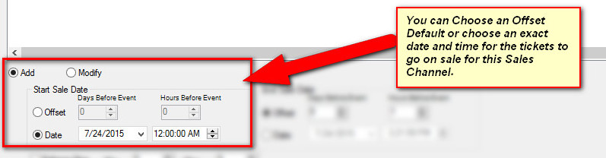

5. In the End Sale Date column, choose the Offset or the exact Date when you want sales to end.
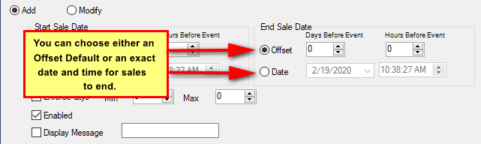
6. Check Enforce Qtys and set the Min and Max, if there needs to be a restriction on how many tickets a customer can purchase.
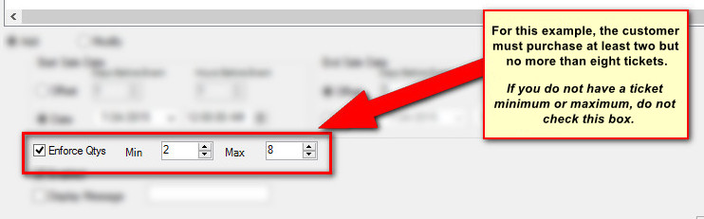
7. Display Message allows you to add a specific message that will appear online when you do not want tickets to be available online or if the event has no more inventory left to sell (e.g. Rush Line Only, Sold Out, etc.).
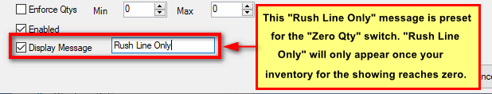

8. Click Apply to save the information and OK to close the screen.

9. If you need to make any adjustments to the on-sale dates and times, repeat Steps 1 through 3. Select the Modify radio button to make any necessary changes.
