Renewing a Membership in AMS
1. Log in to Agile Ticketing Solutions with your username and password. If you have not received your user credentials, please contact your system administrator to set up your username and password.
2. Make sure that you are cashed in before starting sales for the day. (See How to Cash In and Create a Daily User Batch in AMS Sales for further instructions.)
3. Click the Member icon to search for the member's account.
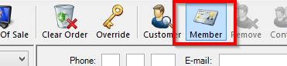
4. Search for the member’s record via last name, email address, member number, etc. A list of member records will appear. Select the member record you want to change and click OK.
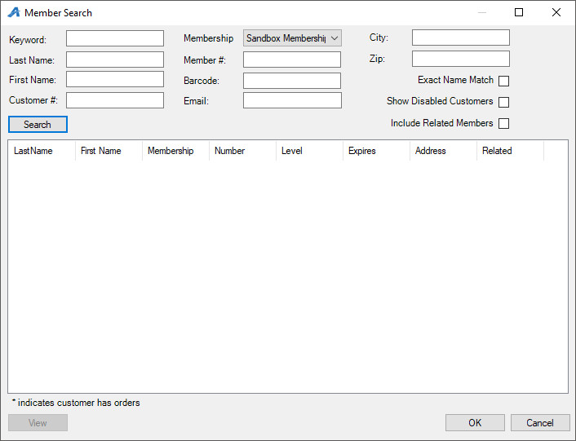

5. When you are in the member’s account, select the Membership tab on the left side of the screen. Select the membership program from the list underneath. This will allow you to see all membership options.
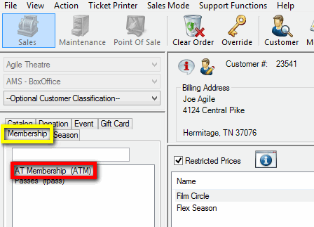
6. When renewing a membership, make sure the Restricted Prices box is checked in order to see all pricing options.
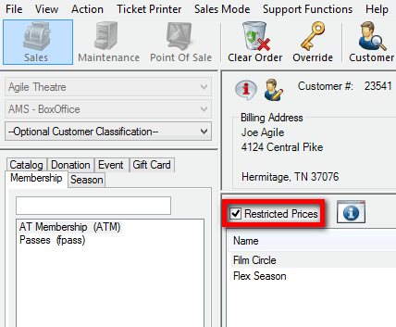
7. Select the membership option you want to renew, located under the Restricted Prices check box. Then, select the Membership Type and add the quantity of memberships the customer wants to purchase. Be sure to select a membership type with {Renewal} listed at the end of the name. Otherwise, you will be selling the customer an additional membership rather than renewing the one they already have.
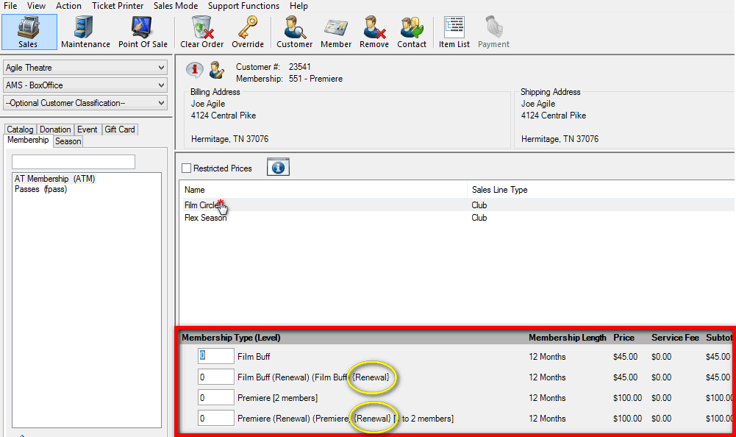
NOTE: In this example, the Membership Length is twelve months. Entering a quantity of (1) renewal will renew the membership for one year; entering a quantity of (2) will renew the membership for two years.
8. After selecting the membership type and quantity, click Proceed in the lower-right corner.
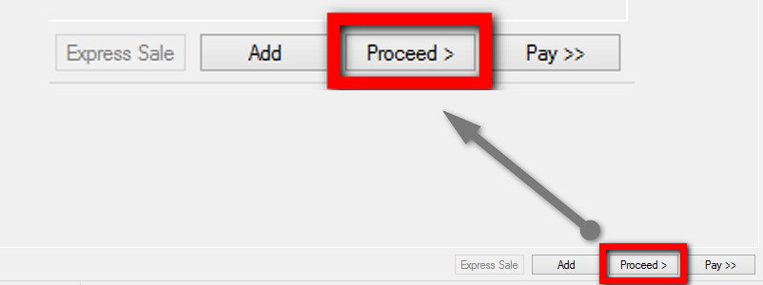
9. A window asking you to select a membership number to renew will appear. Make sure to choose the customer's current membership number to continue their membership history.
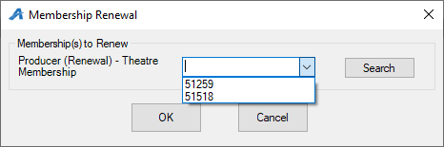
10. Another window asking you to assign the membership to the member’s name will appear. Select the name for the account you are working on and click OK.
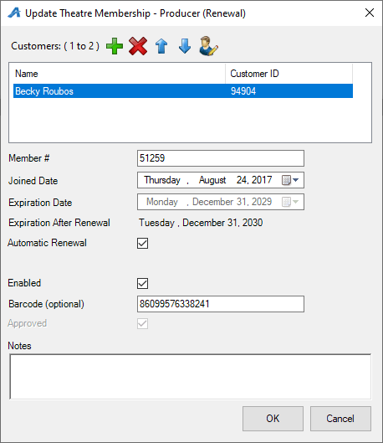
NOTE: Some memberships may be assigned to more than one person. Click the plus icon to add additional customers to such memberships.
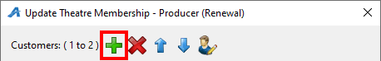
11. The Item Summary screen will appear. Here, you can review the order before processing a payment and finalizing the order.
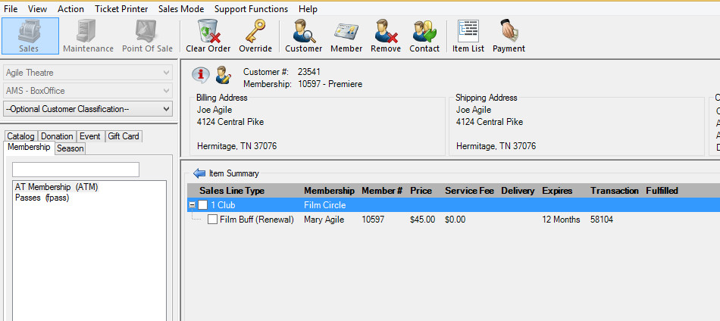
12. Once you confirm that everything on the Item Summary screen is correct, click Proceed in the lower right-hand corner.
13. The Change Delivery Methods window will appear. Select the delivery method desired and then click OK.
NOTE: Typically, the delivery method will be US Mail.
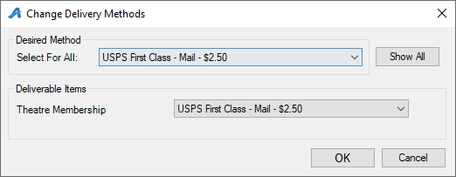
14. On the payment screen, select the payment method. (e.g. Cash, MasterCard, Visa, Gift Card, etc.)
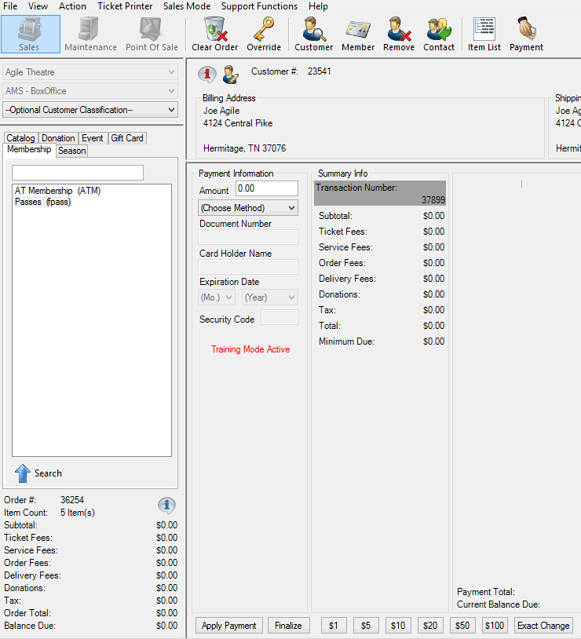
NOTE: If you are using a POS station or have a USB Credit Card swipe attached to your terminal, at this point you can swipe the credit card. All the credit card information will automatically populate and finalize the order.
15. Click Apply Payment to complete the order.
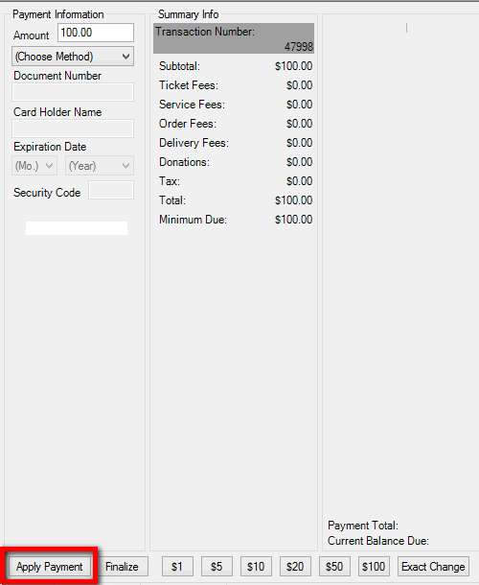
NOTE: If there is no balance due on the order, or if you are processing a comp membership type, then you will only need to click Finalize to complete the transaction.

16. Once the order has finalized, the Order Confirmation page will appear.
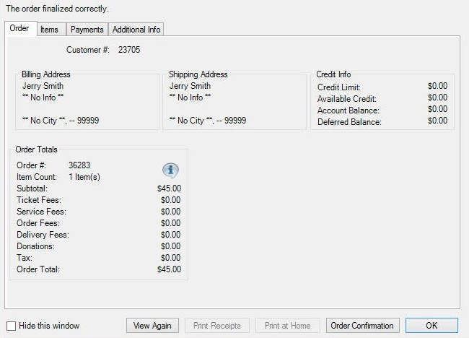

17. Click Order Confirmation to start the confirmation process.
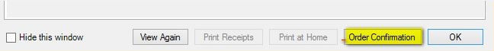
18. The Order Confirmation Options box will appear. Make sure the email address is correct, add any message you want to appear on the confirmation email, and click Send Confirmation to email the confirmation receipt. Another window saying the email has been sent successfully will appear. Click OK and Close. You are now ready to begin another transaction in AMS.
