Importing Showings
You are now able to import your showing times. First, you need to make sure that you have created the show that you wish to import the showings into. Click here to see our article Building an Individual Show or, if you have multiple shows that you wish to import, click here to see Show Import Instructions.
1. Log into Administration.
2. Open the blue Sales Organization folder that houses your shows and select the Show icon.
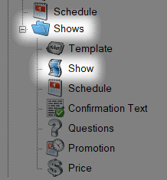
3. Right-click in the Showing area and select Import.
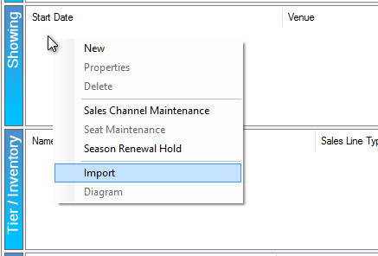

4. Click the Import Example button to save the Import spreadsheet example to your desktop.
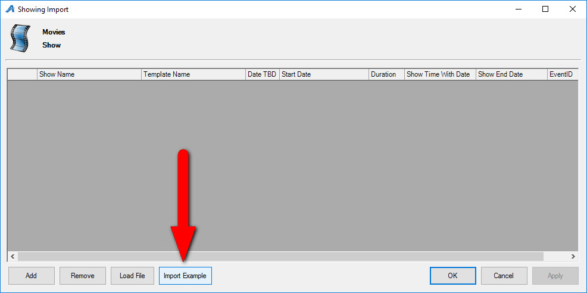

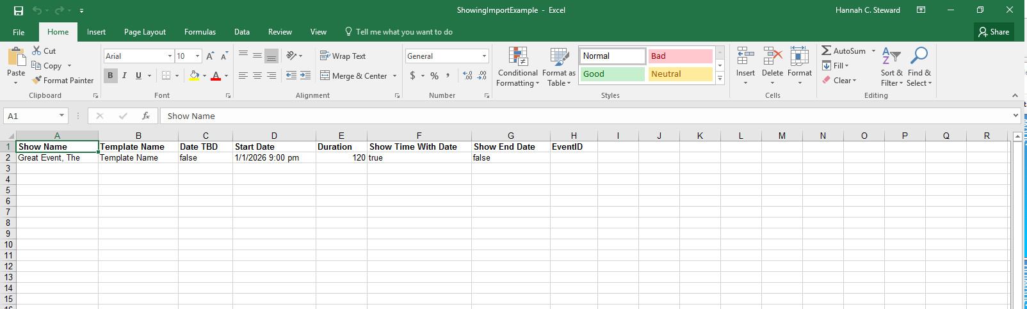
5. Fill in the spreadsheet with the showing information.
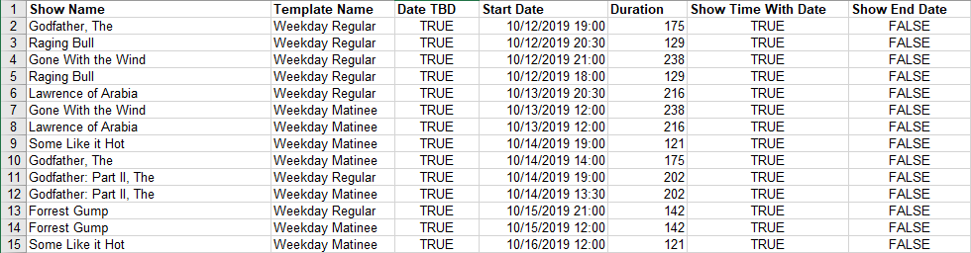
A. Show name: In Column A, you will need to enter the Internal Name of a show. This is the shortened version of the show's name that customers will not see. (The Internal Name should have been determined when you created the show. To view or edit a Show's Internal Name, select the Show icon, right-click the show, and select Properties.)
B. Template Name: In Column B, you will need to enter the name of the template that you created for the show.
C. Date TBD: If the dates of your show have not yet been finalized, you can type "TRUE" in Column C. If they are finalized, and you want them to appear online, make sure the column says FALSE.
D. Start Date: In Column D, you will need to enter the start date and time of the showing.
E. Duration: Enter the duration of the show in Column E. Please note that the duration needs to be entered in minutes.
F. Show Time with Date: If you wish for the time and date of the show to appear on the website, type "TRUE" in Column F.
G. Show End Date: If your organization publishes the end date time on their website, make sure that you enter "TRUE" in Column G
H. Event ID: The event ID will be generated by Agile once you Import the showings. This column has a 50-character limit.

6. Once you have filled out the Import spreadsheet, return to Agile Administration and the blue Sales Organization Folder that will house your shows.

7. Right-click in the Showing area and select Import.
8. Click Load File and select the completed import spreadsheet.
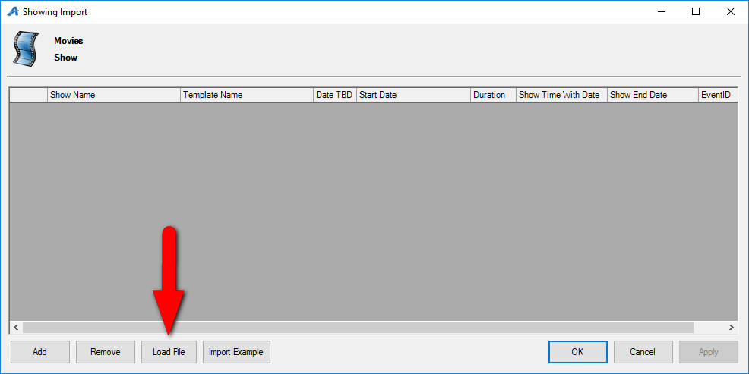

9. All showing information should appear in the Showing Import window.
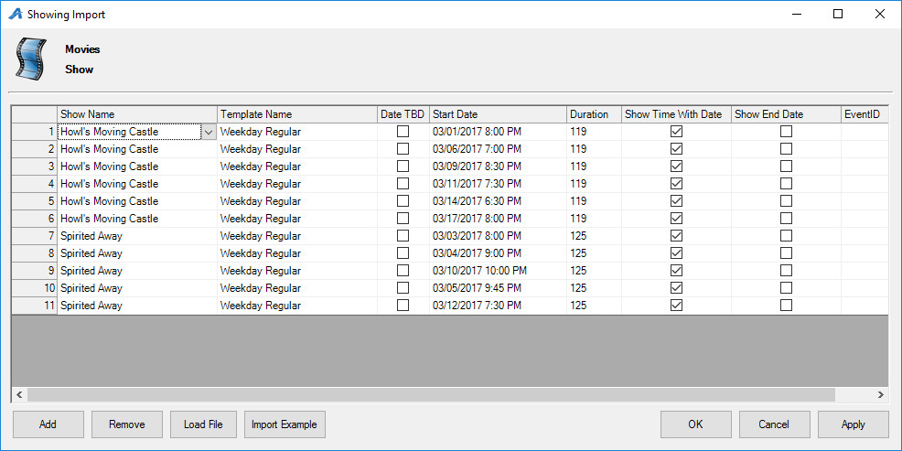
10. At this point, you can make edits to your showing by double-clicking the field you wish to edit.
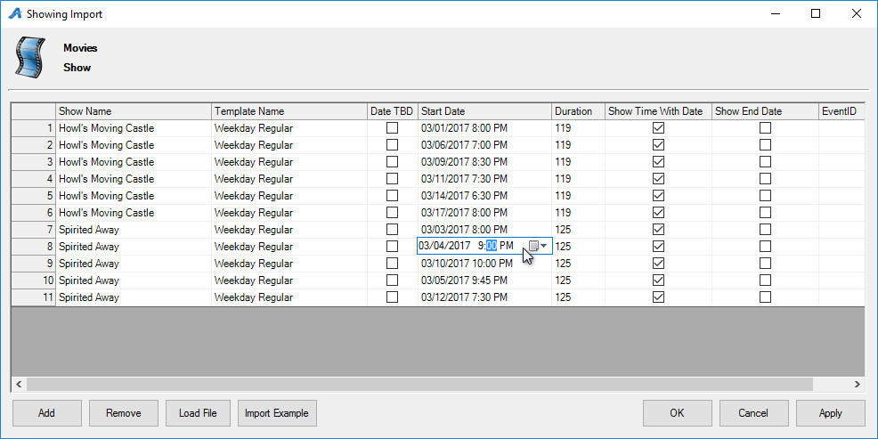
11. Once all the information is correct, click Apply to import your showings.

12. Clicking Apply should also generate a ShowingImportResults spreadsheet. Please save this in a secure location just in case you ever need to upload the showings to Agile again.
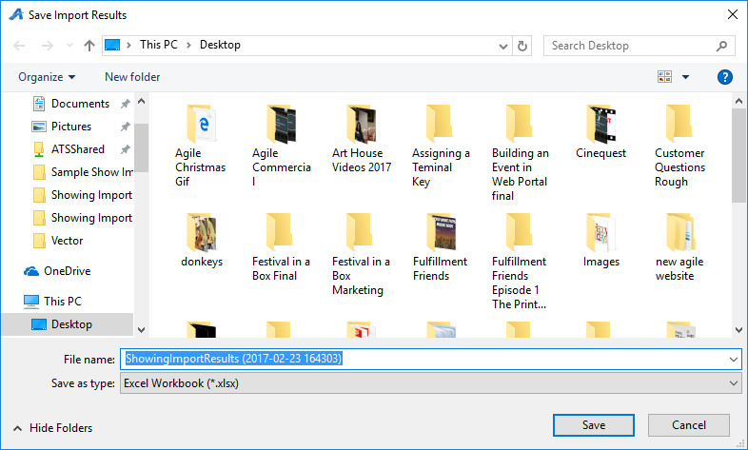
13. Before you are able to view these showings on your website, you will need to put them on-sale. See the article Placing Multiple Shows/Events on Sale to learn more.

