Printing Individual Tickets Using Regular Batch Fulfillment
- Log in to Agile and Cash In for the day. (Please see "How to Cash In and Create a Daily User Batch in AMS" on how to Cash In.)

- Click Support Functions at the top of the screen.
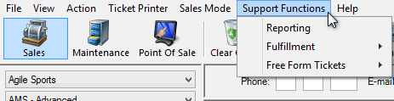

- Move the cursor to Fulfillment.
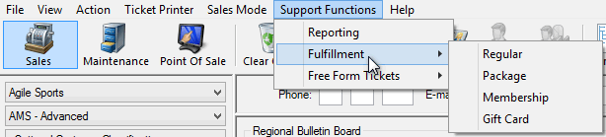

- Move the cursor to Regular.
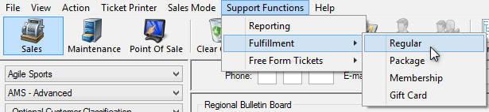
- A Fulfillment screen will pop up. On the left side of the screen you will see a list of Delivery Methods with the number of tickets to print.
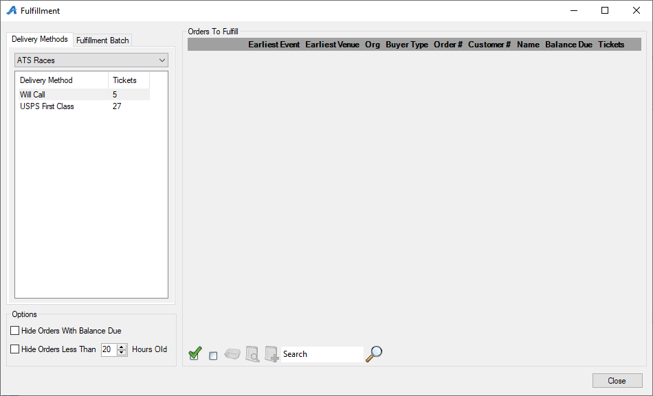

- Choose Will Call and the list of orders that are in will call will appear.
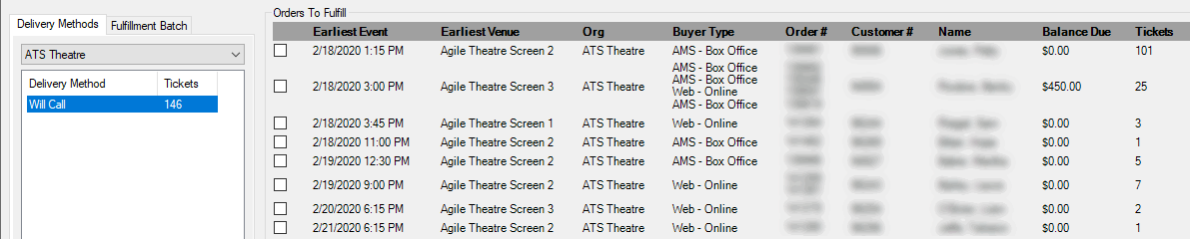

- Click the boxes next to the orders you want to print. If you want to print the entire list, select the Green Check Mark icon at the bottom of the screen, and it will select all of the orders to be printed.
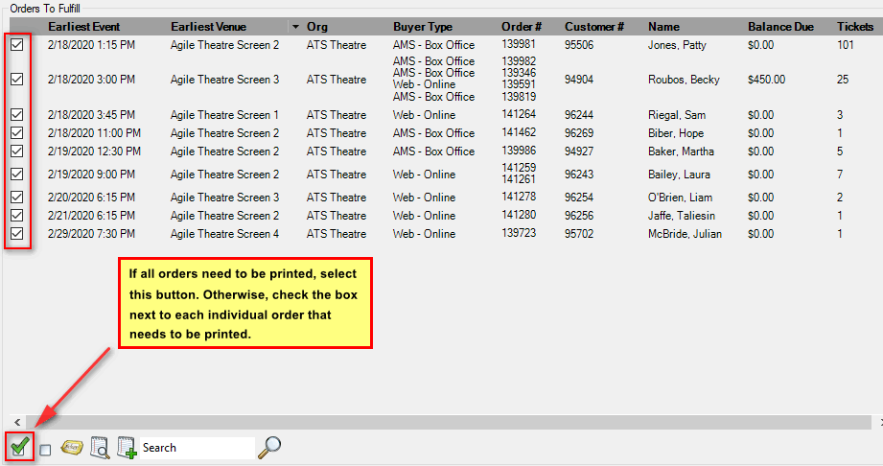
- Once all the orders are selected, click the Ticket Icon at the bottom of the screen.
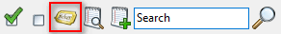
- The Fulfillment Options window will open. From the Available Printer list on the left side of the screen, double-click the ticket printer to move it to the Selected Printers column. Un-check Print Payment Receipts, and make sure that there is a Header Format selected. Also, make sure that the Sort Orders By is set to "Last Name," so that the tickets will print by last name in alphabetical order. Click OK to start printing the tickets.
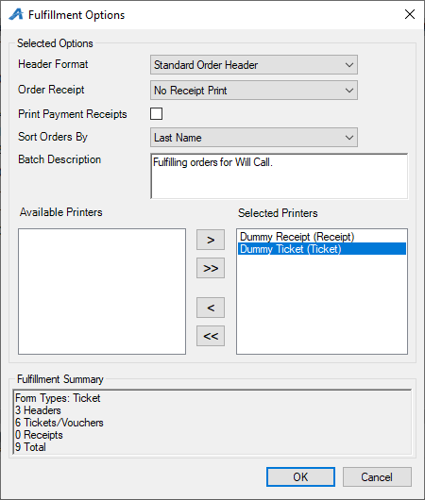
- A progress screen will pop up. Once that is complete, click OK and wait for your tickets to finish printing.
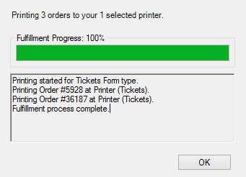
Now your tickets are printed and can be stuffed into envelopes for will call or mail.

