Promotion Codes: Creating and Attaching Codes to Prices
Promotion Codes allow you to set a password for a specific price that will only be accessible to customers who enter that code. This is can be used for pre-sales or any specific discount promotion that needs to be hidden from the general public.
In order to build promo codes, you will need to login to Agile Admin.
- Open the Corporation Organization where you are needing to build the promotion code.
- Open either the blue Sales Organization folder or, if certain permissions have been set up, open the Settings folder.
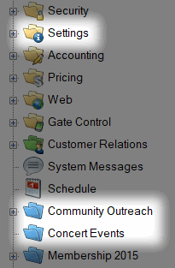
- In either folder, select the Promotion icon.
.
- Right-click in the Promotion box and select New.
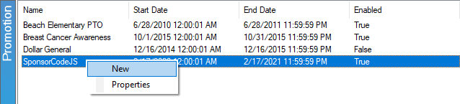
- A Promotions window will appear. This is where you will assign information for your code.
- In the General tab:
  - Assign the Name of the Promotion (e.g. Breast Cancer Awareness, Buy One Get One Free, Sponsor 1, etc.).
  - Set the Start Date and End Date during which the Promotion Code will be active.
  - Check mark the Enabled box to make this Promotion active.
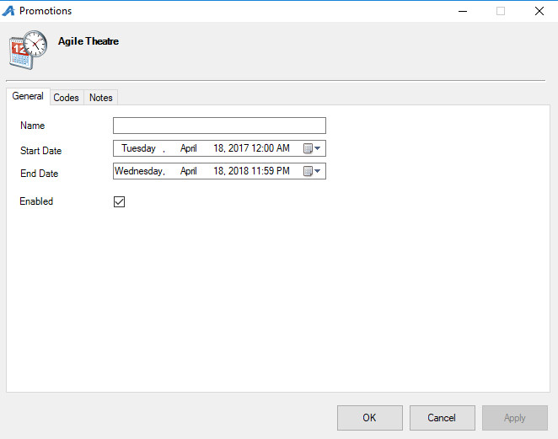
- In the Codes Tab, click Add Code.
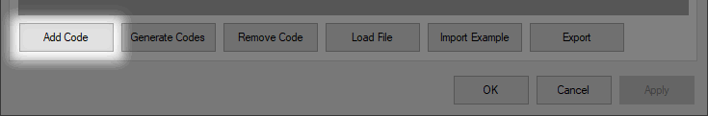

- Double-click the Code box to type the code you wish to add.
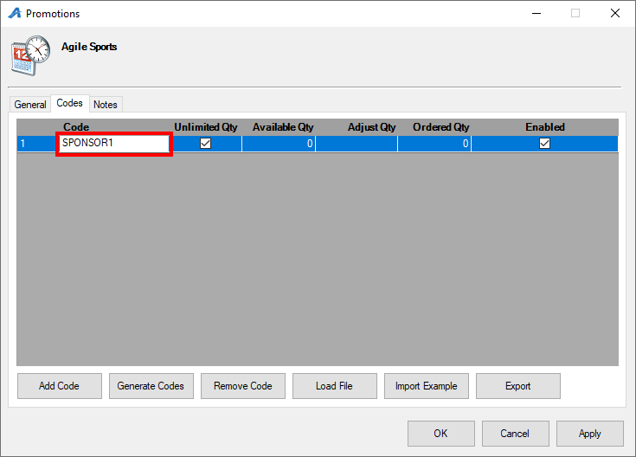

- If the promotion code's use should be restricted, un-check the Unlimited Qty box, double-click the cell beneath Adjust Qty, and type the number of times the code should be used.
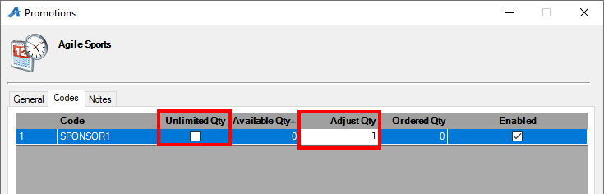

- If this code should have unlimited use, check the Unlimited Qty box.
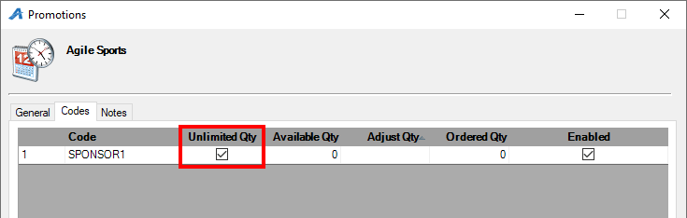
8. The Notes tab is a place to record any internal notes you may have about the promotion code.
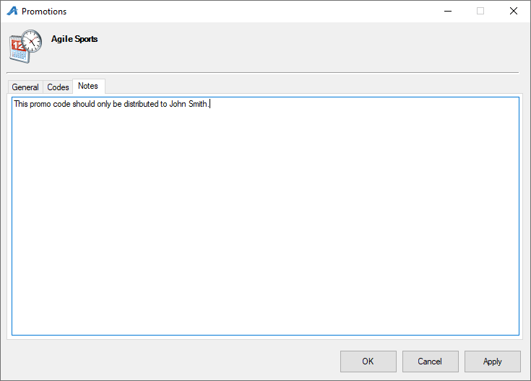
9. Once you have assigned all these values, click Apply. Your promotion code is now ready to be assigned to specific ticket types.
10. Once you have created your promotion code, you will need to go to your event and assign the promotion code to an Event Price located under either the Event or Template icon.
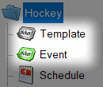
11. In the Event Price box, right-click the Price to which you want to add a promotion code and select Properties.
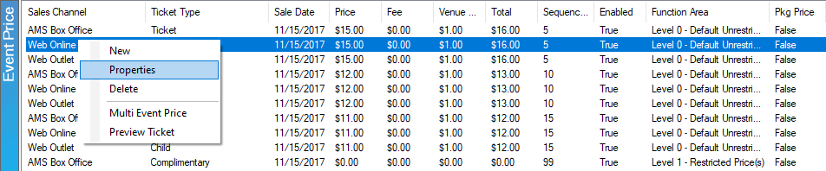
12. The Event Price window will appear. Select the Promotions tab.
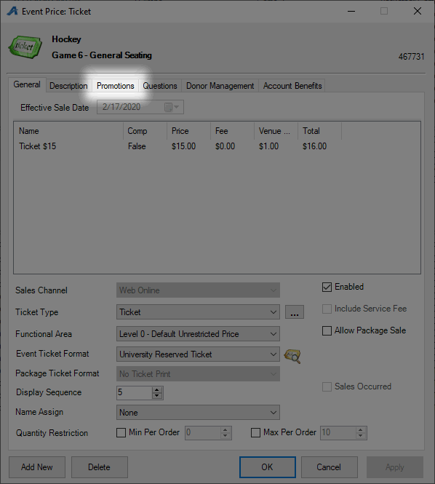
13. A list of available promotions will appear in the Available Promotions column on the left side of the window. Select the promotion you want to add and click the ">" symbol to move the code to the Selected Promotions column.
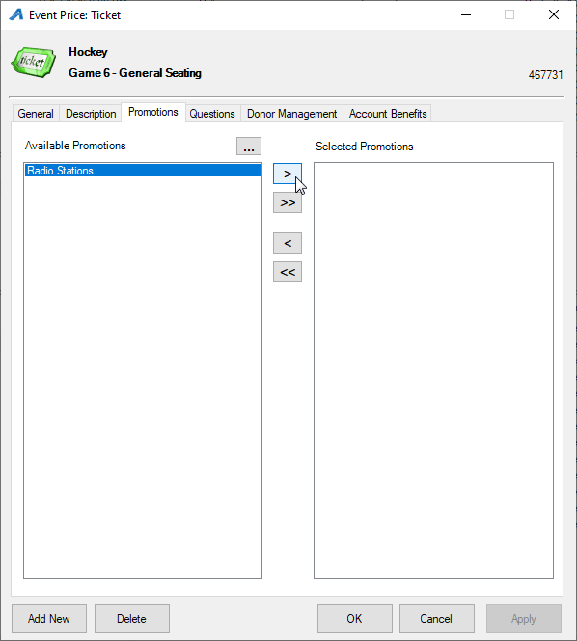
14. Once the promotion code is in the Selected Promotions columns, select Apply to save your changes to the price and click OK to close the window.

15. Your code is now ready for use on that particular ticket price. Repeat Steps 10 through 14 to add the code to multiple ticket prices. (For instance, if you wanted the promotion code to be available both online and at the box office, then you would need to add the code to ticket prices on both the Web Online and AMS Box Office Sales Channels.)

