Selling a New Membership in POS
1. Login to Agile Ticketing Solutions. If you have not received your user credentials, please contact your system administrator to set up your username and password.
2. Make sure that you are cashed in before starting sales for the day. See "How to Cash In Using POS" for further instructions.
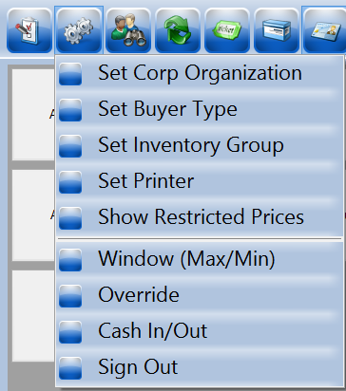
3. You will need to set a buyer type before you can start processing sales for the day. To do so, click Action (the gears icon) at the top of the screen and select Set Buyer Type. A screen will appear where you can choose the buyer type.
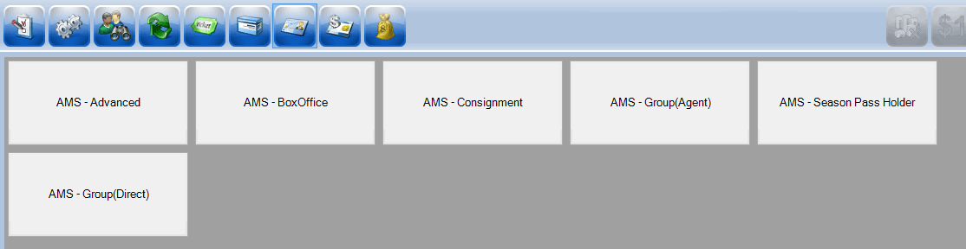
NOTE: If your company has multiple organizations, you will need to select which one you are working with before you can select the buyer type.
4. Select AMS - Advance, AMS-Membership, or another equivalent buyer type.
5. Click the Customer icon to search for a customer account.
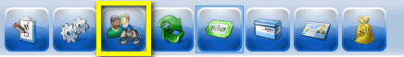
Search by name or member number to pull up a customer’s account. A list of customer records will appear. Double-click the customer's record if their name appears in the list.
NOTE: If a Customer is a member, their member number and membership type will appear below their name.
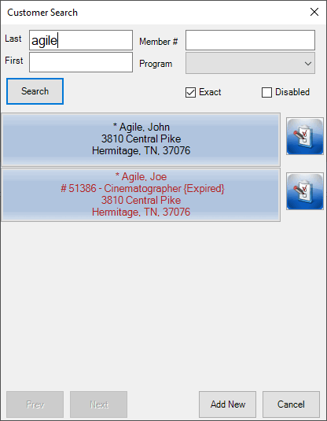

6. If the customer does not have a customer account, you will need to create a new customer account by clicking Add New.
7. Once you click Add New, the Quick Add Customer window will appear. Fill in the customer’s information and select OK.
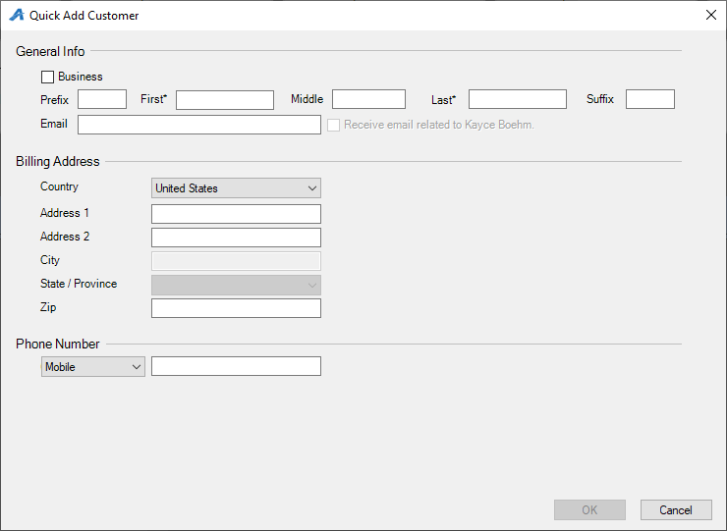
NOTE: You will know you are in a customer’s account when you see their name listed in the lower-right corner.
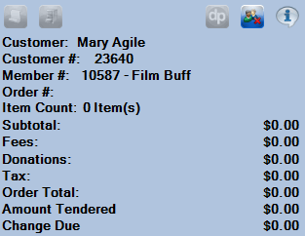
8. Once you are in the customer’s account, select the Membership icon in the upper portion of the screen. Then, choose the correct membership program from the list below.
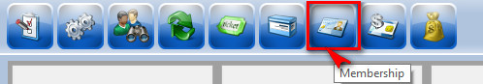
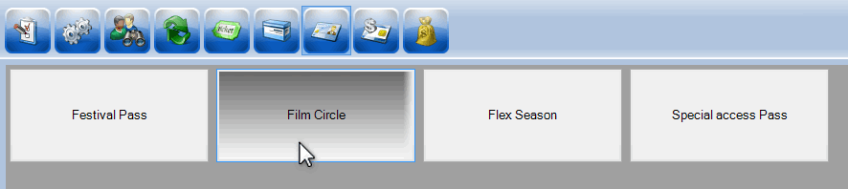

9. Once you select the membership program, membership types will be listed below the membership program. Select the membership type you want to add to a customer’s account.
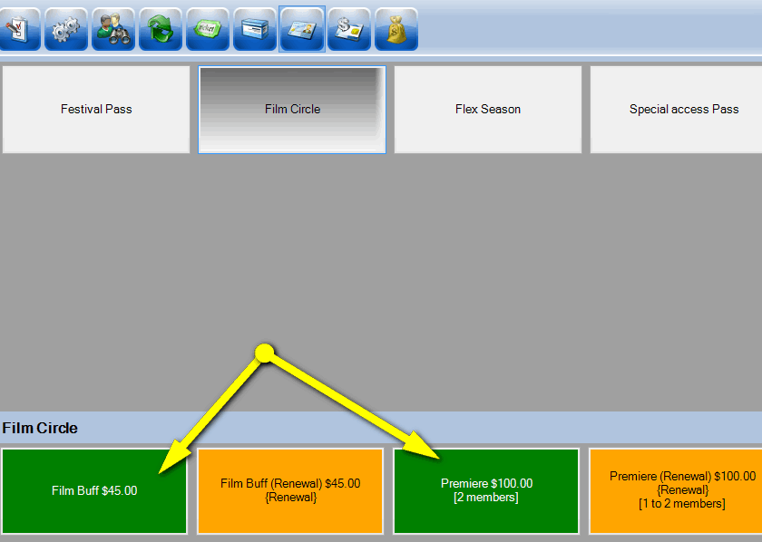
NOTE: If you are adding a membership for the first time, make sure not to select a membership category with renewal in the price name (See instructions on “How to Renew a Membership on POS”).
10. A window asking you to assign the membership to a member’s name will appear. Select the correct name and click OK.
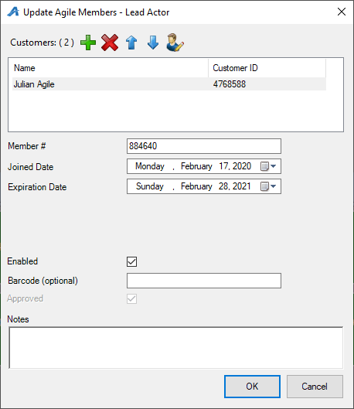
Image 5.
NOTE: Some memberships allow more than one person to be assigned to it. Make sure to click the green plus sign to add a second customer to those memberships that allow multiple members.
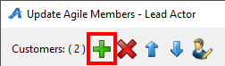
Image 5.1

11. To make sure the order is correct, view the Item Summary section at the right side of the screen.
12. Once an order has been confirmed, click the Enter Payment icon.
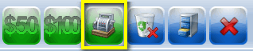
13. A screen asking you to change the delivery method will appear. Select the desired method of delivery and click OK.
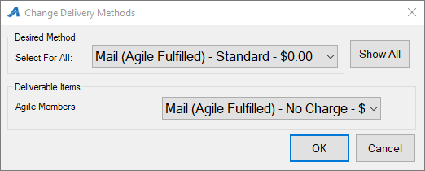
14. Another screen asking you to choose the method of payment will appear. Select the payment type that corresponds to how the customer wishes to pay (e.g. Cash, MasterCard, Visa, Gift Card, etc.).
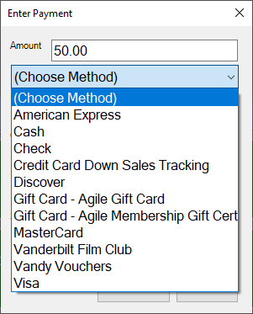
NOTE: At this point, if you have a USB Credit Card swipe attached to your terminal, you can swipe the credit card. All credit card information will automatically populate and finalize the order.
15. Click Proceed to complete the order.
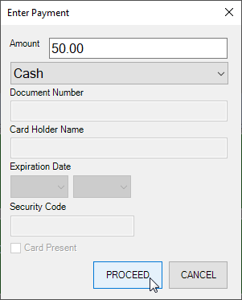
16. You will know the order is complete when Last Order appears at the top of the window in the lower-right corner and the window turns yellow.
