Reset a Password in Administration
Any Administrator of an organization can easily reset passwords for other users in that organization.
1. Log In to Administration.
2. Select the Security folder.
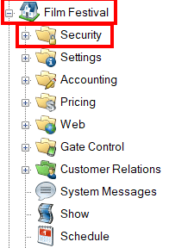
3.Click the Users icon.
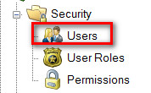
4. Find the existing User from the list of usernames.
5. Right-click the User and select Set Password.
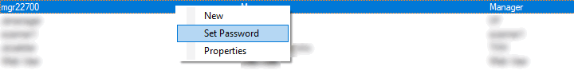

6. Create the New Password and Confirm Password.
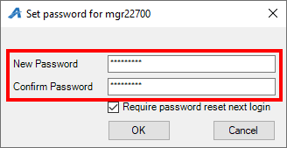
7. If you are setting a Temporary Password for this User, make sure to check Require Password Reset Next Login. This will require the User to create a new password when they first log in to the system.
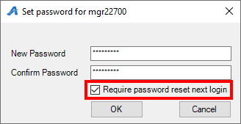
8. Once completed, click OK.
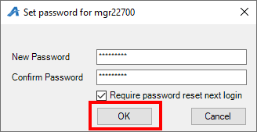
NOTE: Make sure that the password is at least eight characters long and includes one uppercase letter and one numeric character. Users will be required to change their password every 90 days.

