Adding a New Customer Record in POS
1. Click the Customer Search Icon.
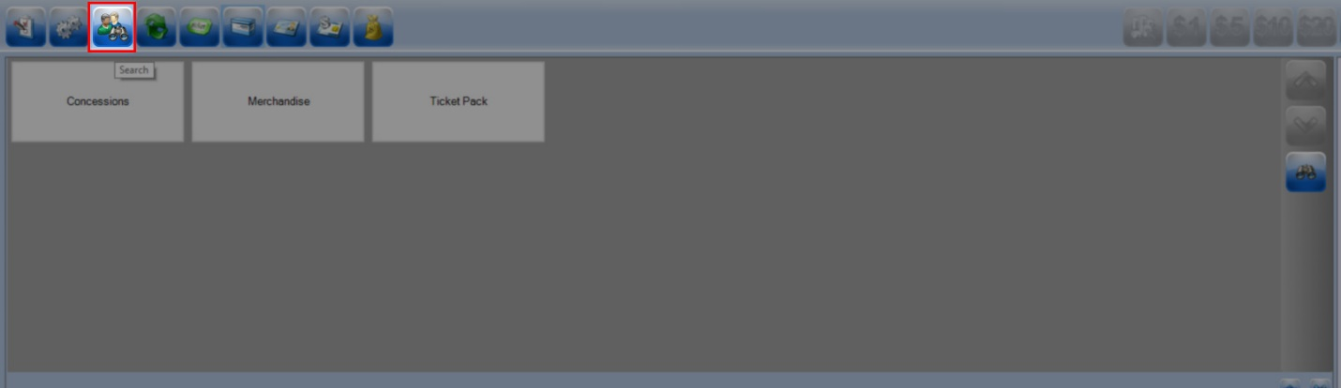

2. Enter the customer's Last Name and First Name, and then click Search to make sure that the customer is not already in the system.
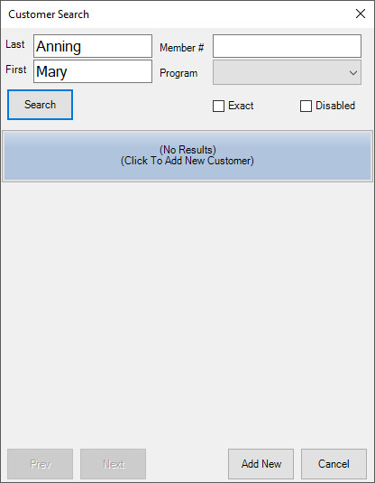
3. If the customer is not in the system, click the Add New button at the bottom of the Customer Search window.
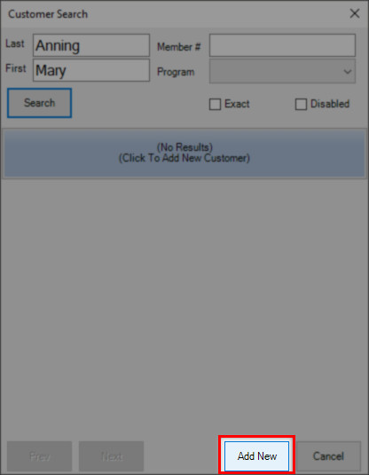

4. Enter the customer's first and last name. We suggest that you capture as much customer information as you can. This includes email, billing address, and a phone number.
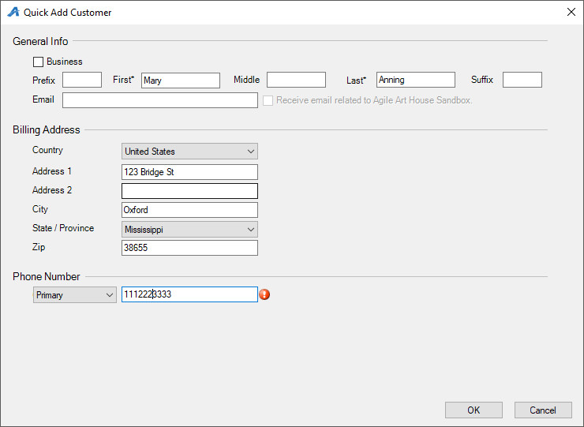

5. Click OK to save the customer's information. You are now ready to process that customer's order.

