Selling a Gift Card using POS
- Login to Agile Sales with your username and password. If you have not received your username and password, please contact your system administrator to set up your login credentials. Make sure that you are cashed in before starting sales for the day. See "How to Cash In Using POS" for further instructions.
- You will need to set the buyer type before you start processing sales for the day. To do so, click the Action (Gears) icon at the top of the screen and select “Set Buyer Type." A screen will appear where you can choose the buyer type.
NOTE: If your company has multiple corporate organizations in Agile, you will need to select the proper one from Set Corp Organization before you can select a buyer type.
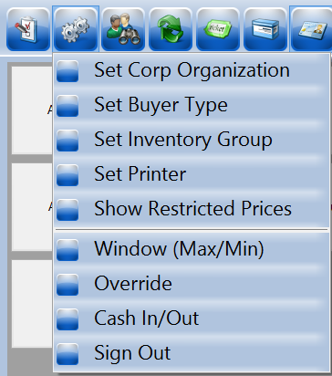
- Select "AMS - Box Office."
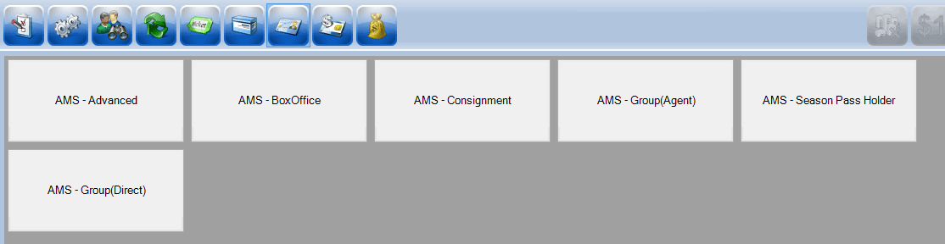
- Click the Gift Card button in the upper portion of the screen. Then, select the proper gift card program.
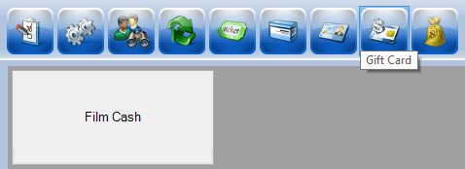
- You can either choose a preset amount or select "Enter Amount" if the customer is wanting a different amount added to the card.
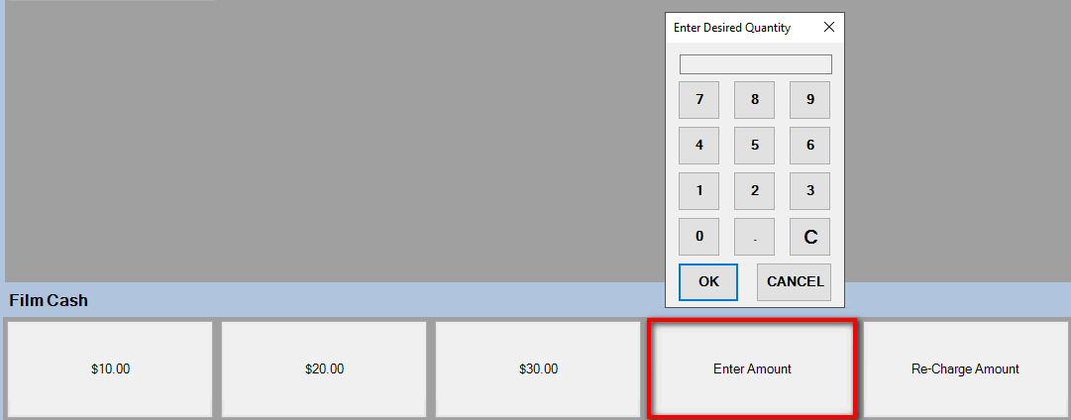
NOTE: If the customer already has a card, they can recharge the card's balance. Click the "Re-Charge Amount" button to add a new balance to the existing card.
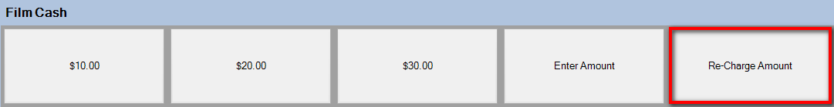
- Once you have selected an amount, the Gift Card Lookup prompt will appear. Swipe the gift card. After the gift card number populates on the screen, click Assign to add the balance to the card.
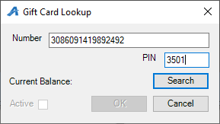
- To confirm an order, view the Item Summary section at the right side of the screen to make sure the order is correct.
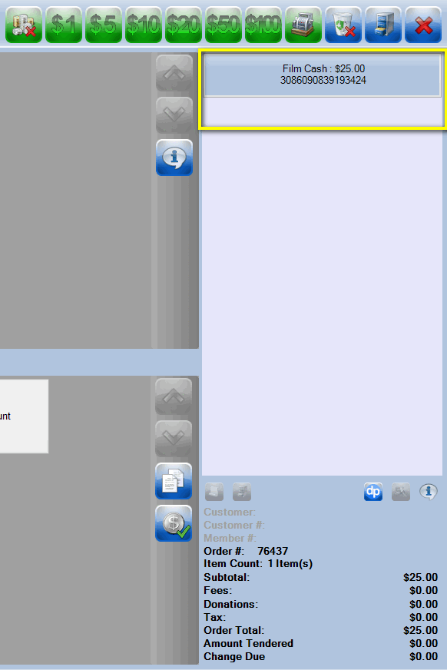
- Once an order has been confirmed, click the Enter Payment icon.
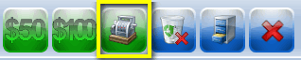
- A new window will ask you to change the delivery method. Select the desired method of delivery and click OK.
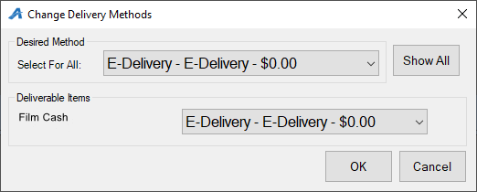

- Another screen will ask you to choose the method of payment. Select the payment type that corresponds with how the customer wishes to pay (Cash, MasterCard, Visa, Gift Card, etc.).
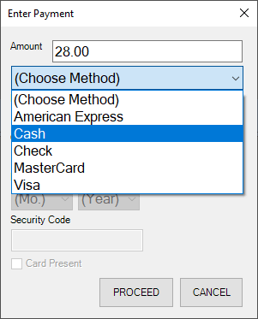
NOTE: At this point, if you have a USB Credit Card swipe attached to your terminal, you can swipe the credit card. All credit card information will populate and automatically finalize the order.
- Click Proceed to complete the order.
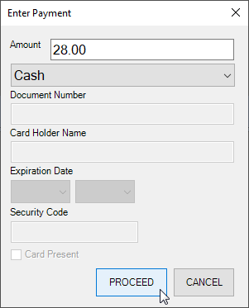
- You will know the order is complete when the window in the lower-right corner turns yellow and says “Last Order” at the top of that window.
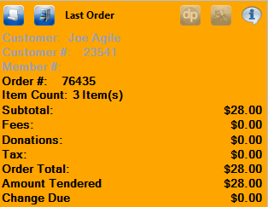
NOTE: The above information allows you to sell a gift card without capturing customer information. We recommend capturing customer information whenever possible, but it is not necessary. To assign the gift card to a customer record, select the Customer icon at the top of the POS screen. Either search for an existing customer or click "Add New."
- If a customer already has a gift card and wants to know how much money is on it, you can go to the Gift Card Program and then click the Check Balance icon to the right of the dollar amounts.
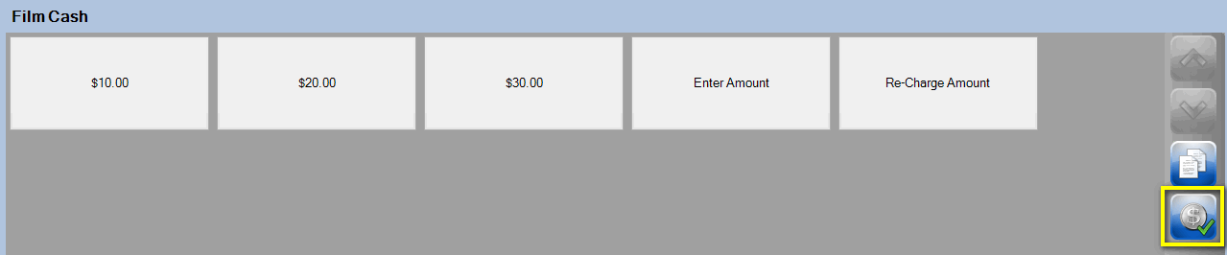
- When you click the Check Balance icon, the Gift Card Lookup window will appear. Swipe or manually enter the card number. Click Search, and the balance will appear on the screen.
