Recharge A Gift Card
- In Sales click the Gift Card tab.
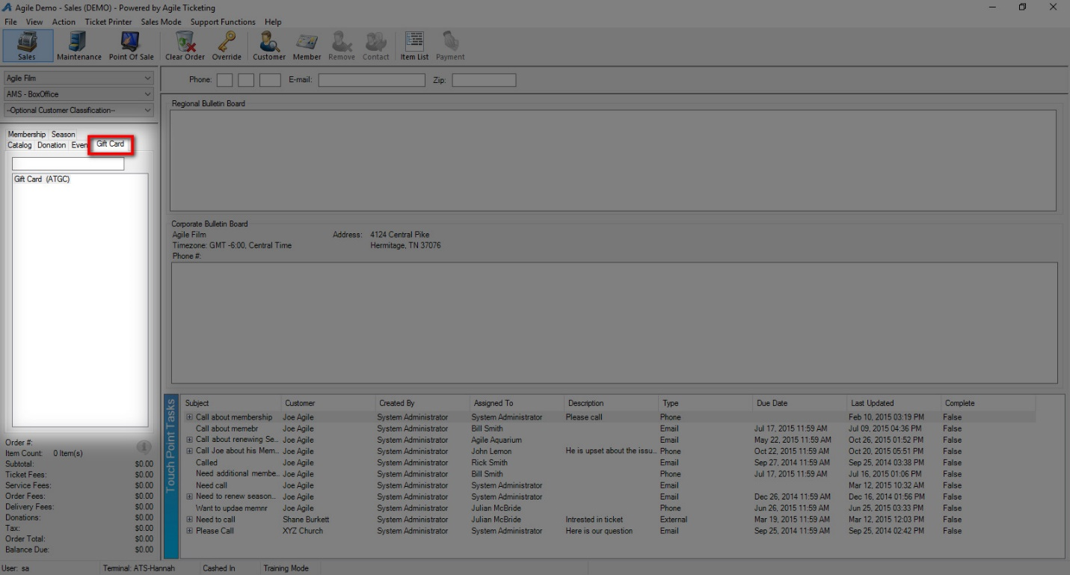

- Select your Gift Card Program.

- In the Recharge Amount area, enter the monetary amount to be placed on the card.
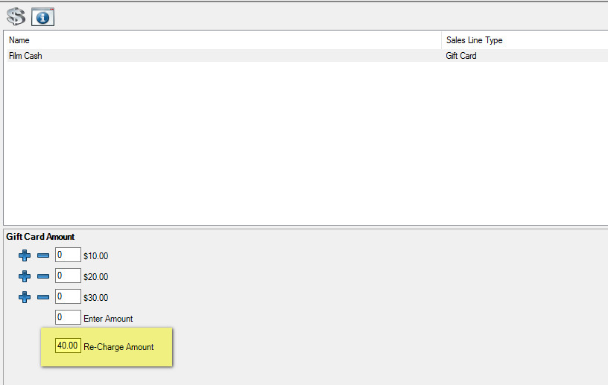
- Click Add in the bottom corner.
- A pop-up will appear. Swipe the card or enter the gift card number. Click Ok. 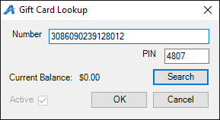

- Confirm the amount on the Item Summary page. If everything looks correct, click Proceed.
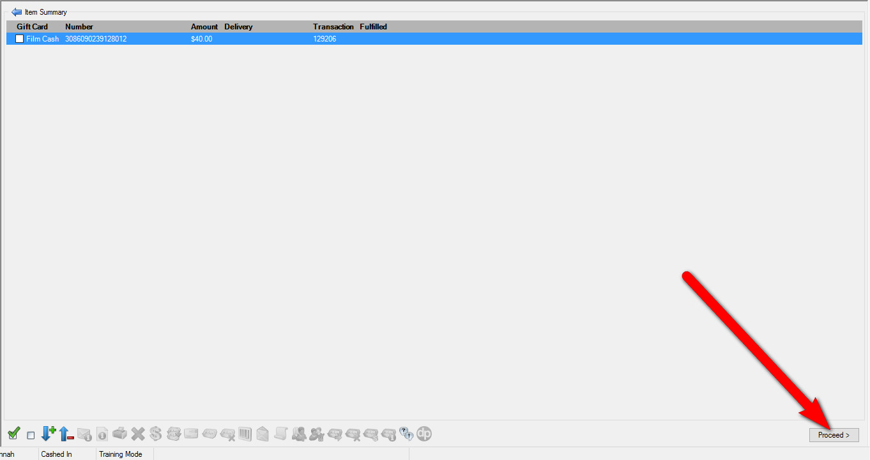

- In the Payment Screen, process the payment and click Apply Payment.
