Gift Card Bulk Fulfillment
Clients that sell their Gift Cards online can process the cards through bulk fulfillment to fulfill these cards. Follow the steps below:
Fulfillment to Assign the Amount to Gift Cards
1. Log into Agile and Cash In.
2. At the top of the screen, click Support Functions/Fulfillment/Gift Cards.
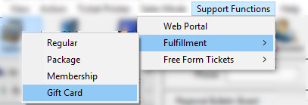
3. In the Gift Card Fulfillment window, select the Gift Card program that is listed (i.e Agile Art House Gift Card, etc.).
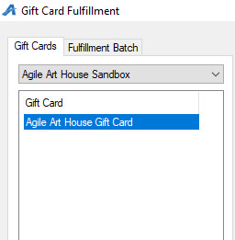

4. You will see a list of orders that need to be fulfilled. Checkmark the order(s) you wish to fulfill.
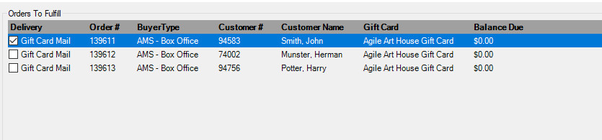
5. Click the Ticket Icon at the bottom of the screen.

6. In the Fulfillment Options window:
* Uncheck the Print Payment Receipts
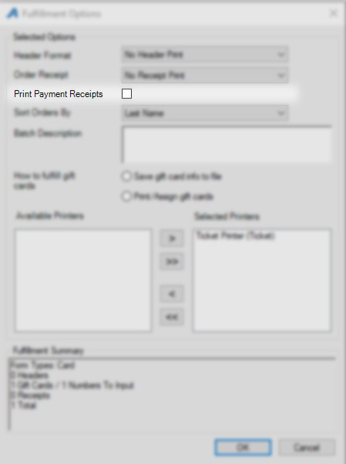
* Select the Print/Assign gift cards Radio Button
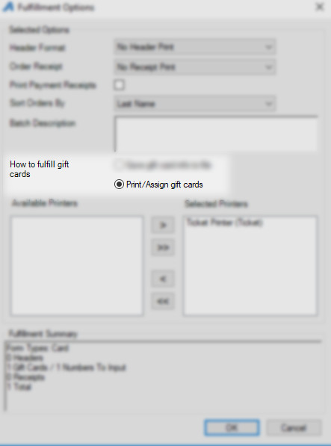
* Make sure that the "Faux Printer" is in the Selected Printers column.
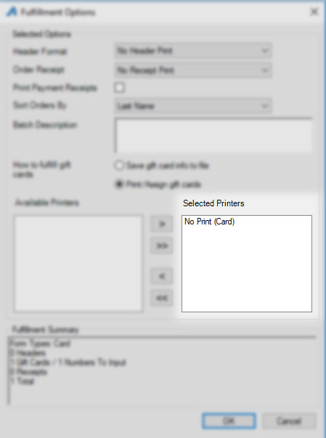
* Click on OK to start the fulfillment process.

7. The Fulfillment Progress window will appear, and then the Gift Card Lookup window will appear.
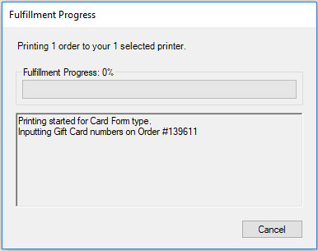
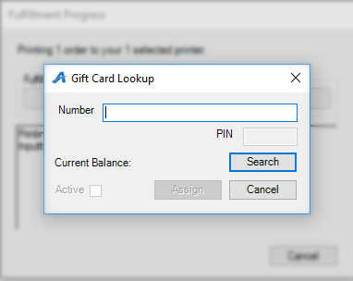

8. Enter the Gift Card Number to assign the amount the customer has purchased. You can manually enter the number, or, if you have a credit card swipe attached to your computer, you can swipe the card. Click Search to find the PIN and then click Assign to add the amount to the card.
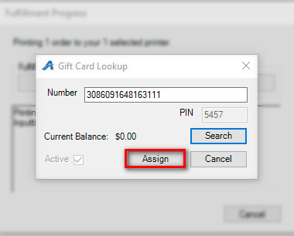

9. Click on OK to complete the Fulfillment process.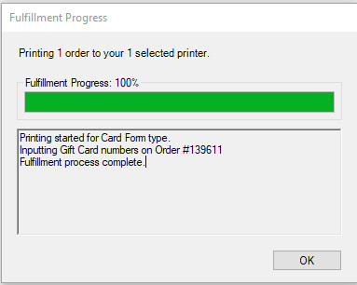
Printing the Gift Card Letters for Mailing
1. Switch to Administration in Agile.
2. Open the House Icon to see all the folders in the organization tree.
3. Click the Green Customer Relations folder.
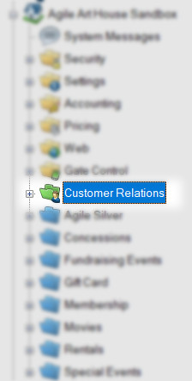

4. Select Emails and Letters.
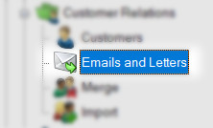
5. Right-click on Gift Card Fulfillment Letter, and select Properties.
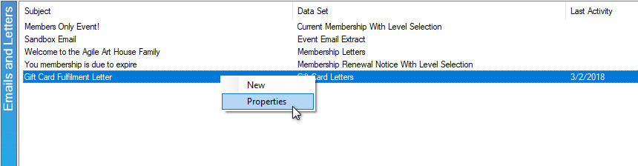
6. Click the Set Parameters button.
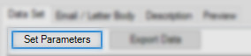

7. In the Variables tab, select the Fulfillment batch that you just printed from the drop-down and select OK.
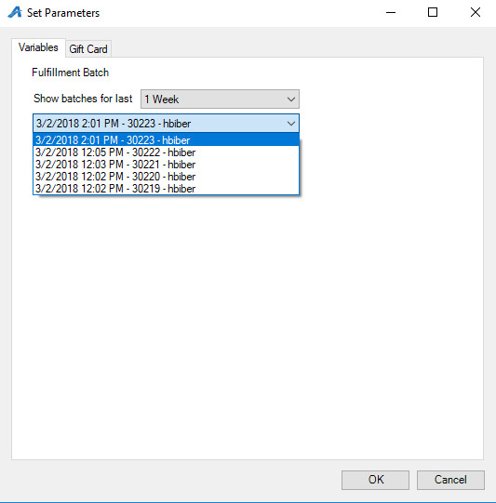

8. The orders you just printed will appear in the Data Set window.
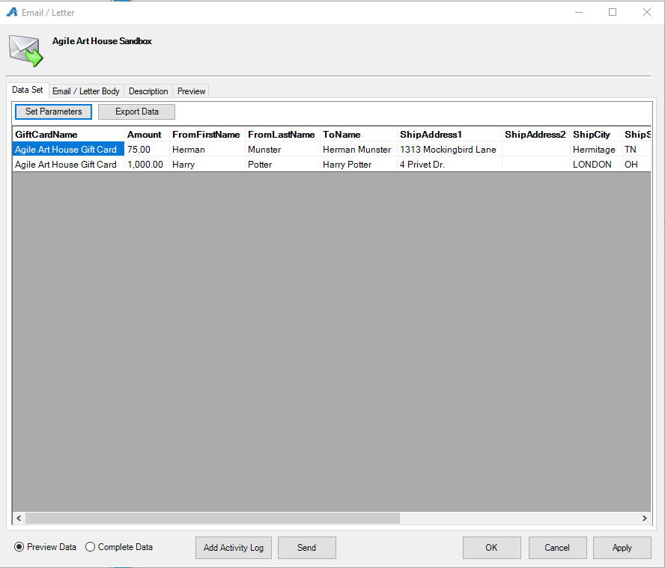
9. Click the Preview tab.
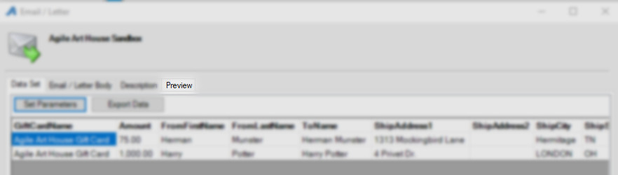

10. At the bottom of this window, click the Show All button, and then click Print.
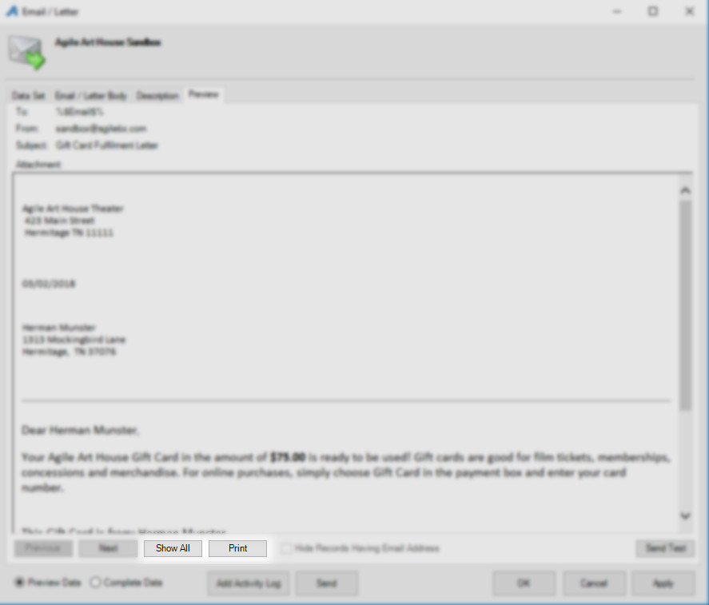

11. A CRM Activity Log window will appear. Click Yes so that the activity log will be saved for when you printed these letters.
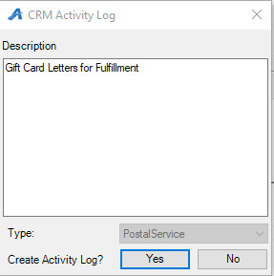

12. The Print Preview window will open.
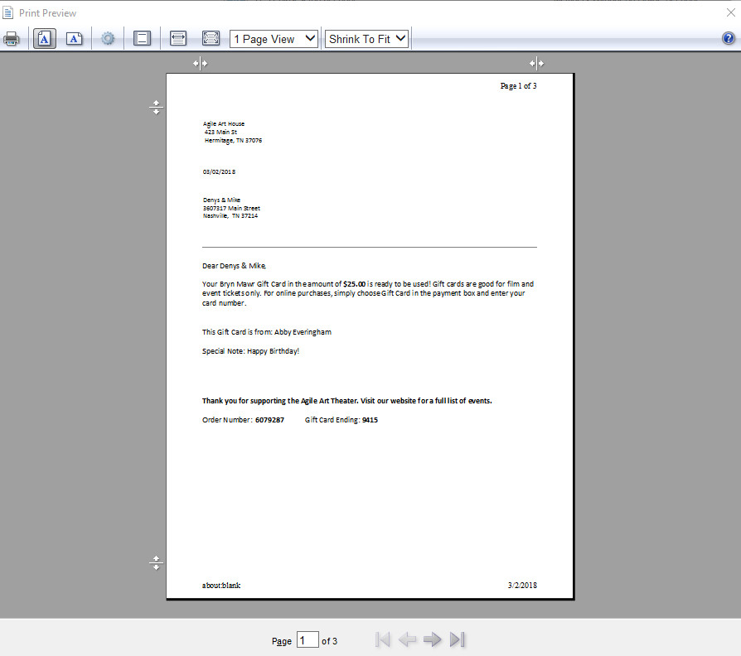
13. In the menu at the top of the screen, click the middle icon to turn the headers and footers off.
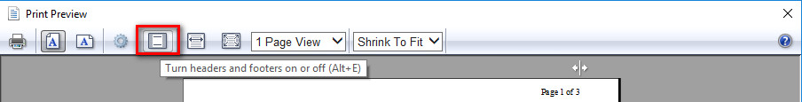

14. You can click the arrows at the bottom of the window to scroll through each letter, if there is more than one letter.
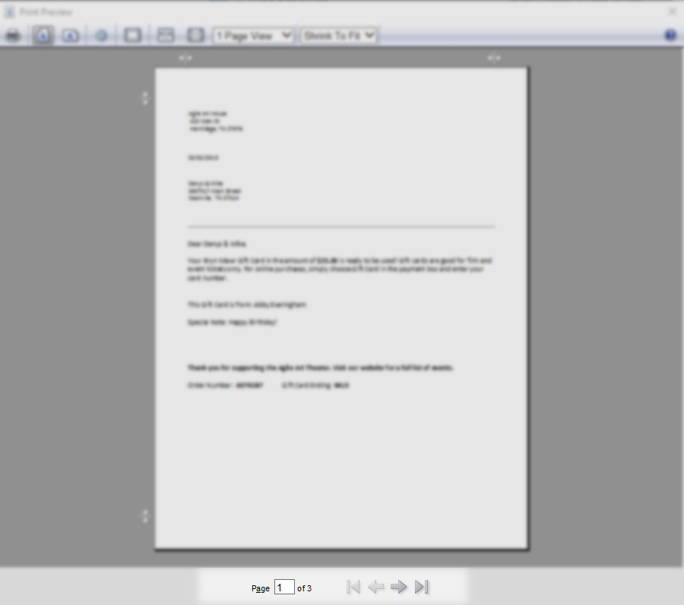

15. Click the Printer Icon from the menu at the top of the window when you are ready to print the letters.
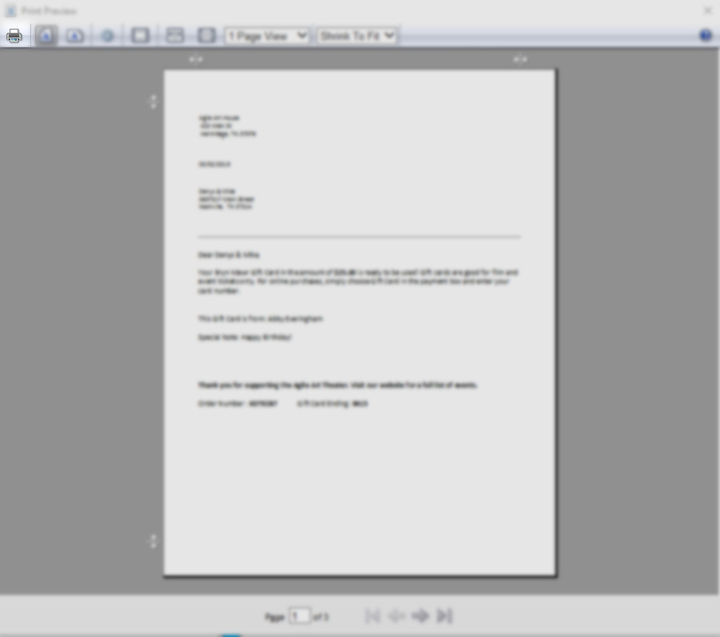

16. Once completed, click OK to close the letter window.

