Create An Agile List: Catalog Entry Point
1. Log into Administration.
2. Select the House Icon .
3. Open the Web folder.
4. Select the Entry Points icon.
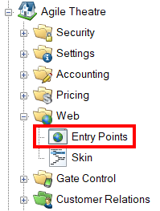
5. Highlight and select the Entry Point Group where you will create the URL.
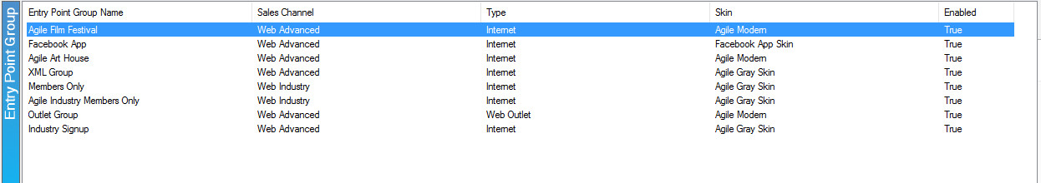
6. In the Entry Point field, right-click. Select New, Agile List, and Catalog.
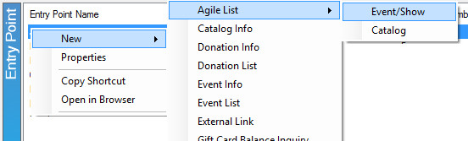

7. Fill out the following areas on the General tab (not all will be applicable to your needs):
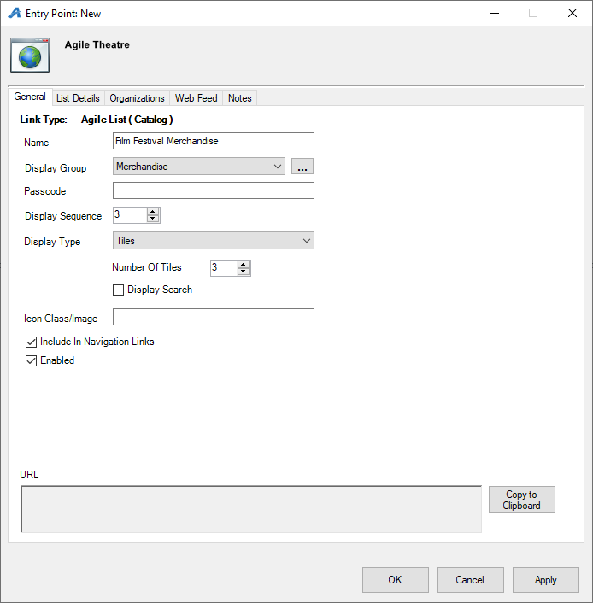
- Name the URL (This will show up in your navigation menu).
- You can select or create a Display Group if you want it to be a part of a specific group on your navigation menu.
- Add a Passcode only if you need the URL to only be available to users who enter the passcode. Leave Passcode blank if the URL can be accessed by the general public.
- Display Sequence sorts what order this page will appear in online.
- Display Type determines how catalog items are viewed online.
- Display Search will add a search bar to the page.
8. The List Details tab gives you control over what pieces of information are listed about each item. Check the boxes on the left-hand side to enable. Filters allow the customer to sort the listings online by Custom Property (click here to learn more about Custom Properties). To enable these, select the filter(s) needed from the drop-down menu and select the green plus button.
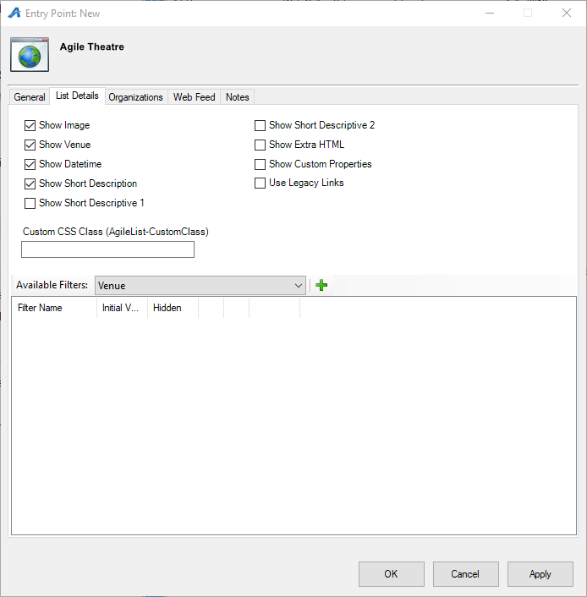

9. The Organizations tab determines which sales folder(s) appear in the list online. (Note: this may need to be updated yearly.)
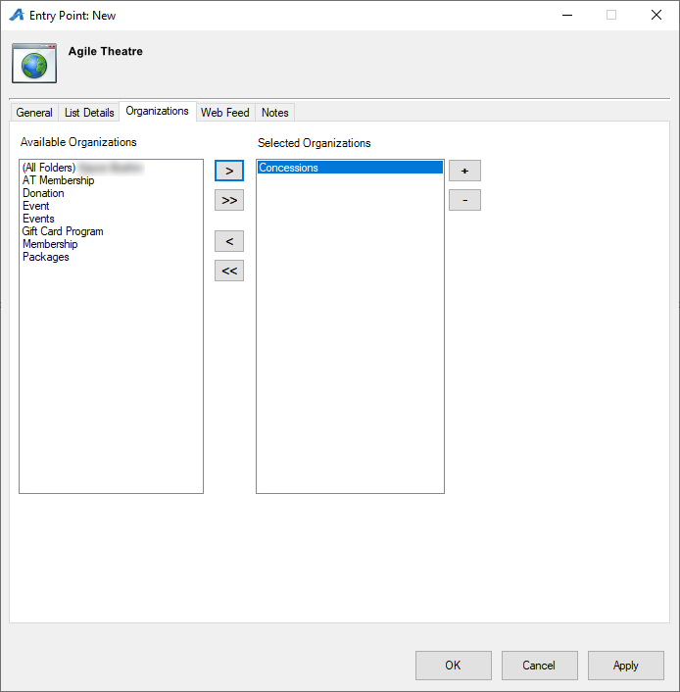

10. The Web Feed tab provides the XML Feed for your organization's website if you choose to use XML Feeds instead of Agile pages.
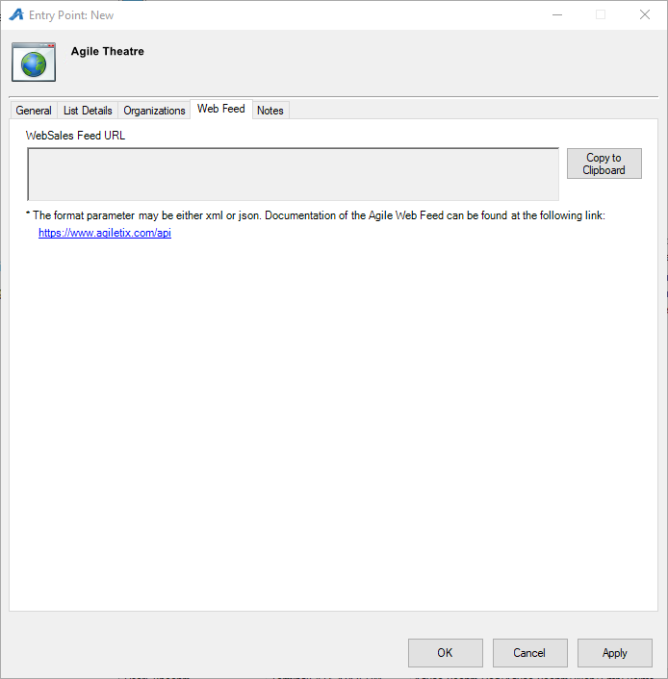

11. The Notes tab is for internal use only. We recommend adding details here about how this URL will be used.
