Searching and Filtering in Bulk Fulfillment
1. Log into Sales
2. Click on Support Functions, Fulfillment, and Regular
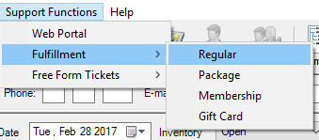
3. This will take you to the Bulk Fulfillment area. Click on Will Call from the Delivery Methods section on the left.
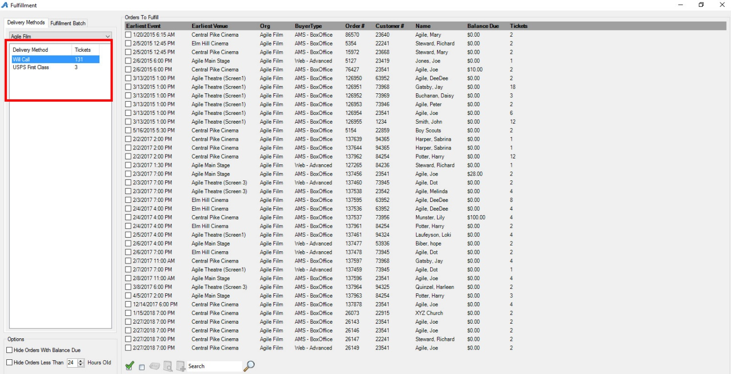
4. In order to search for an individual person, enter the Name of the Person in the Search field at the bottom of the screen. This will then pull all of the Customer Orders for anyone with that Name. Select the Order(s) you wish to print.
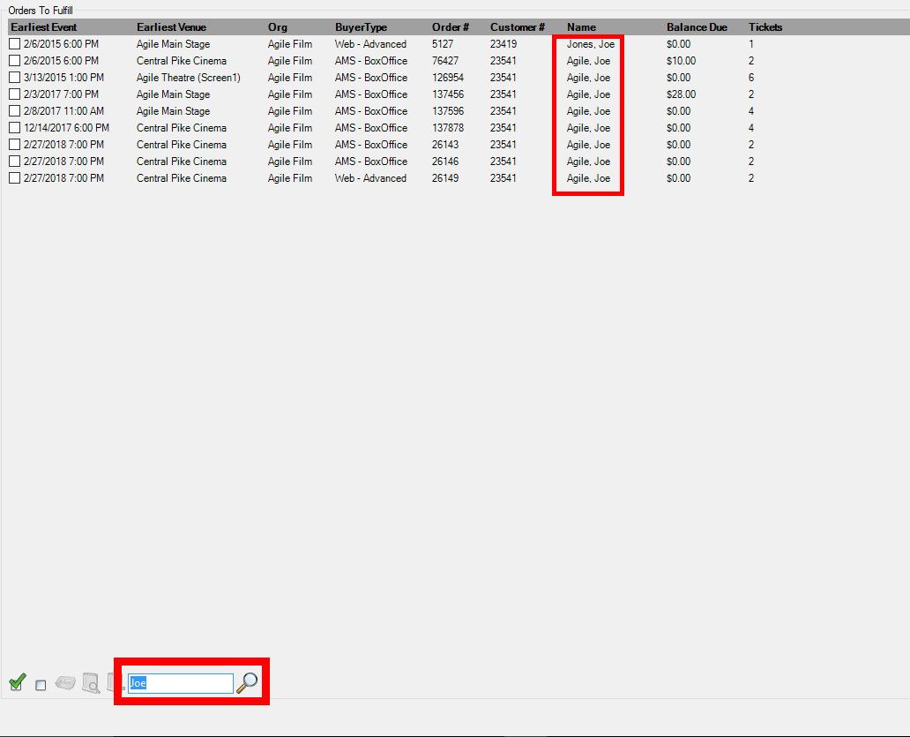
5. You can Filter columns to show only the specific orders/items you wish to print. Choose the column header you wish to Filter and click on the up/down arrow. Choose the filter parameters you wish to see. (i.e. event, venue, org, buyer type, order number, confirmation number, name).
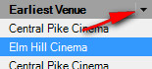
6. From here you can deselect information and narrow your search field.
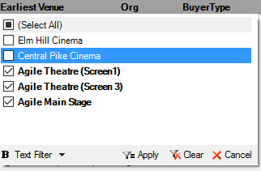
7. Select Apply to set your filter perimeters.
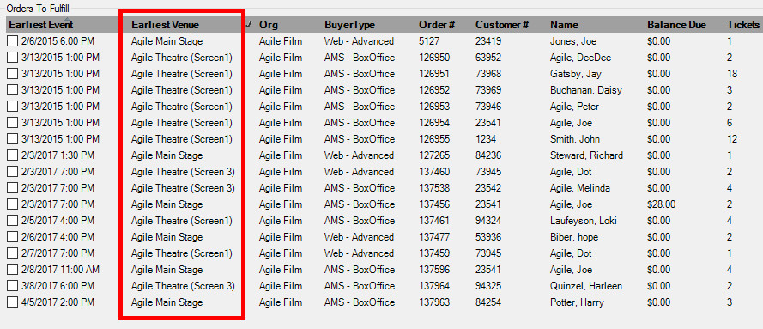
8. You are now ready to print the filtered or selected items in the fulfillment queue.

