How To Set Up A Gift Membership Program

Gift Membership is a way for customers to purchase a membership as a gift. We use the Gift Certificate/Card feature to create this internal gift program. We recommend adding this to your existing Membership Sales Organization (Blue Folder) in Administration.
*NOTE: Gift Memberships do not automatically process into an actual Membership. It is just a payment method that one of your staff from your organization will need to use when processing the actual Membership for the person who will receive the membership card as a gift.
1. In the Membership sales organization folder, select the Gift Card Program. Right click in the Gift Card Program field and select New.
2. To create your Gift Membership Sales Line Type, click the ellipsis button and enter "Gift Membership" as the name of the Sales Line Type.
3. Create an account for this program to be reported to (i.e. Gift Membership Program).
4. Create the name of the program and place it in the Gift Card Program Name field as well as the Internal Name field.
5. Production Type must be set as Internal gift program.
6. Project Code should also be set up as Gift Memberships.

7. In the Suggested Amounts field, enter the total amounts of your membership prices that you wish to be available for gifting.
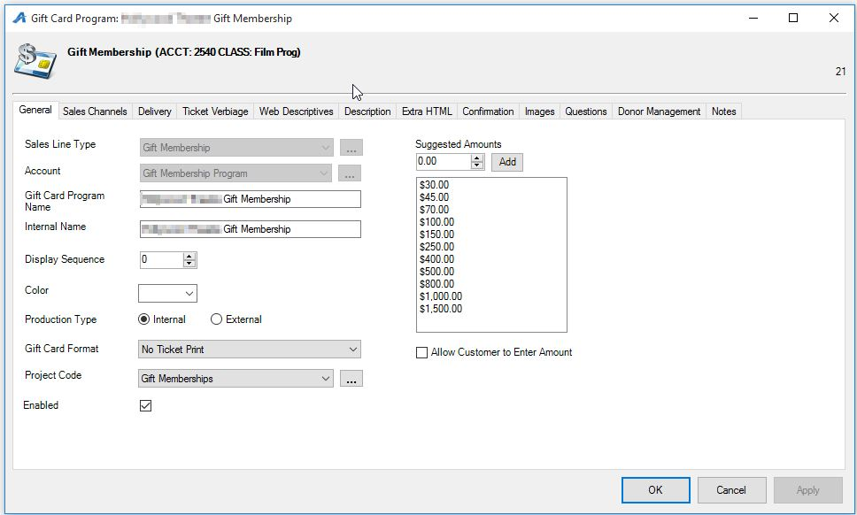

8. Set the program on sale by clicking the Sales Channels tab, and select the options that are available to your customers. Make sure to set both the on-sale Start Date and the End Date.
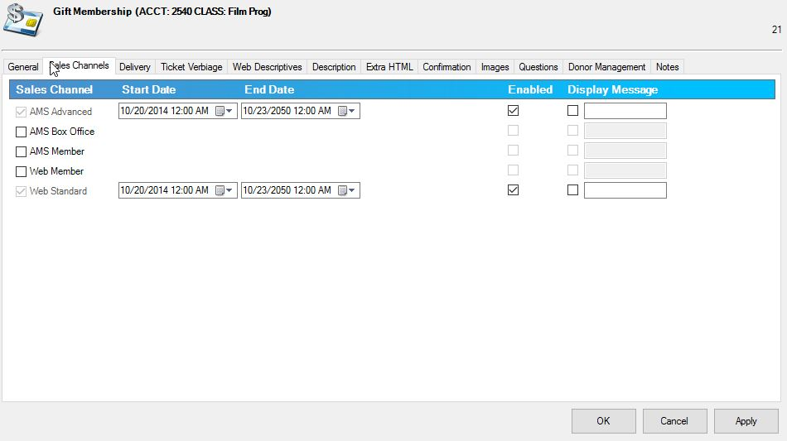

9. Click on the Delivery tab and move Email Confirmation to the Selected Delivery Methods column. This will send the purchaser (person giving the gift) a detailed email confirming the order.
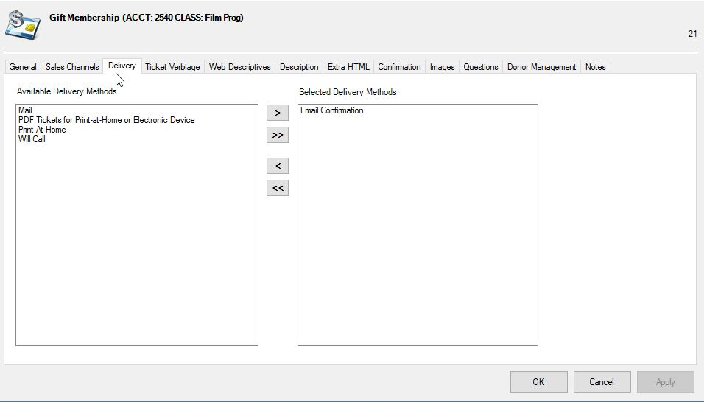
10. Click the Descriptions & Confirmation tabs to include text if applicable.
11. Click the Questions tab to set up and apply the series of Questions that will be used to get the information about the person receiving the Gift Membership.
NOTE: These must be set up to gather information about the person receiving this membership and allow your staff to process the appropriate membership type and level. See the image below for the questions that we recommend that you use. To create these questions, click the Ellipsis button. For more information on how to create questions, see Creating Order Questions.
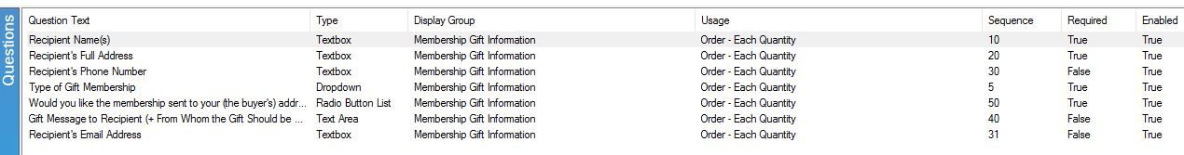
12. Once you have created your questions, add them to the Selected Questions column.
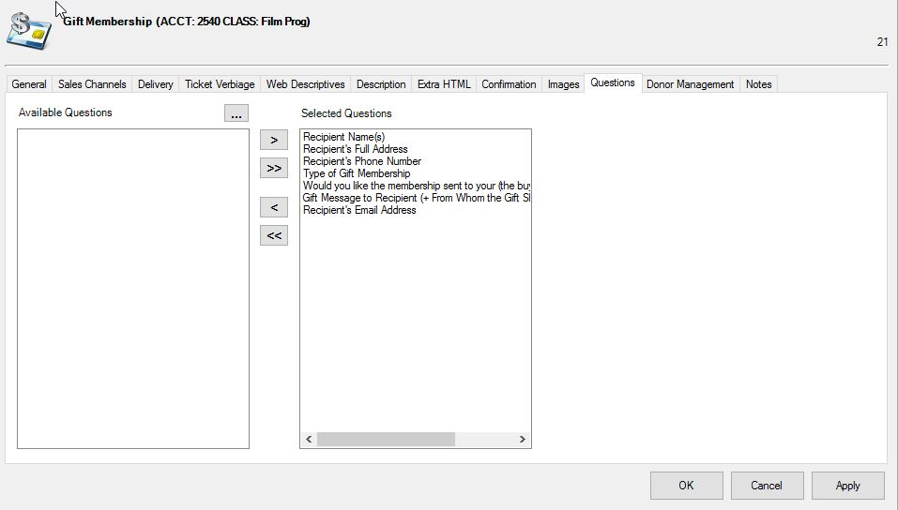
For information on how to process the orders, see the How to Process/Sell Gift Memberships.

