Generating Random Promotion Codes
1. Log into Administration.
2. Click the House icon and select the Blue Folder where you wish to create your Promotion Codes.
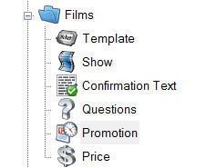
3. Click the Promotion icon.
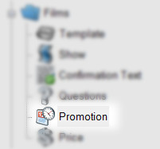
4. Right-click in the Promotion window and select New.

5. In the General tab, add the Name of your Promotion and set a Start and End Date for when this promotion will be available.
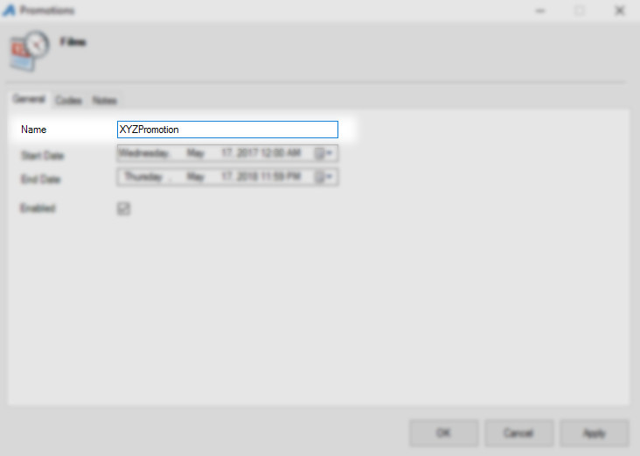

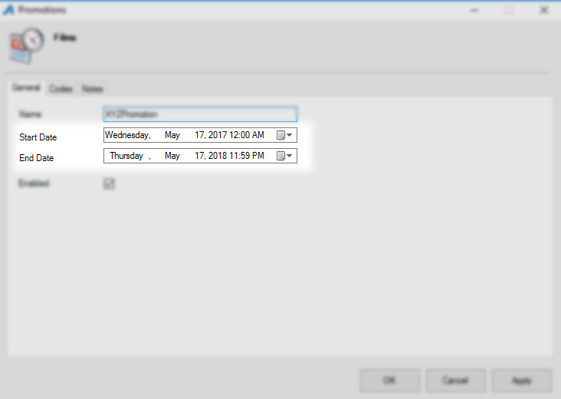

6. Next, go to the Codes tab.
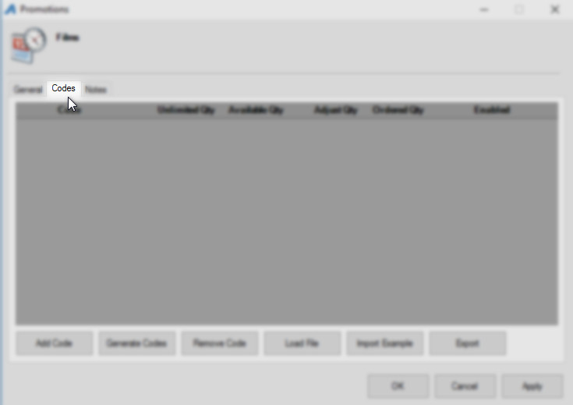
7. Click the Generate Codes button at the bottom of the screen.
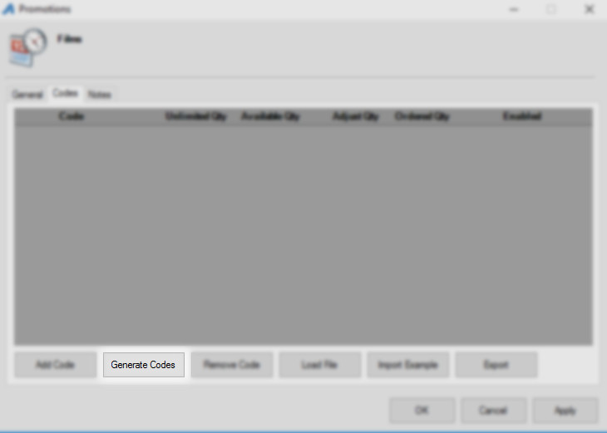
8. Enter the Number of Codes you want to generate.
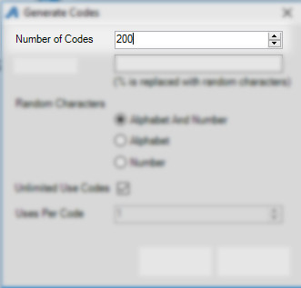
9. In the Code Format, you will create what you want your code to look like (i.e. SponsorPromo %). If you do not put in any format, a code will be generated made up of 5 characters.
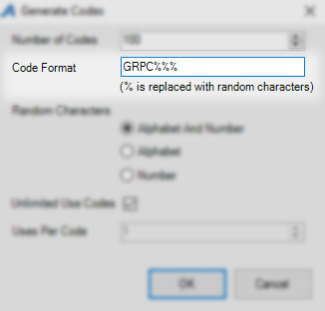

10. Select the radio button next to the type of Random Characters you would like to generate. You can have it generate a combination of Alphabet and Numbers, just Alphabet characters, or just Number characters.
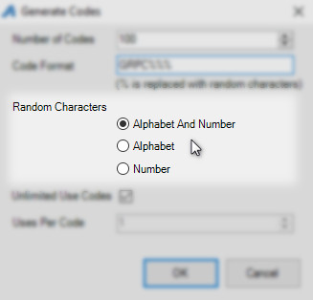
11. Uncheck Unlimited Use Codes if you want to put a restriction on the number of times the code can be used. Make sure to enter the Uses Per Code if you are restricting the number of times the code can be used. If the Code(s) have no restrictions, then make sure that the box next to Unlimited Use Codes is checked.
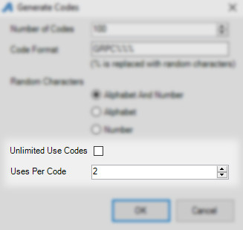
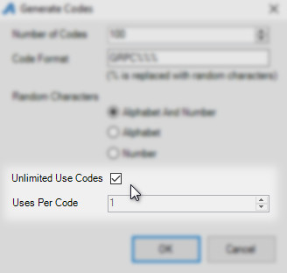
12. Once everything has been completed, click OK.
13. You should see your generated codes appear in the Codes window. You can edit your codes directly from this window. Click the Export button to generate a spreadsheet of the codes and save it to your computer.
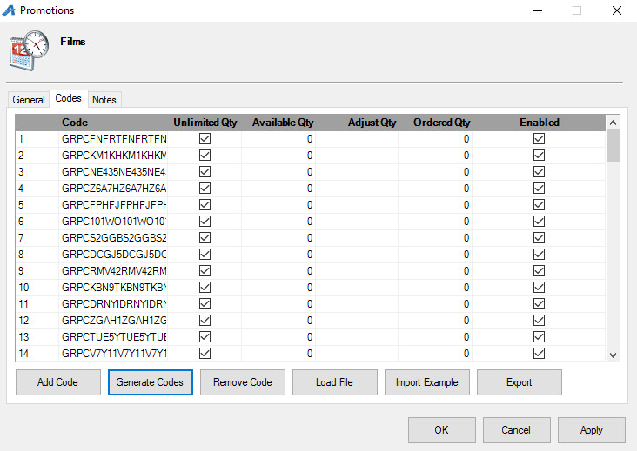
13. Click Apply and OK to save the codes.
