# How To Sell A Ticket Pack In AMS

**Want to learn more? Sign up today for our ATSU Learning Webinar:**[Everything You Need To Know About Ticket Packs and Customer Benefits.](http://prod1.agileticketing.net/websales/pages/info.aspx?evtinfo=145292~7578f108-cf35-4050-b14c-a88eebcdebe5&epguid=6c98ed01-c78b-4472-bfe3-2ec5430b8b7d&)

Selling ticket packs in AMS is easy, but there are a few steps that are required in order for the customer to be able to access the benefits online.

1. Log in to Sales in AMS.

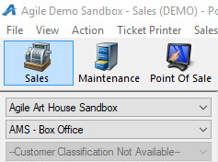

2. Select the Catalog tab, and then select the Program that your ticket pack is built under (i.e. Membership, Merchandise, etc.)

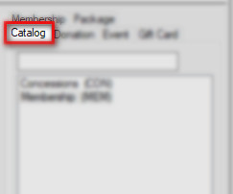

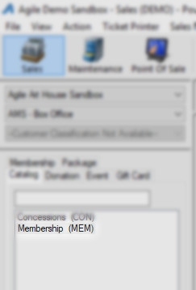

3. Choose the Ticket Pack that you wish to sell.

4. Before you process the order, click the Customer icon to search for the customer. If they are not an existing customer in the system, you**MUST** create a new Customer Record. You**MUST**include the customer's name and email address, as this is how the customer can access their ticket pack benefits online.

[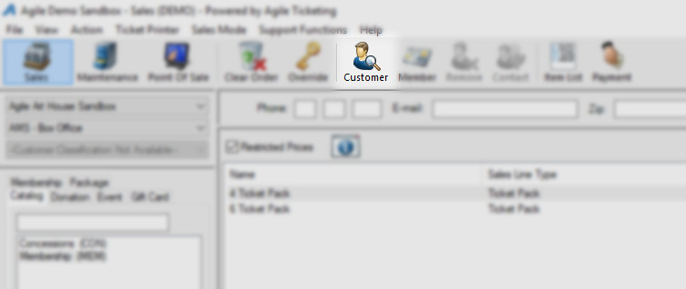](https://support.agiletix.com/hc/article_attachments/115014073303/TP4.jpg)

Search for Customer OR

[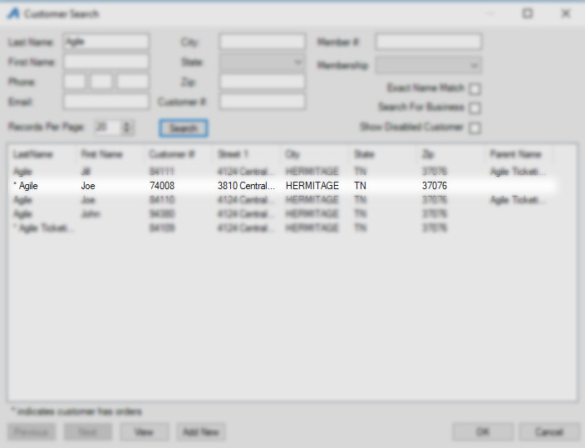](https://support.agiletix.com/hc/article_attachments/115014073283/TP5.jpg)

Create New Customer

[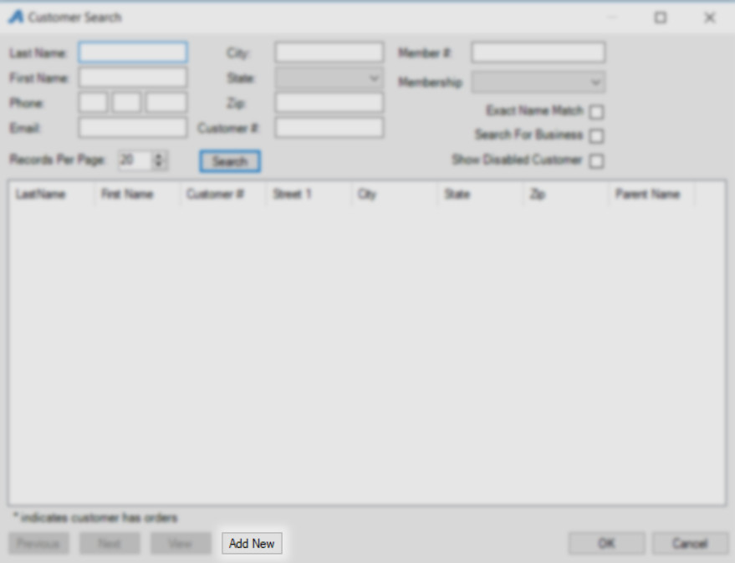](https://support.agiletix.com/hc/article_attachments/115014073263/TP6.jpg)

[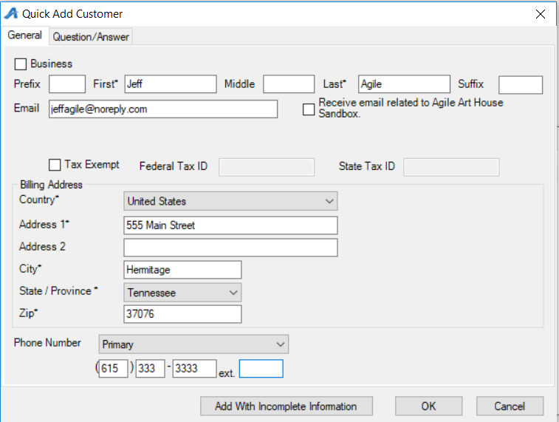](https://support.agiletix.com/hc/article_attachments/115014073243/TP7.jpg)

5. Enter the number of ticket packs that the customer is purchasing and click **Proceed**.

[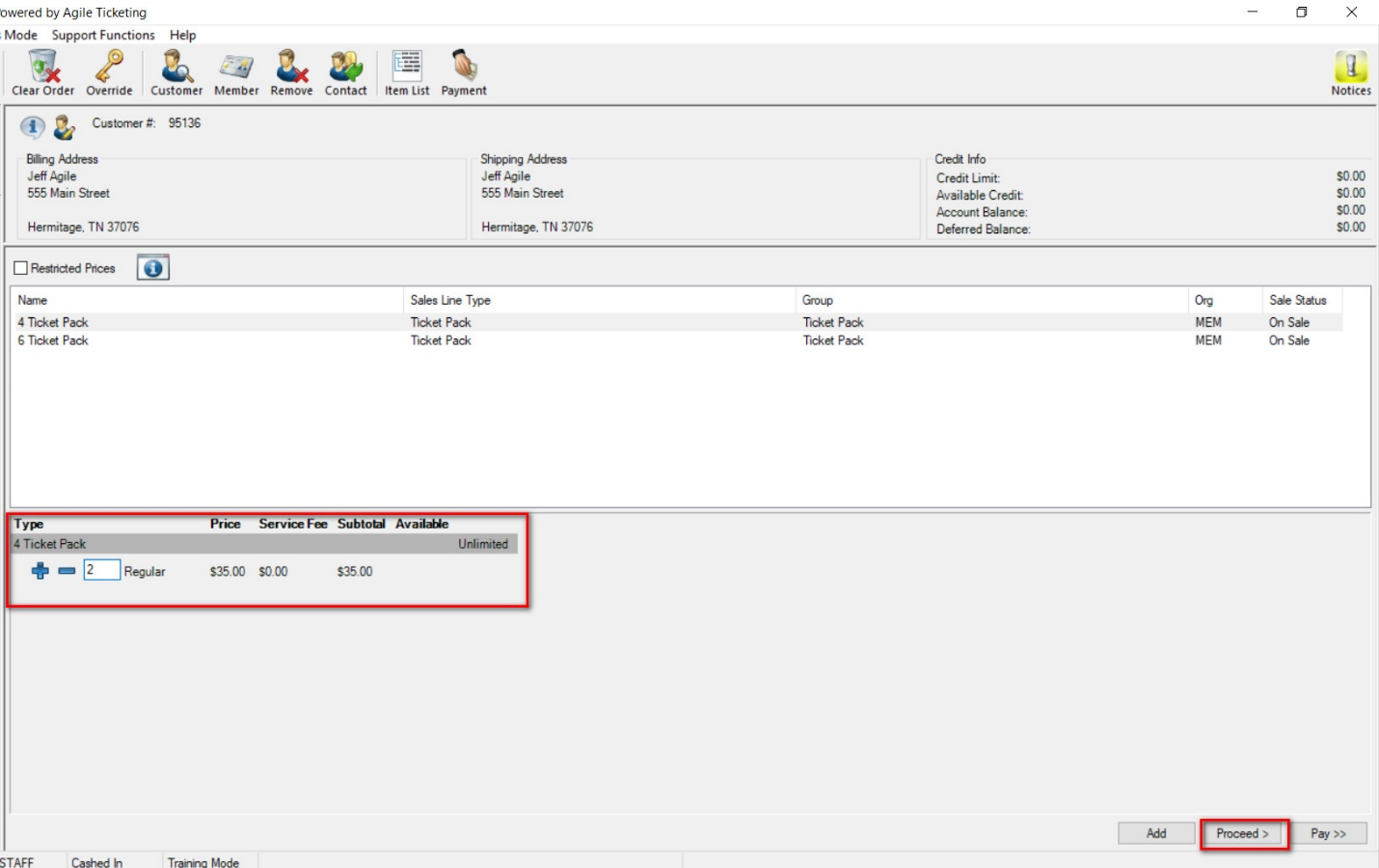](https://support.agiletix.com/hc/article_attachments/115014073223/TP8.jpg)

6. Take Payment and finalize the order.

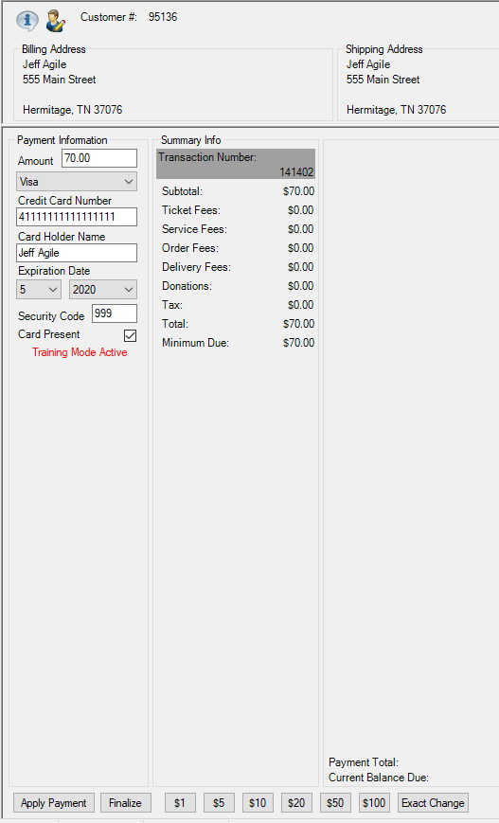

7. Once the order is complete, the customer will be able to access their ticket packs by logging in with their email address.

[**CLICK HERE**](https://support.agiletix.com/hc/en-us/articles/115003197146-How-to-Redeem-your-Ticket-Pack)to learn how to Redeem Ticket Packs.