Processing An Order Using A Gift Card

1. Add events, memberships, passes, and any other items to the customer's order and click the **Proceed** button. On the **Item Summary** screen, review the items the customer is wanting to purchase. If the order is correct, click **Proceed**.

[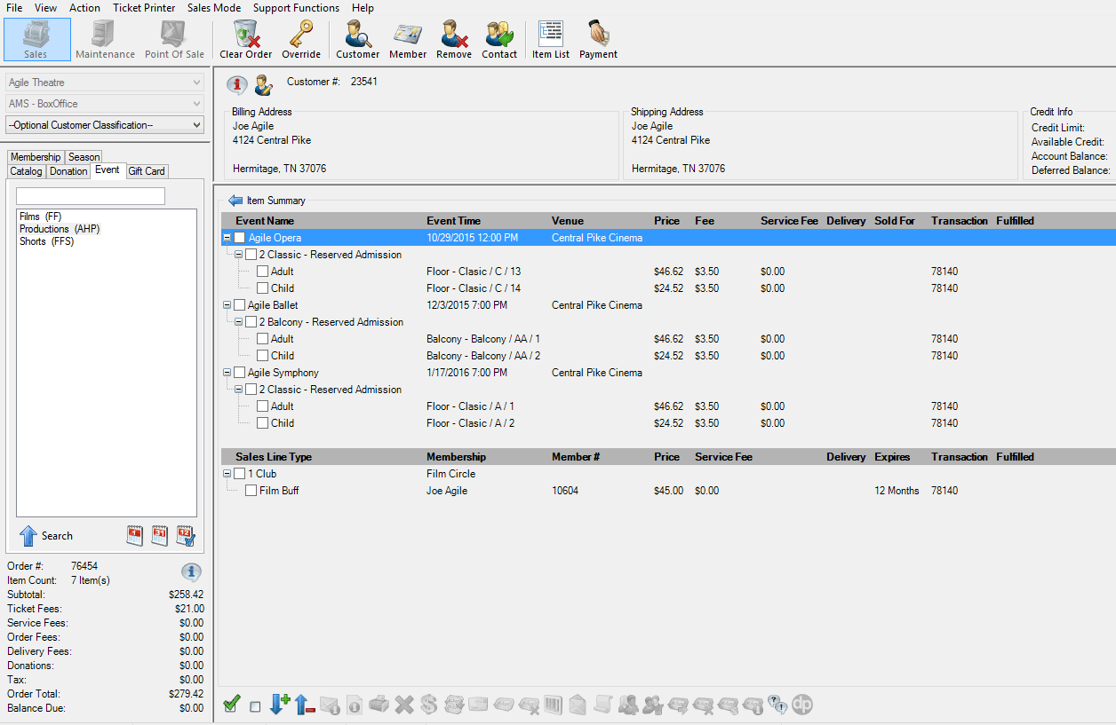](https://support.agiletix.com/hc/en-us/article_attachments/202440944/item_summary.png)

1. A window will pop up asking you to select the delivery method. Choose how the customer would like to receive each item. Then, click **OK**.

[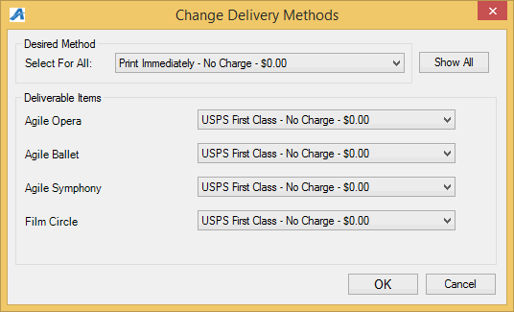](https://support.agiletix.com/hc/en-us/article_attachments/202440934/Change_Delivery_Method_window.png)

1. The payment screen will appear. In the **Choose Method** drop-down list, select **Gift Card**.

[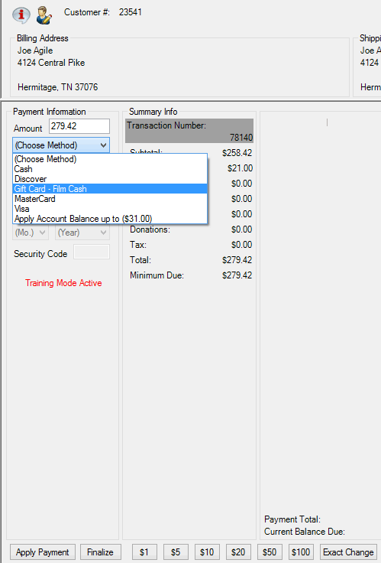](https://support.agiletix.com/hc/en-us/article_attachments/202440924/Choose_Payment-Gift_Card.png)

1. A **Gift Card Lookup** window will appear. If you have a USB swipe attached to your device, you may swipe the gift card at this time. Otherwise, type the **Gift Card Number** and click **Search**.  
   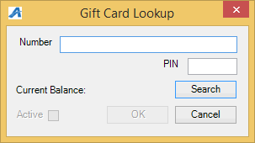
2. The remaining amount on the card will appear in the **Current Balance** area of the window.

[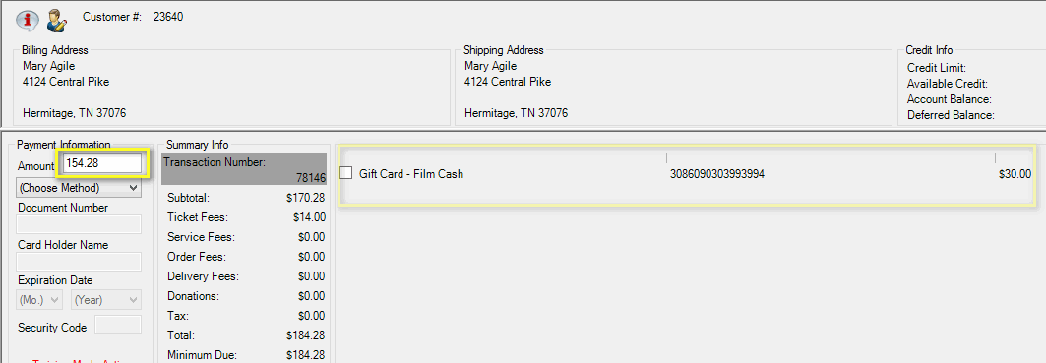](https://support.agiletix.com/hc/en-us/article_attachments/202453514/Apply_partial_payment_with_gift_card.png)

**NOTE**: If the amount on the card is more than the amount owed, the gift card will process the order like a credit card and automatically finalize the order with a remaining balance on the card.

1. If there is money still due on the order, you will then need to add another payment type (cash, check, etc.) to complete the transaction.

**Adding Money to a Gift Card**

1. In **Sales**, click the**Gift Card** tab.

[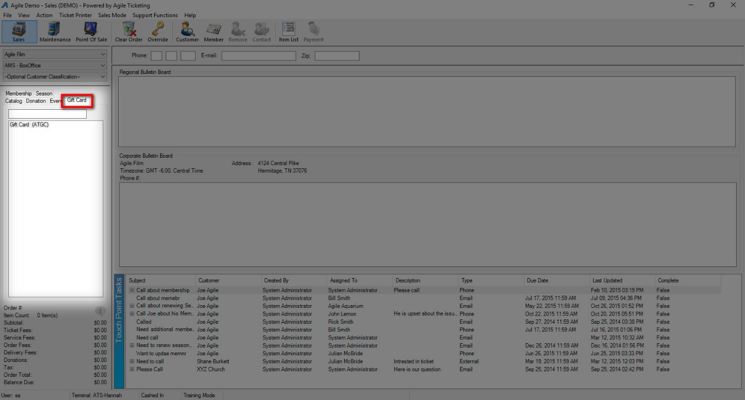](https://support.agiletix.com/hc/en-us/article_attachments/203193913/Gift_Card_Tab.jpg)

1. Select your **Gift Card Program**.
2. In the **Recharge Amount** area, enter the monetary amount to be placed on the card.

[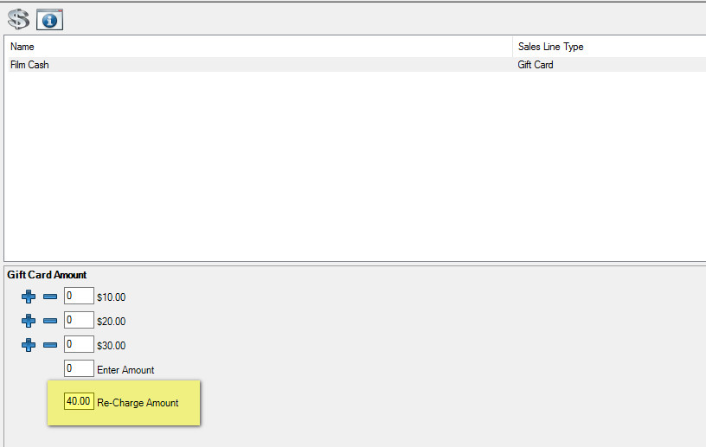](https://support.agiletix.com/hc/en-us/article_attachments/203193963/Re_Charge_amount_2.jpg)

1. Click **Add** in the bottom-right corner of the screen.
2. The Gift Card Lookup window will appear. Swipe the card or enter the gift card number. Click **OK**.

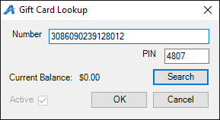

1. Confirm the amount on the **Item Summary** page. If everything looks correct, click **Proceed**.

[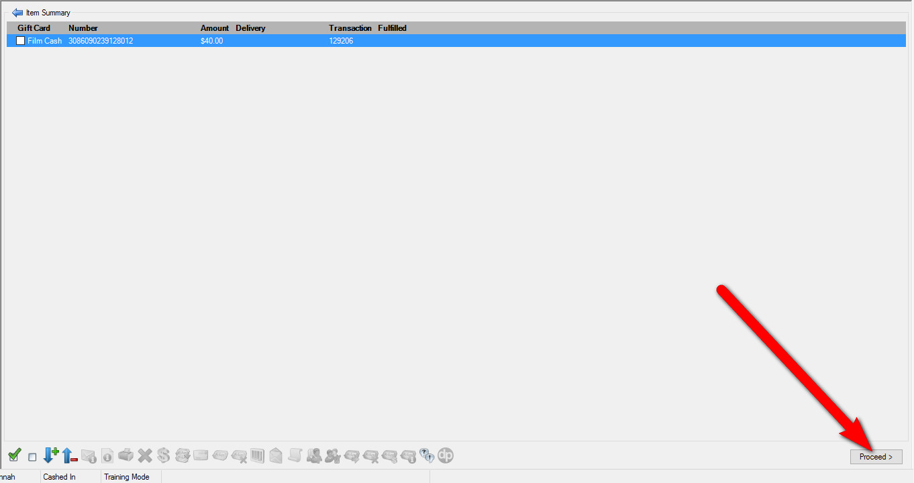](https://support.agiletix.com/hc/en-us/article_attachments/203194023/Item_Summary_4.jpg)

1. In the **Payment Screen**, process the payment and click **Apply Payment**.

[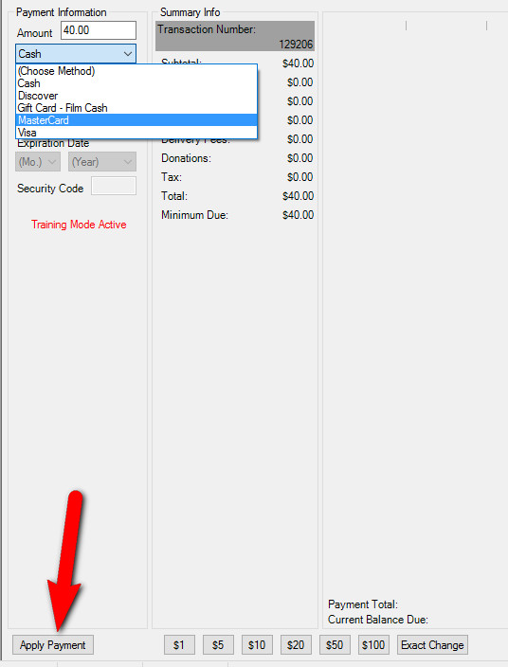](https://support.agiletix.com/hc/en-us/article_attachments/203044676/Apply_Payment.jpg)