Creating A Calendar View Entry Point
1. Log into Administration.
2. Click on the House Icon.
3. Open the Web Folder, and select the Entry Points icon.
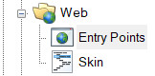
4. Highlight the Entry Point Group by clicking on it.
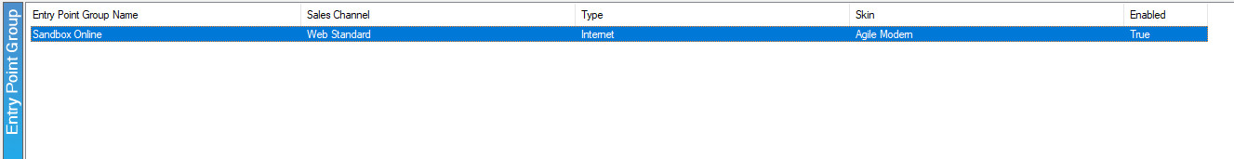
5. Right-click in the Entry Point area and hover over New, then Agile List option, and select Event/Show.
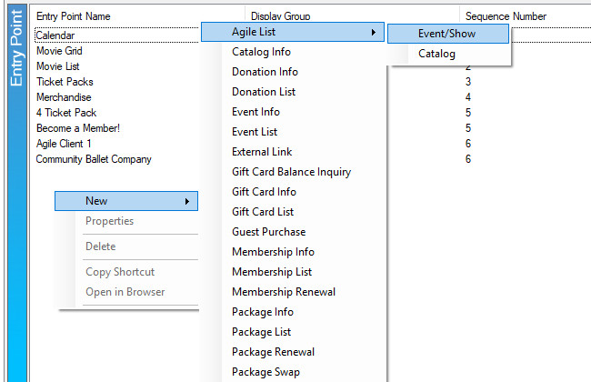

6. You should now be in the Entry Point: New pop-up. Fill out the following in the General tab:
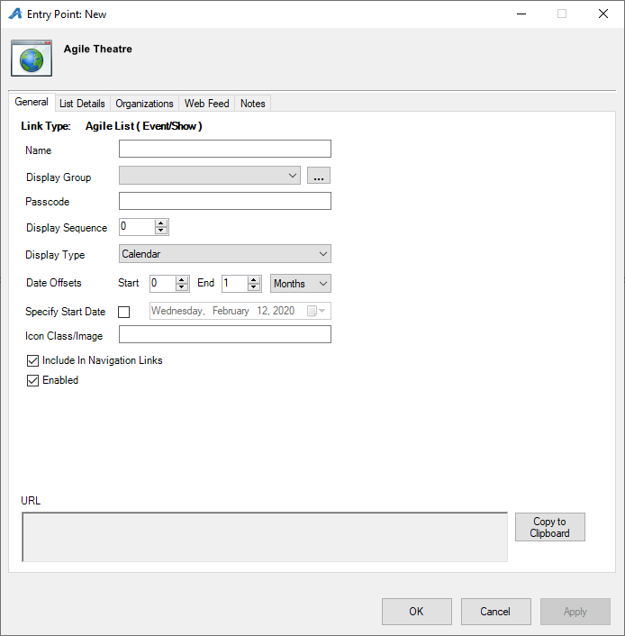
A. Enter the Name of the Entry Point (Note: this name will appear on your ticketing page).
B. You can house this entry point in a Display Group by clicking a display group from the drop-down menu, or you can create a new display group by clicking the ellipsis button . The name of the Display Group will appear as the title of a drop-down list in your navigation bar.
C. Enter a Passcode that will only allow users with the passcode to access this entry point.
D. Enter your Display Sequence.
E. In the Display Type, select Calendar.
F. In Date Offsets, you can set a specific range of time for events/shows to appear online. Anything outside of those dates will not appear. We suggest a 12-month Calendar view.
G. If you have a specific date when you want your events/shows to be displayed, you can check the box next to Specify Start Date and the enter in that date.
H. Un-check Enabled if the Entry Point should no longer be active, and un-check Include In Navigation Links if the Entry Point should not appear in the navigation bar on your website.
I. The URL generates after Apply is clicked.
7. The List Details tab gives you control over what pieces of information are listed about each item. Check each box to make a particular piece of information visible to customers. Filters allow the customer to sort the listings online by Custom Property (click here to learn more about Custom Properties). To enable these, select the filter(s) needed from the drop-down menu and click the green plus icon.
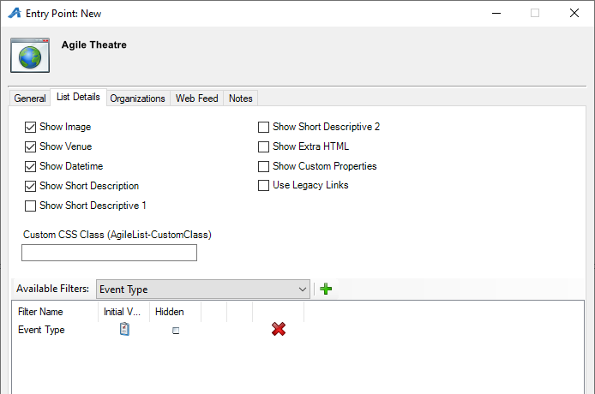

8. The Organizations tab determines which sales folder(s) appear in the list online. (Note: this may need to be updated yearly.)

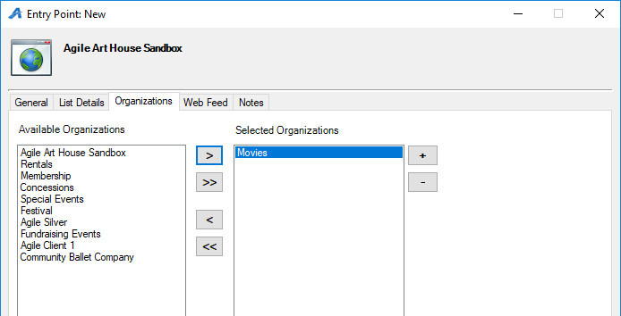
9. The Web Feed tab provides the XML Feed for your organization's website if you choose to use XML Feeds instead of Agile pages. This will be automatically generated when Apply is clicked.

10. The Notes tab is for internal use only. We recommend adding details here about how this URL is being used.
