Creating A Package Entry Point

Entry Points allow you to create unique URLs that are pointed to certain Sales Folders, Items, Packages, Memberships or Donations.
1. Log in under Administration.
2. Choose the Web folder and click the Entry Points icon.
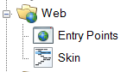
3. Select the Entry Point Group where you will be creating the Entry Point(s). If you do not have an Entry Point Group, see How to Create Entry Point Groups.
4. In the Entry Point field, right-click and select New. You will see a list of menu options. To create an entry point for a single package, select Package Info. To create an entry point for a list of packages, hover the mouse over Agile List and select Package.
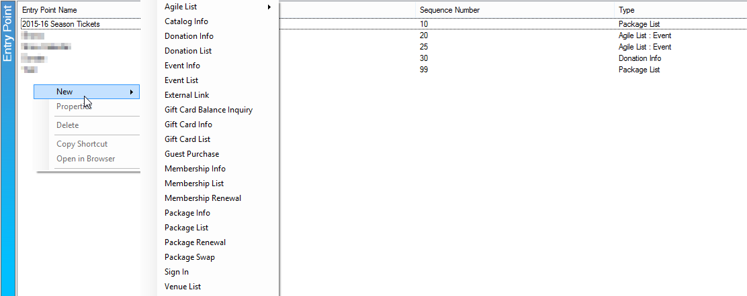

5. In the General Tab, Name your entry point.
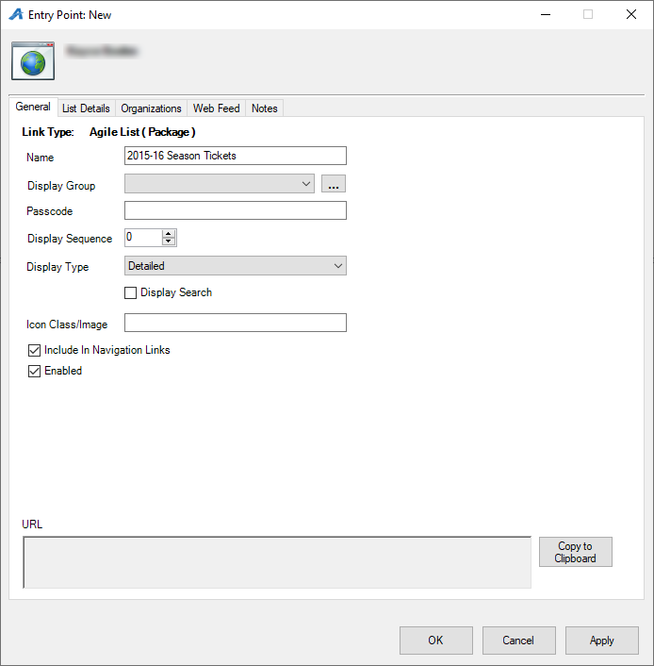
6. A Display Group can be created if you need this entry point to be displayed under a certain heading online.
7. A Passcode can be set if users must enter a password to access the items on the page.
8. Display Sequence allows you to set the sort order of the link on the online navigation menu.
9. Display Type allows you to choose the look and feel of the list. Simple or Detailed are what Agile recommends for Package type Entry Points.

10. In the Organizations tab, move the Sales Organization folder to the Selected Organizations column.
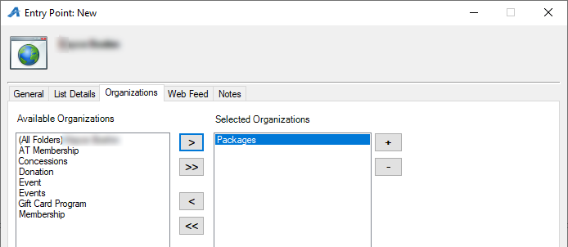
11. Once you have set this information, click Apply. This will automatically generate the URL and Web Feed links.
12. Right-click the Entry Point and select Copy Shortcut. This will copy the URL to your computer's clipboard. You can then paste the URL to an email for an email blast, or, if you are an administrator for your website, add the link to the appropriate area on your website.
