Creating A Schedule View Entry Point
1. Log into Administration.
2. Click on the House Icon .
3. Open the Web folder and click the Entry Point icon.
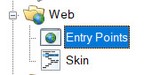
4. Highlight the Entry Point Group by clicking it.
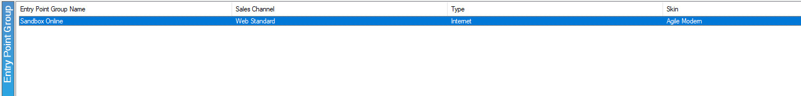
5. Right-click in the Entry Point area and hover the mouse over New and the Agile List option. Select Event/Show.
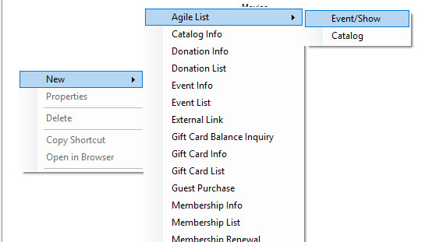

6. You should now be in the Entry Point: New window. Fill out the following in the General tab:
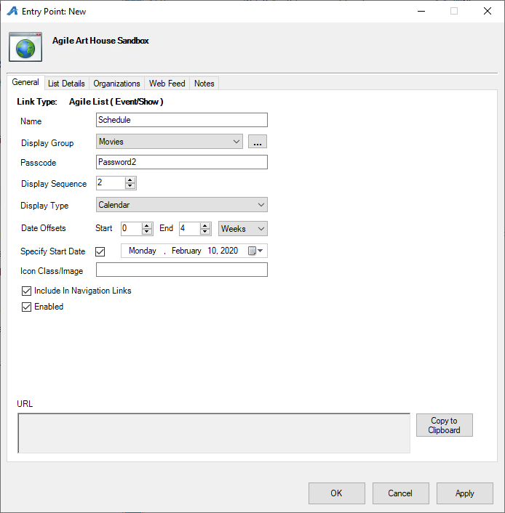
A. Enter the Name of the entry point (Note: this name will appear on your ticketing page).
B. You can house this entry point in a Display Group by clicking a display group from the drop-down. Or, you can create a new display group by clicking the ellipsis button . The name of the Display Group will appear as a drop-down list in your navigation bar.
C. Enter a Passcode that will only allow people with the passcode to access this entry point.
D. Enter your Display Sequence.
E. In the Display Type, select Schedule. Then, if you wish for your events/shows to be searchable, you can check the box next to Display Search.
F. In the Date Offsets, you can set a specific range of time for events/shows to appear online. Anything outside of those dates will not appear.
G. If you have a specific date when you want your events/shows to start appearing, you can check the box next to Specify Start Date and then enter in that date.
H. Un-check Enabled if the Entry Point should no longer be active, and un-check Include In Navigation Links if the Entry Point should not appear in the navigation bar on your website.
I. This is where the entry point's URL will automatically generate after Apply is clicked.
7. The List Details tab gives you control over what is listed about each item. Check each box to make a particular piece of information visible to customers. Filters allow the customer to sort the listings online by Custom Property (click here to learn more about Custom Properties). To enable these, select the filter(s) needed from the drop-down and select the green plus icon.
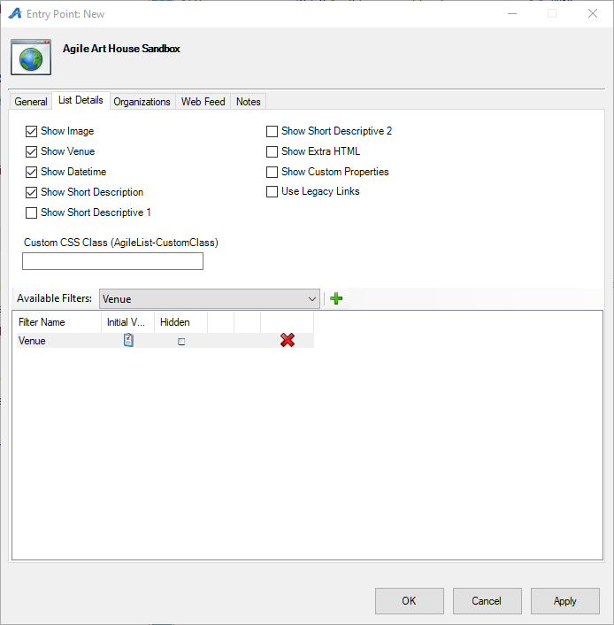
8. The Organizations tab determines which sales folder(s) will appear in the list online. (Note: This may need to be updated yearly.)
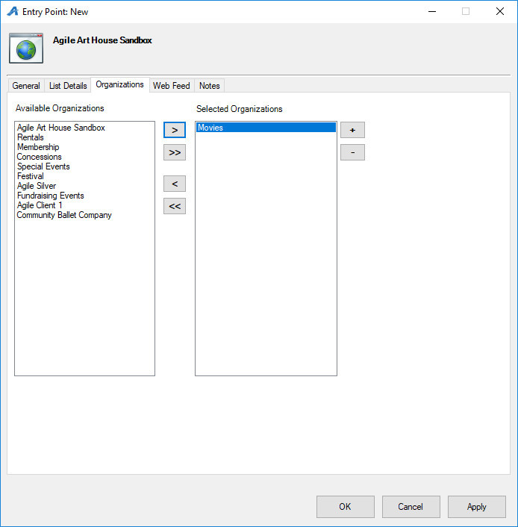

9. The Web Feed tab provides the XML Feed for your organization's website if you choose to use XML Feeds instead of Agile pages. This will be automatically generated when Apply is clicked.
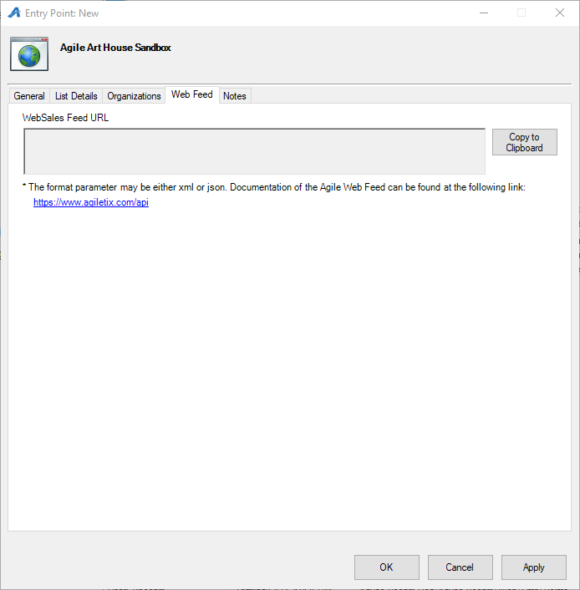

10. The Notes tab is for internal use only. We recommend adding details here about how this URL is being used.
