Cashing Out Using the POS and Closing a Daily User Batch

The cash-handling information listed below, along with the instructions on how to close out the *Daily User Batch* at the end of your shift, are suggested best practices that Agile has found to be useful for our clients. However, **ALWAYS follow your own organization's policies and procedures when handling cash.** If you do not know what your organization's policies are, contact your manager for standard operating procedures.

1. Ping your Cash Drawer to count the total cash and any checks in the drawer (Agile recommends pulling the drawer out of the register and counting the money in a secure room away from customers).
2. Click the **Action**(Gears) button in the menu at the top of the screen. Then, select **Cash In/Out** (See Image 1).  
   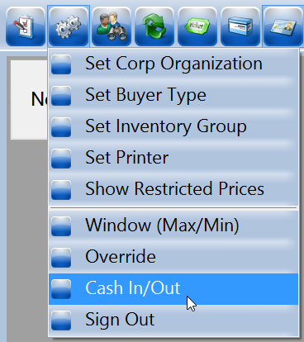  
   Image 1.
3. The **Agent Cash In/Cash Out** window will appear (See Image 2).

[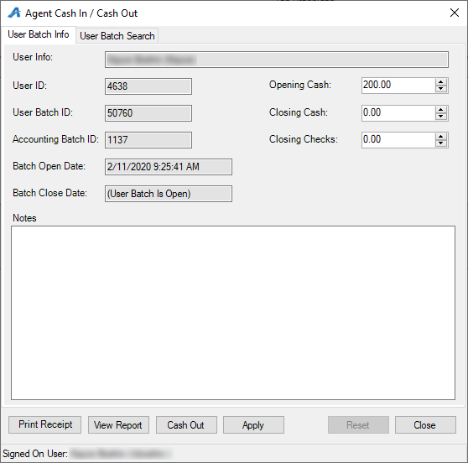](https://support.agiletix.com/hc/article_attachments/360049567971/COUPOSCDUBstep3.png)

Image 2. 

1. In the **Closing Cash** field at the top of the screen, enter the total amount of cash in the drawer (See Image 3).

[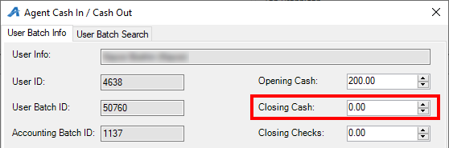](https://support.agiletix.com/hc/article_attachments/360049441352/COUPOSCDUBstep4edit.png)

Image 3.

1. If you took any checks as payment, enter the total amount into the **Closing Checks** field (See Image 4).

[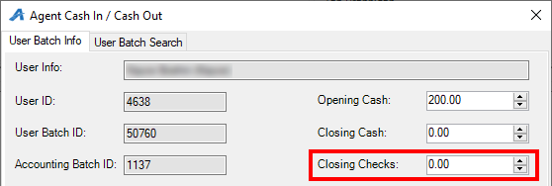](https://support.agiletix.com/hc/article_attachments/360049441412/COUPOSCDUBstep5edit.png)

Image 4.

1. Once you have entered your closing information, click **Apply** at the bottom of the screen to save your information (See Image 5).

[](https://support.agiletix.com/hc/article_attachments/360049567991/COUPOSCDUBstep6edit.png)

Image 5.

1. Click **View Report** to open your **User Batch Audit** **report** for the day (See Image 6).

[](https://support.agiletix.com/hc/article_attachments/360049568011/COUPOSCDUBstep7edit.png)

Image 6.

1. At the top of the User Batch Audit report, you will see the **Reconciliation** **summary**. This will show your Opening Till, Closing Till, Total Sales, and the total amount of cash to be accounted for at the end of the shift. If you are short, there will be parentheses around the number at the bottom of the list. If you are over or at balance, the number will have no parentheses. Any notes entered on the Agent Cash In/Cash Out window will be displayed at the bottom of the report (See Image 7).

[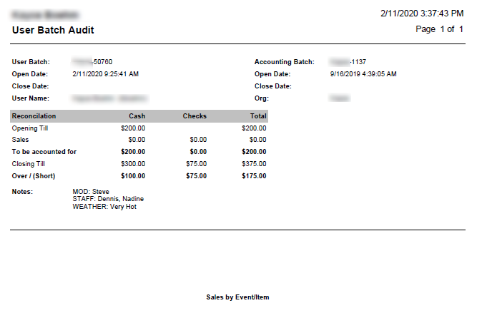](https://support.agiletix.com/hc/article_attachments/360049441472/COUPOSCDUBstep8.png)

Image 7  
  
**NOTE:** If your drawer does not balance, it is recommended you find the cause, type the explanation into the notes field, and explain to your supervising manager why you are not balanced.

1. Once you balance, go back to your **Cash In/Out** window and click the "**Cash Out**" Button (See Image 9).

[](https://support.agiletix.com/hc/article_attachments/360049568151/COUPOSCDUBstep9.png)