Event Reminder Email
Want to learn more? Sign up today for our ATSU Learning Webinar: You've Got Mail: How to Use Agile's CRM

Agile Ticketing Solutions now has the ability to have customers set up Event Reminder Emails. Follow these steps to create your Event Email Reminders.
1. Login to Administration.
2. Click on the House icon to see all of your folders.
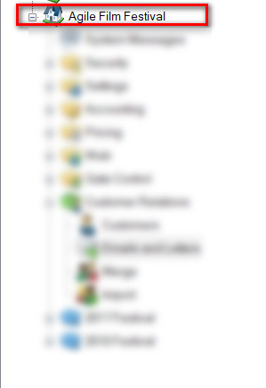

3. Click on the green Customer Relations Folder.
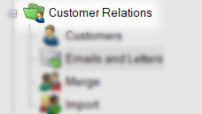
4. Select Emails and Letters.
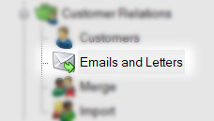
5. In the Emails and Letters field, right-click and select New.
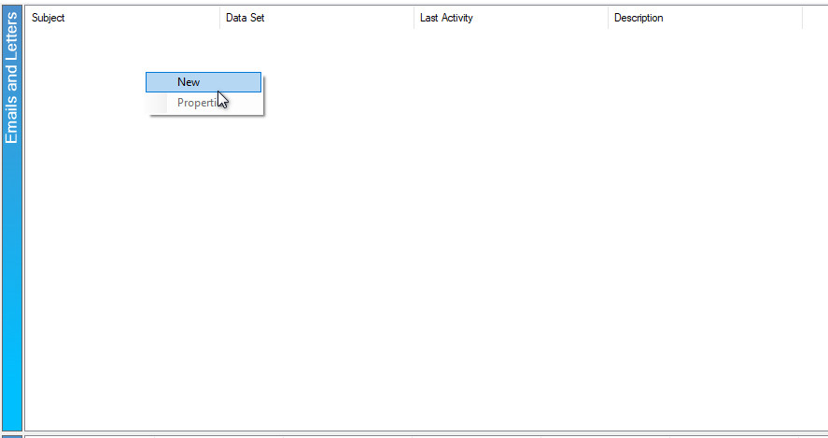

6. In the Query Data Set drop-down, choose Event Reminders. You will see the list of Data Elements that are available in this Query. Click OK.
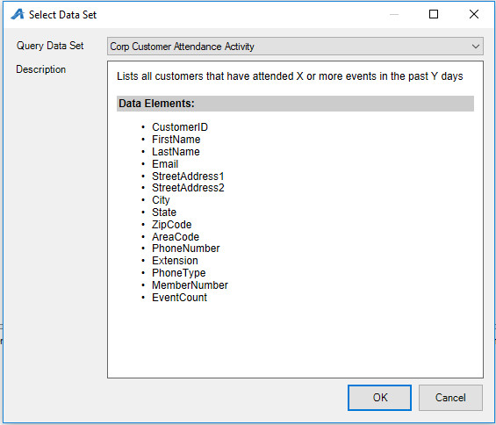
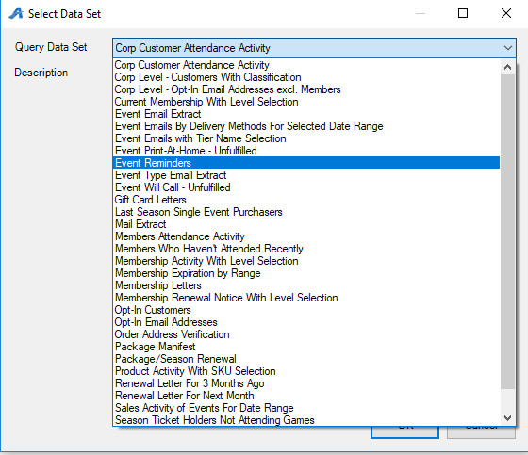
7. On the DataSet tab, click Set Parameters.
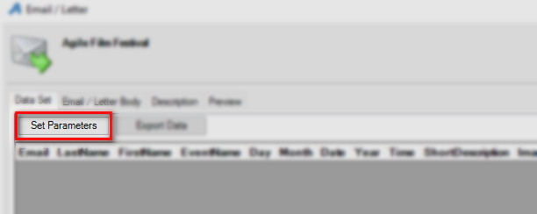

8. In the Set Parameters window, choose the number of Days Before Event that you wish this email to be sent.
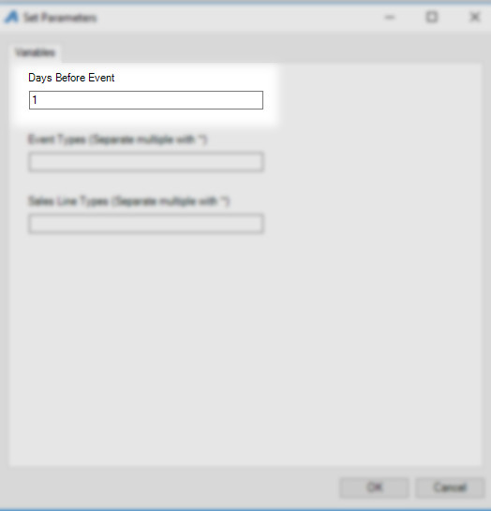

9. Event Types allows you to only send this email for certain events. If your email can go to all event types, then leave this field blank.
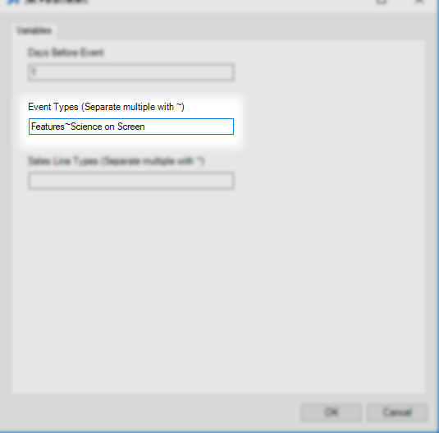

10. You can also send emails based on a specific Sales Line Type. Leave this field blank if you do not wish to send email based on Sales Line Types.
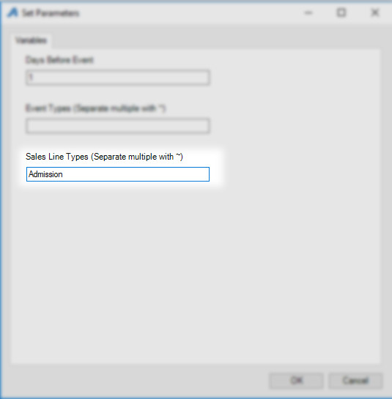

11. Once you have set up your parameters, you can now go to the Email/Letter Body tab to start writing your email.
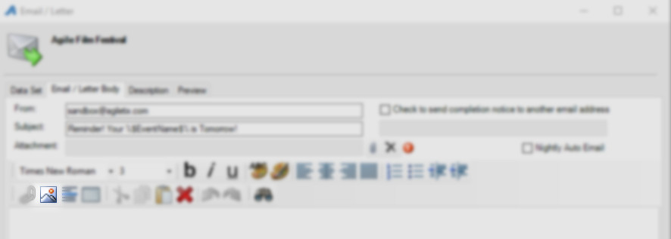

12. Each of the DataSet Elements can be merged into your email to allow for specific information to be sent to the customer.
a. Enter the subject of your email. Note, you can right-click in the subject line and enter an element such as the Event Name that will then populate the title of each event.
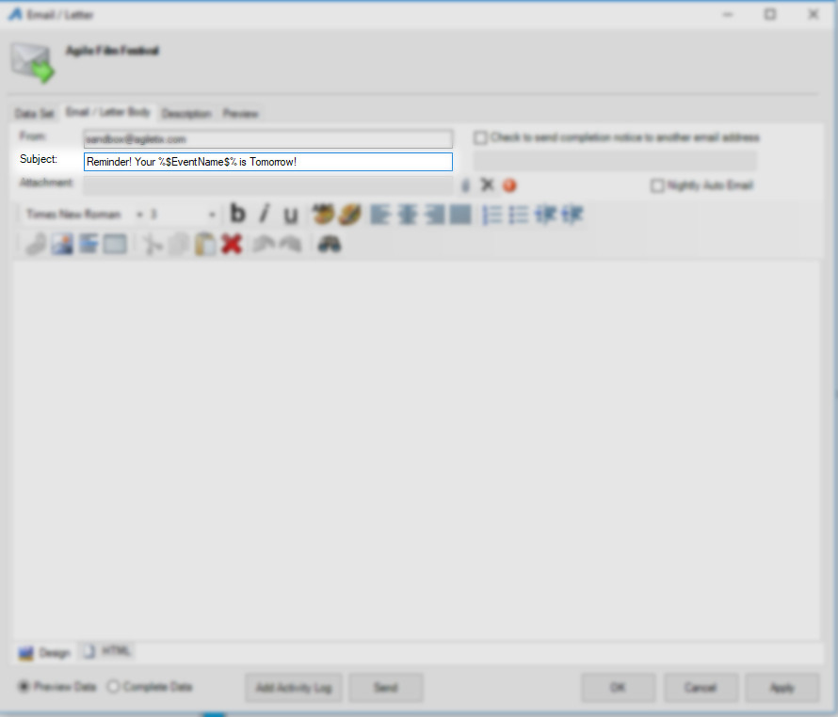
b. If you wish to add an image to the top of the email, such as your logo, click on the Image icon. Click Import to upload your image, or if your image is already in the image library, click the drop-down to select from the list of images.
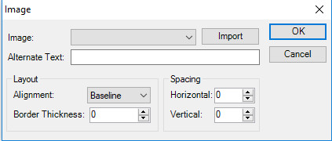

c. To Add specific Elements, right-click and select Insert to see the list of elements that can be added. Elements include the following:
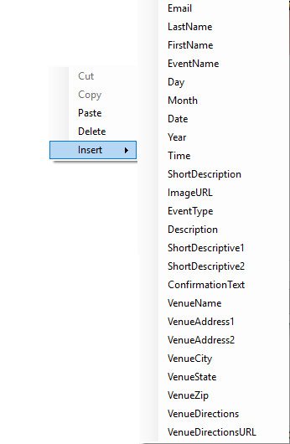

All of these fields can be pulled from the event itself and merged into your email. See the sample image for the Email Body.
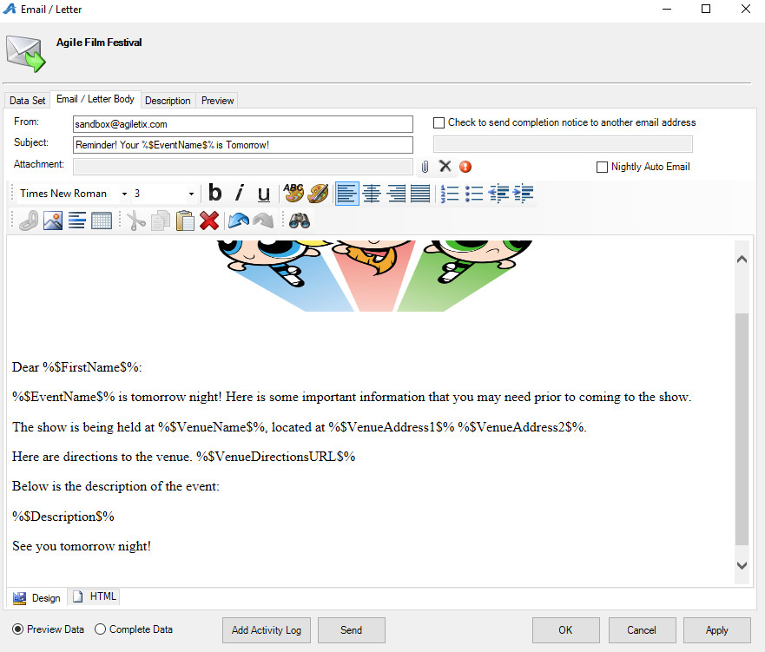
13. Once you have completed drafting your email, you can either send it yourself by clicking on the Preview tab, or you can contact a member of our support team, and they can set up the Nightly Automation that will search and for events that fit your pre-set parameters and automatically send the email.

