Manually Adding A Membership Benefit To An Existing Member

Normally when a membership program is built, a member's benefits are determined by the benefit group attached to the membership they purchased or renewed. At times, however, there may be a need to manually add a benefit to an existing member's account (i.e. adding a special comp benefit for a specific member's account as a thank you for something special that they did for your organization, customer relations issues, etc.). The steps below will show you how to add these benefits manually to a member's account.
1. Search for the Customer's Membership account by clicking the Member Button and entering their last name or membership number. Then, select the Customer account for this member.
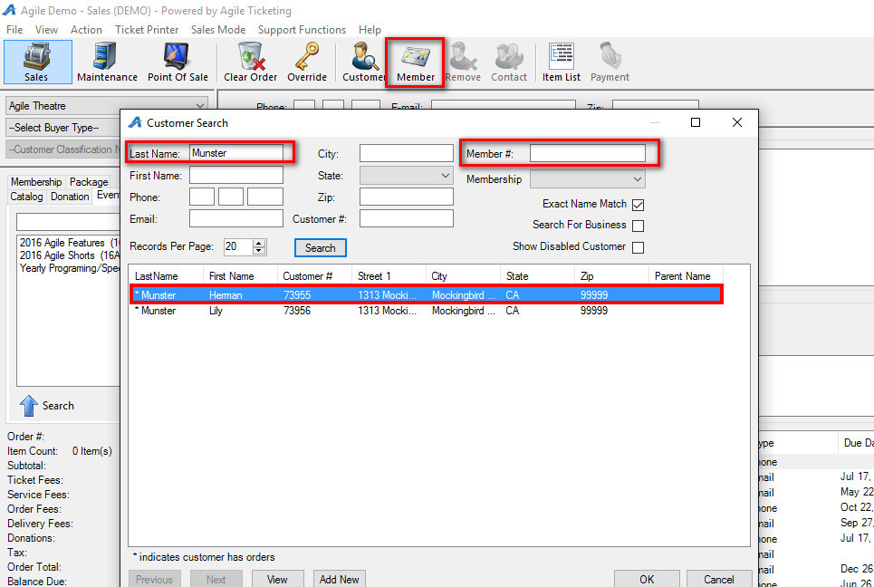

2. Click the Customer Number to open the Customer Account Record.
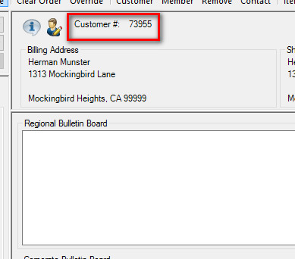
3. In the Customer Account window, select the Memberships tab.
4. Right-click the Membership and select Properties to open up the Order Member Properties window.
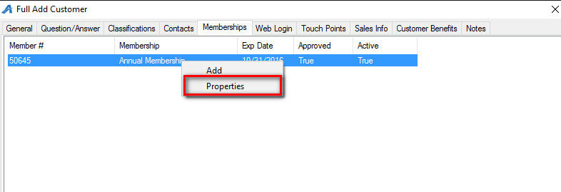

5. Select the Benefit Groups tab.
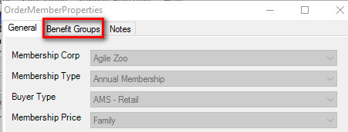
6. Right-click in the window. If you need to add a benefit, select Add. If you only need to edit a benefit, select Properties.
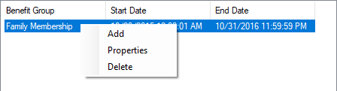
7. In the Membership Benefit Group Properties window, select the Benefit Group that you are manually adding to the Membership Record.
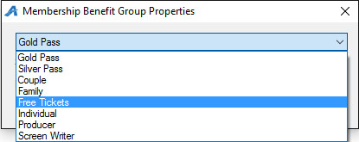
8. Adjust the Start Date and End Date for when this benefit will be available. Once completed, click OK and then close the Member Properties window.
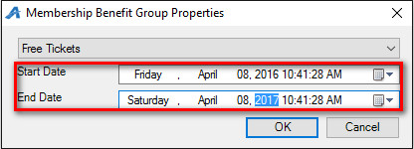
NOTE: If you make a mistake and select the wrong Benefit Group, you can right-click the benefit, select Delete, and make a new benefit with the correct Benefit Group.

