How To Add Fair Market Value To Ticket Prices With No Cash Value

Some organizations have $0.00 priced tickets that are not true comps but do have a monetary value that needs to be tracked based on the tickets' value. The following steps are how to edit existing price types to add the Fair Market Value.
1. In Administration, open the Blue Folder with the Price Types that you will be editing.
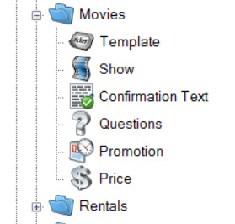
2. Click the Price (Dollar Sign) icon.
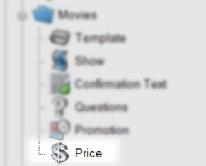
3. Highlight the Price Type that you will be editing.
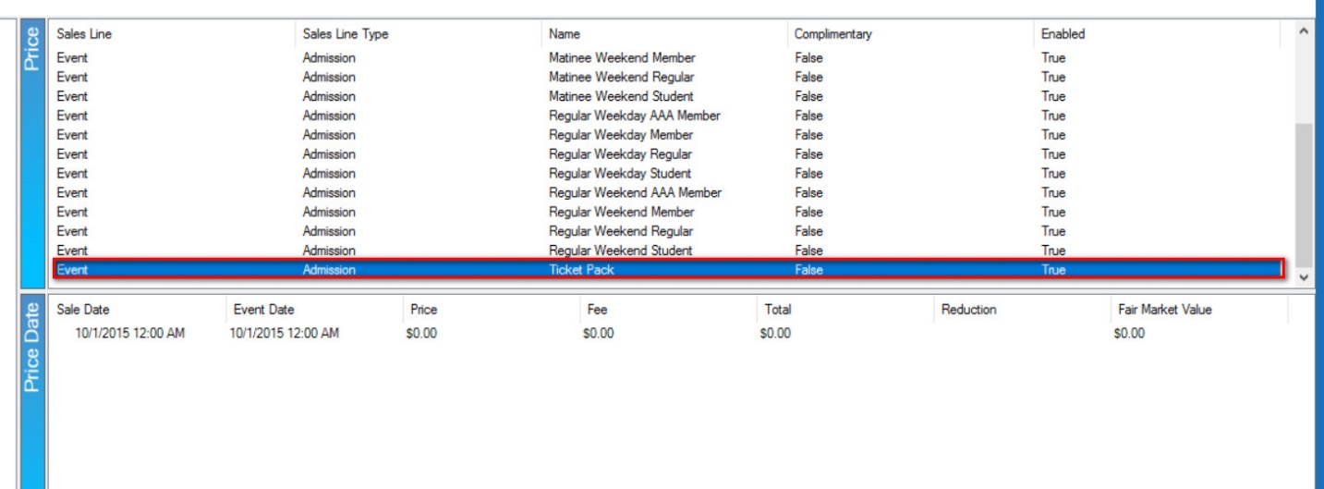
4. Right-click the current Price Date and select Properties.
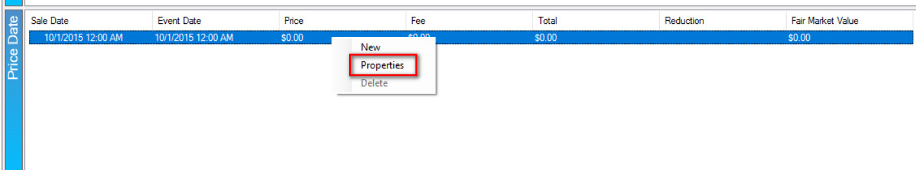

5. Enter the Fair Market Value for this price.
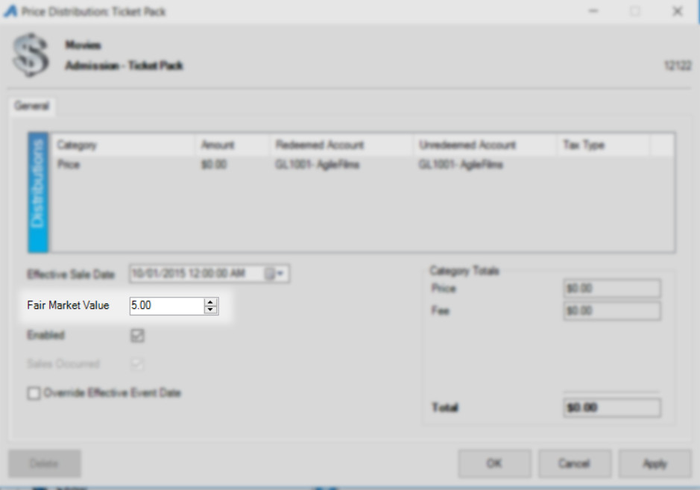
6. Click Apply and OK to save and close the window.
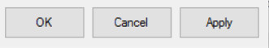
7. Repeat steps 1 through 6 for any tickets that you will need Fair Market Value to be reported.
The Gross Revenue - Box Office Statement and the Gross Revenue - Rentrak/EDI are the current reports that can include the Fair Market Value amount on the reports.
To ensure that the Fair Market Value appears on these reports, you will need to check the Include Price Category 2 in Ticket Price box.

