Selling From An Inventory Hold In POS
Want to learn more? Sign up today for our ATSU Learning Webinar: The ABC's of Basic Sales in Agile
Some organizations need to place a certain number of tickets on a hold status in order to accommodate specific use. These steps will show you how to sell directly from those holds in POS.
1. Click Action and select Set Inventory Group.
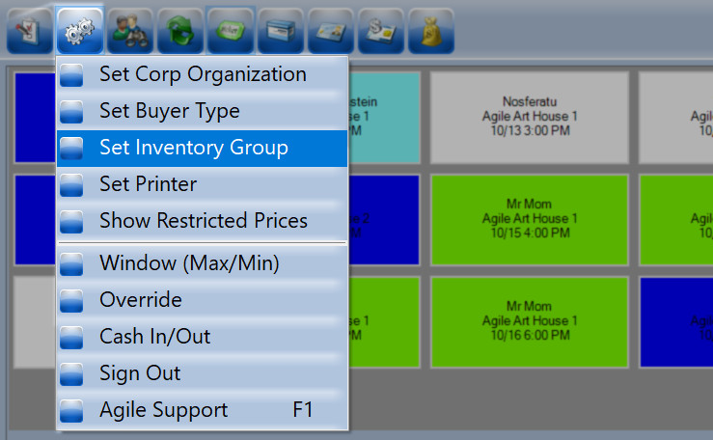
2. Choose the Inventory Group Hold that you wish to sell from.
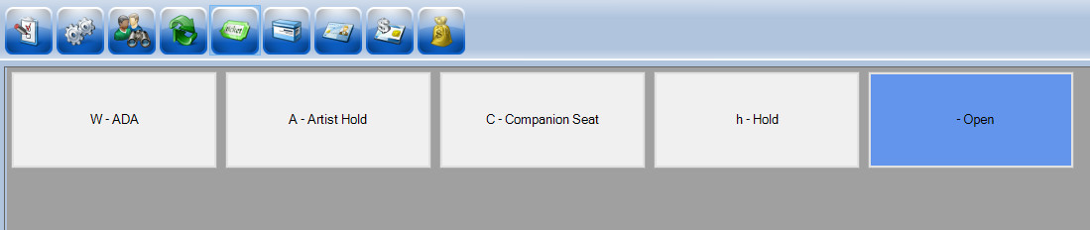
3. Click the Event icon and select the Event you wish to sell.
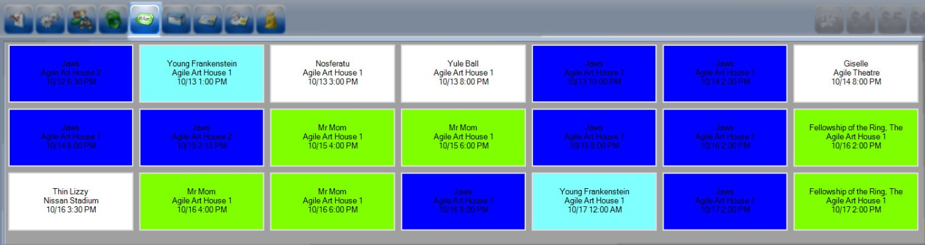
4. Select the Price or section you are selling.
NOTE: If selling a reserved seat, click on the Seat icon to see which seats are on hold.

5. The order will appear to the right of the screen.
6. Process the payment.
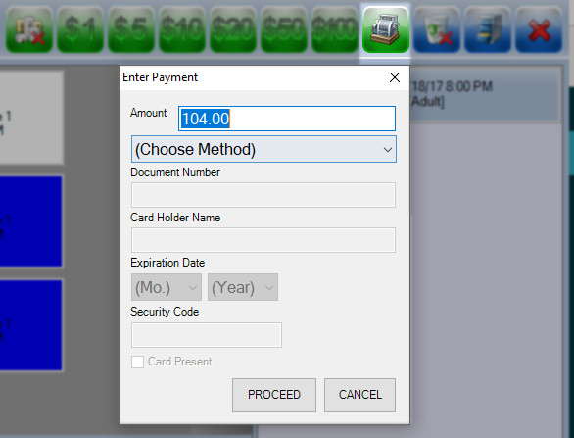
7. Once the payment has been processed, the order summary will turn orange.
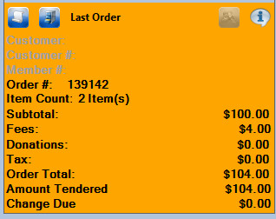
NOTE: Make sure to change your Inventory Hold back to Open once you have completed all transactions using the hold.

