Cashing In and Creating a Daily User Batch in AMS
Any user who logs into Agile Sales to begin their shift must start by opening their Cash In User Batch. The User Batch allows your organization to track your sales for the day.

1. Login to Agile Ticketing Solutions with your username and password. If you haven’t received your user credentials, please contact your system administrator to set up your username and password. (See Image 1)
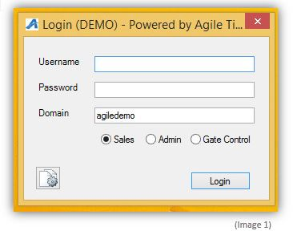
2. Once logged in, you will see "Action" in the menu at the top of the screen. Click Action -> Agent -> Cash In/Out. (See Image 2)
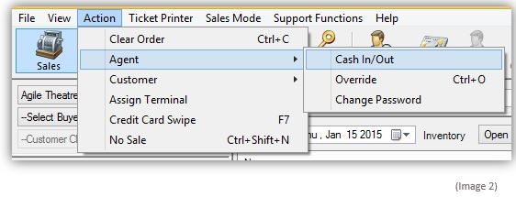

3. The Agent Cash In/Cash Out window will appear. (See Image 3)
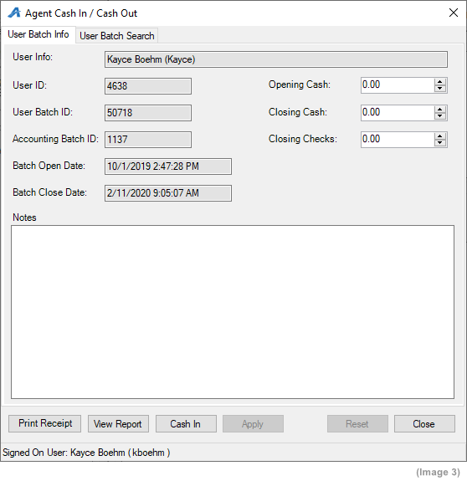

4. Click the "Cash In" button at the bottom of the screen to start your batch for the day. (See Image 4)
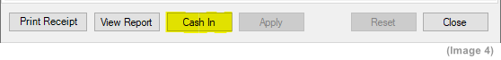

5. Count your beginning cash bank and type it into the Opening Cash field at the top of the screen. (See Images 5 and 6)
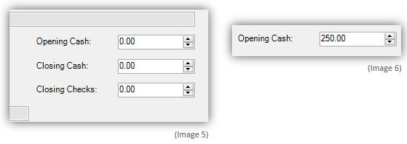
6. Once you have entered your Opening Cash, click Apply at the bottom of the screen. (See Image 7)
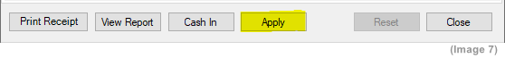
7. Add any special notes in the Notes field (i.e. The manager on-duty for the shift, the exact start time of the shift, etc.). (See Image 8) 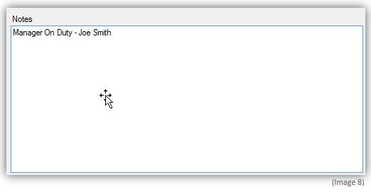
8. Once you have entered your Notes, click Apply at the bottom of the screen to save your information. (See Image 9)
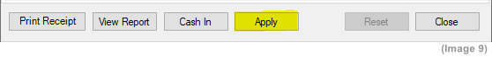
9. Once you have completed your opening procedures for your user batch, click the Close button to close the screen. (See image 10)
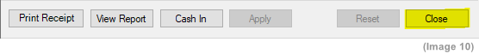
10. You are now ready to start processing sales for the day.

NOTE: Entering in your cash bank will allow you to track your cash sales for the day and balance at the end of your shift. Agile itemizes all sales processed through your user batch and allows you to pull this information on your user batch report by clicking on View Report.
Click here to learn how to Cash Out to close your Daily User Batch and to view your User Batch Report.

