Creating A Membership/Pass Info Entry Point
A Membership or Pass Info entry point displays information specific to a single membership/pass program online.
1. Log into Administration.

2. Click the House icon.

3. Open the Web Folder.

4. Click the Entry Point icon.

5. Select the Entry Point Group.

6. In the Entry Point area, right-click and select New. In the options menu, select Membership Info.
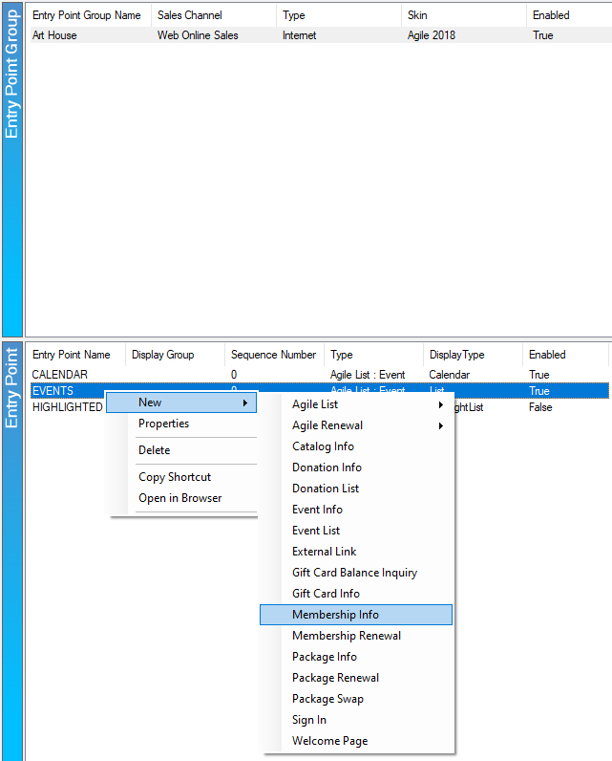

7. You should now be in the Entry Point: New page.
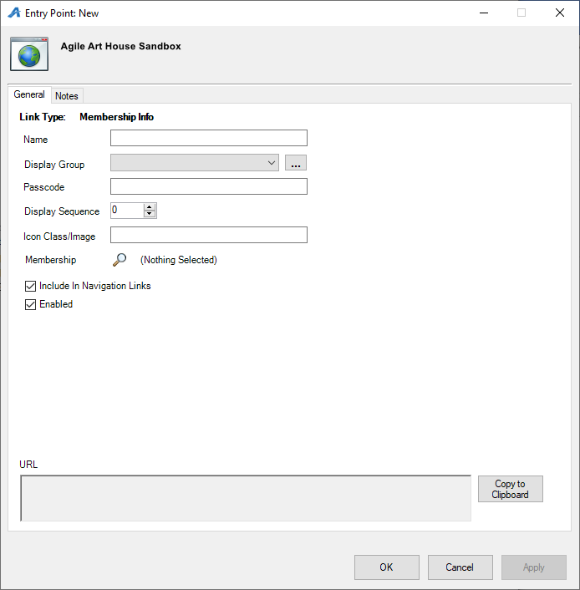
In the General tab:
A. Name your Entry Point. (Please note that whatever you name the Entry Point will appear on the Navigation Bar on your website.
B. Display Group allows you to group specific URLs under the group heading that will appear as a drop-down menu on the Navigation Bar on your website.
C. The Passcode allows you to place your links on the website but will require the Passcode you entered to allow anyone to access the URL. This is a great way to test your events or merchandise before making it visible to the general public.
D. Enter the Display Sequence.
8. Click the Search icon beside Membership.
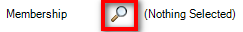
9. Select the Sales Folder where your Membership is housed. In the lower window, click the desired Membership or Pass program.
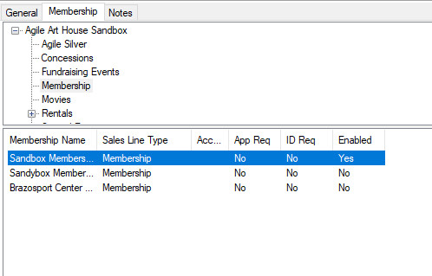
10. In the Notes tab, you can write any notes about your entry point or the Membership/Pass you will be selling.
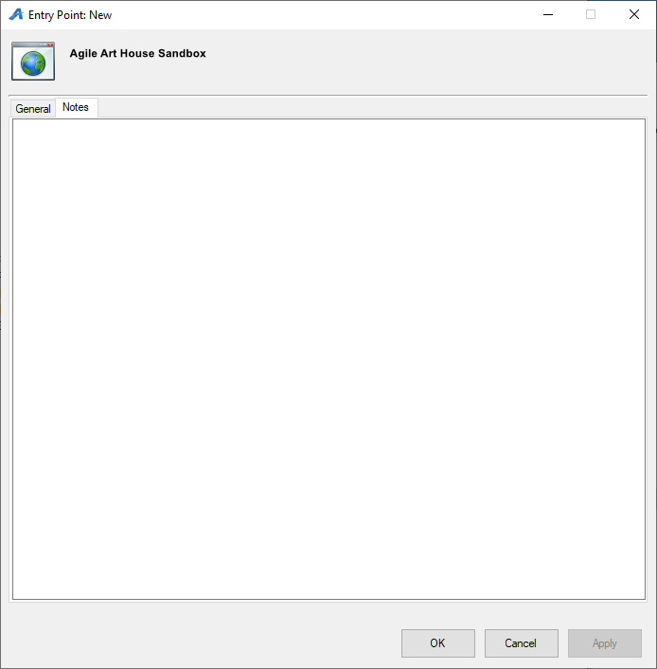
11. Once you have filled out all the information for your entry point, click the Apply button at the bottom of the page.
12. Go back to the General Tab. After you have clicked the Apply button, you will see a URL appear in the URL box at the bottom of the screen. From here, you can copy the URL and attach it to your organization's website.
